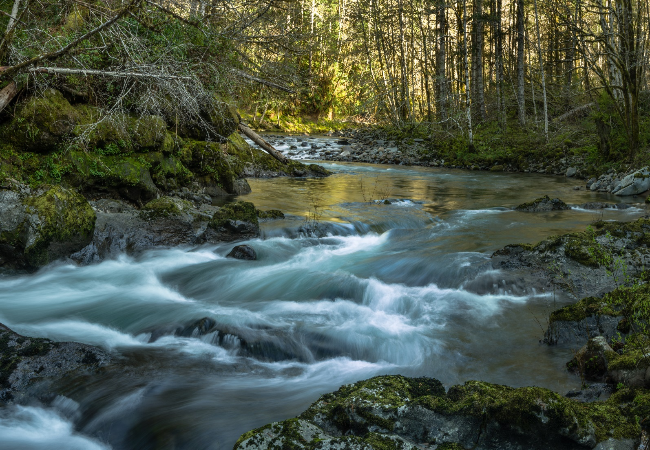

Oregon’s Mid-coast
water planning partnership
  - DRAFT water action plan

May 2022
www.midcoastwaterpartners.com

This page intentionally left blank.

To obtain an electronic copy of this document, visit https://www.midcoastwaterpartners.com
Recommended Citation:
Mid-Coast Water Planning Partnership. 2022. Oregon’s Mid-Coast Water Planning Partnership Water Action Plan. 139pp.

The Integrated Water Management Plan Development Team that developed this document with Mid-Coast stakeholders included Creative Resource Strategies, LLC, Institute for Natural Resources, Oregon Sea Grant, Oregon State University Extension Service, and OSU Libraries and Press. This Project Team worked in collaboration with the Partnership to create the 12/15/21 and earlier drafts of the Water Action Plan using materials drafted by consultants and agency partners. The May 2022 iteration of the Plan and any future updates to the Plan will be made and approved by Mid-Coast Water Planning Partners.
Table of Contents
Acknowledgements vi
Executive Summary vii
The Mid-Coast Water Planning Partnership 1
Mission, Vision, and Goals of the Partnership 1
History and Drivers of the Planning Process 2
Planning Area 9
Guiding Principles 10
Relation to Other Regional Planning Efforts 11
Perceptions and Values of Mid-Coast Regional Stakeholders 14
Environment, Natural Resources, and Economy of Oregon’s Mid-Coast 17
General Overview 17
Understanding Water Resources Quantity, Quality, and Ecological Issues 21
Water Uses and Needs in the Mid-Coast 34
Water Law and Water Rights 34
Overview of Instream Water Uses, Needs, and Challenges 34
Overview Out-of-Stream Water Uses, Needs, and Challenges 40
Water Availability and Future Needs 49
Climate Vulnerability in the Mid-Coast 52
Action Plan 54
Action Plan Development 54
Overview of the Strategic Action Imperatives 57
Implementing the Water Action Plan 61
Anatomy of the Mid-Coast Water Action Plan Implementation Table 64
Imperative 1. Public Awareness and Support 65
Imperative 2. Regional Capacity and Collaboration 69
Imperative 3. Monitoring and Data Sharing 72
Imperative 4. Water Conservation, Efficiency and Reuse 74
Imperative 5. Resilient Water Infrastructure 77
Imperative 6. Source Water Protection 80
Imperative 7. Planning for Water Supply Development Needs (including assessment) 83
Imperative 8. Ecosystem Protection and Enhancement 85
Literature Cited 92
Appendices 94
Appendix A. Definitions 95
Appendix B. Mid-Coast Water Planning Partnership Step Products, Process, and Participants 100
Appendix C. Oregon Explorer Report Hyperlinks and Spatial Data Gaps 107
Appendix D. Crosswalk of the Mid-Coast Water Planning Partnership Plan Actions with Other Important Regional Conservation Initiatives 111
Appendix E. Water Providers by Population Served and Connections 114
Appendix F. Issues Identified During Collaborative Planning but not Carried Forward 115
Appendix G. Oregon’s Mid-Coast Estuaries 116
Appendix H. ODFW Comments Regarding the Draft Action Plan and Instream Demand 118
Appendix I. Water Use and Availability Summaries by Sub-Area 121
Appendix J. State Plan Review Team Feedback, Feedback from Charter Signatories, Compiled 30-day Public Review Feedback that Informed May 2022 Version 138

List of Tables
Table 1. Summary of water quality limited streams by drainage basin. 27
Table 2. Areas of ecological importance. 31
Table 3. Estimated quantity of use by type of use for Lincoln County based on the 2015 water use estimates produced by the US Geological Survey in gallons per day. 40
Table 4. Estimated self-supplied rural domestic water users and demand by sub-area. 45
Table 5. Estimated irrigation water users and amount of water use by sub-area. 46
Table 6. Water Supply and development by sub-Area. 50

List of Figures
Figure 1. The six-step planning process to complete an integrated water management plan for Oregon's Mid-Coast. 7
Figure 2. Sub-areas in the Mid-Coast Planning Area used for planning purposes. 9
Figure 3. Word graphic illustrating the elements of a successful planning process based on sound guidance principles. 10
Figure 4. Graphic illustrating key outcomes of the Oregon Mid-Coast Water Action Plan and the interconnectedness of people, water infrastructure, and natural systems. 13
Figure 5. Key values and perspectives of Mid-Coast stakeholders in 2018 survey. 15
Figure 6. A snapshot of the environment, natural resources, and economy of Oregon's Mid-Coast. 20
Figure 7. Total estimated average annual natural streamflow volume (in acre-feet) of surface water in streams and rivers in the Mid-Coast based on a 1958-1987 period of record. Note that these volumes do not reflect diversions for out-of-stream uses. 22
Figure 8. Photograph of the Tyee formation. Photo Credit: Stanford Project on Deepwater Depositional Systems (https://spodds.stanford.edu/tyee-basin-oregon) 23
Figure 9. Monthly diverted water used by municipal community water systems in the Mid-Coast. 42
Figure 10. Monthly diverted water used by non-municipal community water systems in the Mid-Coast. 43
Figure 11. Projected climate change impacts to important parameters in the Mid-Coast region. 52

Acknowledgements

The Mid-Coast Water Planning Partnership would like to express our appreciation to our planning partners for their expertise and assistance throughout all aspects of our planning process and for their help in writing the Mid-Coast Water Action Plan. After five years and thousands of volunteer hours, we are excited to present this plan to you.
We are grateful for the passion and dedication that Mid-Coast Water Planning Partners have brought to this planning process. Since 2016, we have had partners come and go as with any organization doing long-term water planning, but regardless of the amount of time spent in our organization, we value every minute dedicated by our volunteers.
Water planning processes such as this one would not be possible without financial support and the donation of meeting spaces. We have been very fortunate to have support from the following organizations over the years: the Confederated Tribes of Siletz Indians, Oregon Water Resources Department, Meyer Memorial Trust, Collins Foundation, Oregon Community Foundation, Ford Family Foundation, Seal Rock Water District, Gibson Farms, Lincoln County Farm Bureau, Samaritan Health, City of Lincoln City, City of Toledo, City of Newport, City of Yachats, and Lincoln County.
Place-based integrated water resource planning is a new and innovative approach, and we have learned so much along the way. We hope that future planning groups can take what we have learned and build upon on it as we all work to create a more secure and sustainable water future around the state.

Executive Summary
The purpose of the Oregon Mid-Coast Water Action Plan is to provide a framework and pathway forward to address water supply and use challenges in the Mid-Coast region, and sustainably balance water needs for people and native fish and wildlife. This plan provides direction to meet the collaborative goals of the Mid-Coast Water Planning Partnership.
The plan describes the six-year history of the planning process, and the major steps leading to plan implementation, including public participation and engagement from a diversity of individuals and organizations. Members of the partnership agreed to a suite of guiding principles highlighting common ground, innovation, commitment, flexibility, action, and clarity.
Although this plan is intended to achieve water resource protection objectives critical to the watersheds of the Mid-Coast as well as the people who live, work, and recreate in the Mid-Coast, it also supplements, complements, and supports numerous other federal, state, and local planning efforts currently underway in the region that address, or have a nexus with, water issues.
Foundational to the development of this plan were the technical reports and information developed during planning Steps 2 and 3. These reports describe regional water quality, water quantity, ecology, and built infrastructure issues as well as current and future instream and out-of-stream water uses and needs.
Water Quantity: Streams in the Mid-Coast have high natural streamflow during the winter months (January-March) and low natural streamflow during the summer/Fall months (August-October) as a result of seasonal precipitation patterns. Streams are rain-dominated and responsive to precipitation, reaching high flows during rainstorms. Groundwater inputs contribute base flows in streams during late summer and Fall months. There are eight active real-time streamflow gage locations which produce information to inform water rights administration. Mid-Coast groundwater is not very productive because of low permeability and low storage capacity of the regional geology.
Water Quality: Water quality affects the extent to which water bodies can support beneficial uses, such as drinking water, industrial, agricultural, fish and aquatic life, and wildlife. Oregon’s 2018/2020 Integrated Report and Assessment Database identifies Mid-Coast water bodies that are water quality limited for not meeting one or more water quality parameters, such as temperature, dissolved oxygen, or E. coli. Surface water is the primary source of drinking water for nearly all of the municipal and community water providers in the Mid-Coast. Several water providers in the Mid-Coast use groundwater. Common groundwater contaminants that are monitored include arsenic, lead, nitrates, and fecal coliform bacteria. Several organizations and various private entities conduct periodic water quality monitoring activities in the Mid-Coast.
Ecology: The Mid-Coast supports a variety of habitats, which include streams and springs, lakes, riparian areas, wetlands, and estuaries. There are 12 streams or estuary habitats designated as areas of ecological importance in the Mid-Coast because of the diverse habitats and species they support. Aquatic species of interest and concern in the Mid-Coast include seven species of anadromous salmonids, two species of sturgeon, beaver, and three species of lamprey. Oregon Coast Coho Salmon are listed as threatened under the Endangered Species Act, and large portions of the Mid-Coast are designated as critical habitat for coho. Green Sturgeon also are listed as threatened within the Southern Distinct Population Segment, which includes Yaquina Bay. Sources of habitat degradation include stream channel simplification and incision, warm stream temperatures, altered streamflow timing and watershed function, fine sediment and turbidity related to peak streamflow, and toxic and non-toxic pollutants. Aquatic habitat restoration efforts occur in the Mid-Coast to increase stream channel complexity and off-channel habitat, reduce fine sediment inputs and summer water temperature, address fish passage barriers, and encourage beaver dams, or similar structures.​
Built Infrastructure: The Mid-Coast has 52 potable water providers (cities, water districts, RV and mobile home parks, and state parks), 31 of which are required to have certified water treatment plant (WTP) operators. Few interconnections exist between water providers. Many cities and water districts implement water conservation measures, and nine have developed Water Management and Conservation Plans (WMCPs). The Mid-Coast has 14 entities (cities, resorts/hotels, and industries) with National Pollutant Discharge Elimination System (NPDES) permits to discharge treated wastewater. Discharge locations are the Pacific Ocean, Yaquina River and Bay, Siletz River and Bay, Schooner Creek, and Lint Slough. The discharge locations on streams are all downstream of potable water intakes. Information about wastewater systems and, particularly stormwater systems, is lacking. Cities are likely the only water providers managing stormwater systems. The Mid-Coast, like much of the rest of the United States, has aging infrastructure and insufficient revenue to address many needed upgrades. Consequently, water systems in the Mid-Coast must be managed for resiliency and recovery.
Out-of-stream water use and rights. There are about 1,637 water rights in the Mid-Coast planning area allocated to 29 different uses. Domestic use has the greatest number of water rights (n=703) followed by irrigation (n=419), instream (n=110), and municipal (n=82). The largest water use category in the planning area is for self-supplied industrial use, followed by water used by hatcheries and water for domestic and industrial use provided by community water systems. The largest water users in the region draw water from the Siletz River and have water rights that are senior to the instream water right.
Instream water needs and rights. Fifty-one streams have existing instream water rights, but these instream rights inadequately capture the full range of flows needed to protect current instream ecosystems. Summer streamflows are insufficient in some areas of the Mid-Coast to meet the instream water needs of fish and wildlife. Low streamflows contribute to water quality impairments (e.g., high temperatures and reduced dissolved oxygen) that negatively affect fish and wildlife. Climate change impacts and increased demand from municipal and rural water users are expected to further limit available water in the summer for all uses.
During Step 3 of the planning process, the Partnership achieved consensus on a total of 18 key issues in eight categories—water conservation; natural hazards, vulnerabilities, and emergency preparedness; climate change impacts; local capacity and regional collaboration; water quantity for instream and out-of-stream uses, watershed health, water quality for instream and out-of-stream uses, and infrastructure. Action-oriented imperatives were created to organize and synthesize the key watershed strategies stakeholders described during the planning process to address the priority issues. In addition, cross-cutting imperatives are essential to the success of each of the action-oriented imperatives.
A key component of this plan is implementation table that describes a suite of actions to initiate water objectives and priorities in the Mid-Coast region of Oregon in three phases during the next 10 years. The 59 actions in the implementation table represent the highest priority strategies designated by charter signatories across 8 imperatives - Public awareness and support; Regional capacity and collaboration; Monitoring and data sharing; Resilient water infrastructure; Source water protection; Water supply development; Ecosystem protection and enhancement; Water conservation, efficiency, and reuse.
Actions and Strategies included in the Implementation Table garnered the broadest consensus support within the Partnership. While general feasibility was an implicit driver of consensus support, and often discussed in Partnership conversations, the proposed actions have not been fully considered in light of current state or local laws, or from the perspective of a cost-benefit analysis. Because of the highly specific and technical nature of the potential projects under the proposed actions, individual project Partners, in consultation with the relevant State agencies and local governments, are best equipped to evaluate the feasibility of projects.
The Partnership recognizes that estimated implementation “costs” for many Actions or Strategies do not reflect the benefits, (or return on investment) for ecosystem services, infrastructure risk reductions, or system efficiencies. Calculating these is technically, socially, and economically complex. However, the Partners agreed to examine ecosystem services and other expected outcomes as part of a comprehensive approach to evaluating Plan implementation and investment strategies utilizing available methods, tools, and references.
Preliminary estimated costs to implement the plan over 10 years range from $133,750,000 to $12,032,400,000. Based on this large uncertainty (two orders of magnitude) in full plan implementation costs combined with minimal supporting documentation for most of these estimates, the Partnership agreed that specific budget estimates to implement the Actions need to be developed at the time, considering specific project-scale plans and the scope of work for any Action or Strategy.
Following state recognition process, the Water Action Plan will move into the Implementation phase. The highest priority is continued funding for a dedicated Partnership coordinator position to perform critical duties associated with partner agreements, partner onboarding, identifying the first round of projects (including any already initiated), monitoring and recording implementation progress, seeking funding sources and supporting the work of the Water Action Teams and individuals.

The Mid-Coast Water Planning Partnership recognizes it may not be possible to initiate, or complete, all of the actions in this plan during the next decade. As with any volunteer partnership, actions will be completed as opportunities for funding, collaboration, and resources become available. Regardless, the Mid-Coast Water Planning Partnership believes it is important to highlight and take aggressive action to implement the issues and actions in this plan to ensure a sustainable water future for the Mid-Coast of Oregon and enhance the resilience of the Mid-Coast to climate change stressors.

The Mid-Coast Water Planning Partnership

The Mid-Coast region of Oregon is one of four areas that began piloting a new approach to water planning in 2016 with the Oregon Water Resources Department (OWRD). The purpose of the place-based integrated water resources planning efforts was to implement the Oregon’s 2012 Integrated Water Resources Strategy, which directs OWRD to help communities collaboratively develop and implement integrated solutions to address instream and out-of-stream water challenges and needs within a geographic scope defined by stakeholders. This regional plan will inform updates to the statewide Integrated Water Resources Strategy.
This plan – Mid-Coast Water Planning Partnership Water Action Plan – synthesizes the cumulative work of the Mid-Coast Water Planning Partnership (MCWPP), or the Partnership, and serves as a living document to provide the Partnership the ability to amend its actions to achieve its goals as time and circumstances change. Definitions fundamental to this plan are in Appendix A.

Mission, Vision, and Goals of the Partnership
Mission
The purpose of the Mid-Coast Water Planning Partnership is to develop an inclusive community forum that examines water use in the region, identifies current and potential water challenges, and creates a unified plan to balance water needs.
Vision
Regional partners ensuring balanced water resources for the environment, the economy, and coastal communities.
Goals
Work collaboratively to develop an Integrated Water Resources Plan for the Mid-Coast Region:
- Develop a sustainable water supply for consumptive uses that also protects the environment, supports healthy watersheds, and is resilient to climate change stressors and natural hazards.
- Balance the needs of our ecosystems, our economies, and our communities.
- Develop cross-boundary solutions that help neighbors work together to achieve additive effects.
- Develop and implement integrated regional water management strategies for improved water quality and quantity as well as provide fair access.
- Increase awareness about regional water needs, challenges, and opportunities.
- Improve the resilience of water management infrastructure by identifying emergency water sources and taking steps to access those water resources when needed, and repair water system infrastructure.

History and Drivers of the Planning Process
The Mid-Coast water planning initiative launched in 2016 with a grant from OWRD to the City of Newport to co-convene a collaboration of stakeholders and develop strategies that would address the following key drivers:
- Address aging infrastructure, improve water conservation efforts, enhance regional water supply options, and more effectively share water among uses and users;
- Relieve late season pressure on rivers, streams, and tributaries while meeting water needs for and coastal communities and local industry;
- Create redundancies to enhance resilience during drought, storms, and other natural vulnerabilities; and
- Create a learning and action network for small water providers vulnerable to environmental and regulatory challenges.
During its first meeting, the Mid-Coast water planning initiative became the Mid-Coast Water Planning Partnership. The Partnership is a voluntary association that actively seeks to include diverse perspectives, interests, and expertise regarding water issues on the Mid-Coast. Organizations or individuals may join the Partnership at any time by agreeing to the terms of the Charter. The Partnership includes, but is not limited to, representation and input from municipal water providers; special districts/water districts; industrial water users; local businesses and economic development organizations; coastal residents, rural homeowners, and landowners; conservation/environmental organizations; timber/forestry groups; agricultural groups; fishing groups; recreation groups, academic/scientific community; city and county governments; state and federal agencies; tribes; and elected officials. For an updated list of members, see https://www.midcoastwaterpartners.com.
Key Water Supply Challenges
Some water providers currently face water shortages. Future shortages are projected due to decreasing supplies and increasing demand, especially during peak tourist season.
Low summer stream flows and limited water storage create water shortages for both communities and stream flows critical for fish, recreation, and industry.
Communities need to be better prepared to address natural hazards, vulnerabilities, and emergency preparedness.
During the September 2016 MCWPP kickoff meeting, stakeholders articulated desired outcomes for their planning process. The outcomes included:
- Increased awareness about regional water needs, challenges, and opportunities.
- Development of cross-boundary solutions that help neighbors work together to achieve additive effects.
- Integrated regional water management strategies that are planned and implemented to improve water quality and quantity, ensuring fair access.
- Sustainable water supply for consumptive uses while protecting ecological needs.
- Improved resilience of built infrastructure and watersheds.
- Flow management to store more winter water and raise the water table to alleviate summer low-flow conditions.
- Incentives for water conservation.
- Enhanced understanding of the role of existing rules, regulations, and resources associated with water management and use.
- Water rights that benefit everyone.
- A process that is timely, is multi-decadal in its vision, and is foundational to obtaining additional sources of funding for implementation.
From the outset, the Partnership approached this initiative as a long-term vision that incorporates timely and implementable strategies, and creates a strong foundational plan for obtaining additional sources of funding for implementation. The Partnership determined it would realize its vision for the Action Plan in five steps, in accordance with OWRD guidelines. The Partnership added a sixth step in 2020 b to ensure this Action Plan acknowledges the importance of incorporating adaptive management principles as the plan is implemented. All steps are summarized in Figure 1. More information is contained in Appendix B.
Step 1 (September 2016 – May 2017): Partners convened to initiate the planning process, developed a work plan and schedule, and created an inclusive process. The partnership charter, which defines the purpose and goals of the Partnership, and documents how members agree to work together, was adopted on March 29, 2017.
Step 2 (May 2017 – February 2018): Partners formed four study groups and worked with a consultant team to produce four technical reports characterizing the Mid-Coast’s water quantity, water quality, ecology, and built systems.
Step 3 (February 2018 – September 2020): Partners self-organized into three separate working groups to better understand the current and future instream/ecological water needs and challenges as well as the water needs and challenges of municipalities/special districts, self-supplied water users (rural domestic, agricultural, industrial). The groups spent time learning about the issues together and received technical assistance from multiple agency partners. The working groups produced an agreed upon set of critical issues that formed the basis for strategy development.
Step 4 (September 2020 – June 2021): Partners developed and launched a new website and drafted the plan. Specific strategies that address each key issue were identified and prioritized, and performance metrics were developed to assess progress in implementing strategies.
Step 5a (June 2021 – October 2021): Stakeholders reviewed the draft plan and edits were incorporated.
Step 5b (November – May 2022): Partners reached consensus on a final draft to submit to the state Plan Review Team for feedback. In collaboration with the Plan Review Team, partners worked to address required draft plan improvements to achieve state recognition. Adoption of the May 2022 version of the plan by the Partnership.
Step 6 (June – Onward): Present plan along with the Plan Review Team’s recommendation to the Water Resource Commission for them to officially recognize the plan. Adoption of the plan by additional organizations, plan implementation, monitoring of progress, and adjustments to the plan based on emerging issues and learning that occurs during implementation.
Partnership Structure and Participation – Balanced Representation
This plan was developed with a diversity of entities and individuals living and working in the mid-coast of Oregon. This includes representatives of municipal water providers, special districts and water districts, industrial water users, local businesses, economic development organizations, coastal residents, rural homeowners, landowners, conservation organizations, academic entities, local governments, state and federal agencies, tribes, elected officials, and entities representing agricultural, forestry, fishing, and recreation interests. Mid-Coast Water Planning Partnership charter signatories played a key role in the development of the plan. A list of MCWPP partners can be found here.
In addition, extensive outreach has occurred throughout the six-year process to develop the plan, including:
- Presentations to city councils within the geographic scope of the partnership;
- Press releases to regional media;
- Radio broadcasts;
- Recorded webinars describing planning steps and outcomes (while creating opportunities for feedback and guidance);
- Surveys to obtain feedback on specific elements of plan development;
- Monthly newsletters to share progress on plan development;
- The creation of a website to capture each step of the planning process and key outcomes; such as Storymaps (English & Spanish versions), and compiled information and data;
- Welcome sessions for new partners interested in joining and engaging with the partnership during the development of the plan;
- Public meetings; and
- Targeted outreach to tribes, non-English speaking community members, and small local businesses and industry
The Partnership is guided in its work by Co-Conveners and a Coordinating Committee and is supported by a dedicated Partnership Coordinator as well as a team of consultants. The Co-Conveners have changed during the course of the planning process, but are committed to providing a neutral and balanced forum that ensures diverse partners learn together and work cooperatively on plan development and implementation. The Coordinating Committee meets monthly and advises on overall process design. The Partnership is the decision-making body and operates consistent with the terms of the Charter. The Partnership Coordinator oversees the work of the Partnership and keeps partners connected to the process and to each other. The planning process has been supported by various consultants over time in the development of various technical products and the plan. The Partnership strived for a balanced representation of interests in the composition of the Partnership, Coordinating Committee, and sub-groups for each planning step. A list of participants in each step, along with their affiliation, is provided in Appendix C.
The global COVID-19 pandemic required the Partnership to conduct all of its meetings remotely from March 2020 until plan adoption. Prior to the pandemic, meetings with the full Partnership were held 2-4 times per year in-person, with an opportunity to learn from each other and build networks around water issues. Sub-groups were convened and met as needed to accomplish work in between Partnership meetings. Attendance at Partnership meetings ranged from 20 to 70 participants.
Mid-Coast Water Planning Partners have made a commitment to diversity, equity, and inclusion throughout the planning process recognizing that capacity can be a barrier to high-level participation. The Partnership has been diligent in efforts to listen and engage the Confederated Tribe of Siletz Indians and presented to the Tribal Council on 4 or 5 different occasions. The Tribe’s Biological Programs Director has served as a partnership member as well as Coordinating Committee member to help the Partnership ensure the inclusion of the Tribe’s instream and out of stream water needs are represented in the planning process. In September of 2019, the Tribe co-hosted a quarterly Partnership meeting which included opening remarks from Vice-Chairman Bud Lane and a presentation from the Siletz Tribal Natural Resources Department. The Siletz Tribal Council was also heavily involved in outreach efforts to tribal members during the 2018 and 2021 OKT surveys.
Plan Adoption and State Recognition
The final version of the draft plan was reviewed and approved by consensus, as defined in the Charter, by all those who signed the Charter and reaffirmed their commitment at the beginning of the strategy development phase. The consensus decision was to submit the plan for state review in December 2021. The state Plan Review Team consisted of staff from five state agencies: the Water Resources Department, Department of Fish and Wildlife, Department of Environmental Quality, Department of Agriculture, and Watershed Enhancement Board. The Plan Review Team worked with local field and technical staff to determine if the draft plan demonstrated that the planning and the plan followed the 2015 Draft Planning Guidelines and principles of Oregon’s IWRS. The review took 85-days and feedback was given in three categories: required improvements, plan strengths and considerations for plan implementation (see Appendix J). Concurrent to the state review process, the Partnership conducted a 30-day public review to help gauge community support for the draft and inform future updates to the plan, input was anonymous, and a compiled list of the comments were added to the plan under Appendix J.
In spring 2022, the Planning group and Plan Review Team worked together to create solutions to the questions or concerns posed by partners in December 2021, public review comments and required improvements to satisfy the state’s criteria. Collectively they reached consensus to finalize and adopt the plan as a collaborative at a Partnership meeting on May 11th, 2022. The Planning group will be presenting the final Mid-Coast Water Planning Partnership Water Action Plan along with the Plan Review Team’s recommendation to the Water Resource Commission at their June 2022 meeting for state recognition. For regional plan adoption partners and local organizations, where appropriate, will be asked to sign the Mid-Coast Water Planning Partnership Declaration of Cooperation affirming their commitment to implementation. This may require individuals working within their organizations to discuss and clarify the organization’s level of support. During the regional plan adoption phase, the Partnership will reach out to the Siletz Tribal Council to further discuss and assess their values and priorities as they relate to water resources. A draft Mid-Coast Water Planning Partnership Resolution will be provided to local governments for their consideration. An MOA will be drafted at the beginning of implementation by the Planning group for partners to implement specific projects/actions. The MOA’s developed and signed by partners will be used to track implementation and will inform future plan updates.

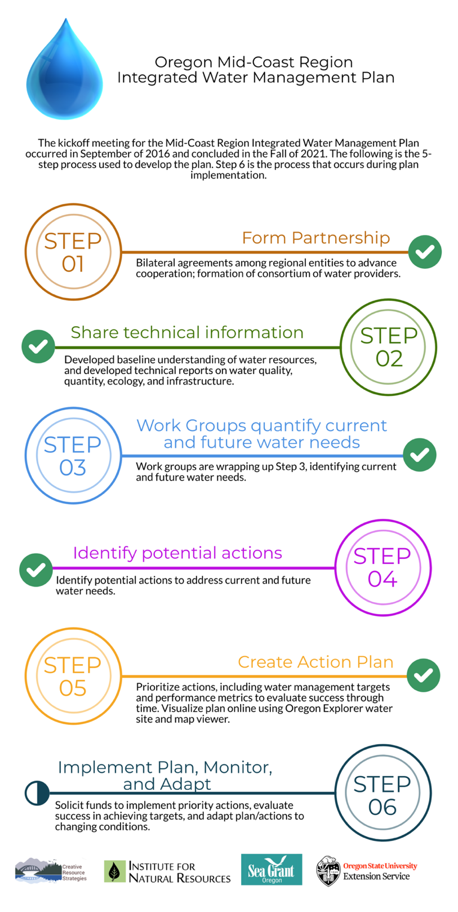
Figure 1. The six-step planning process to complete an integrated water management plan for Oregon's Mid-Coast.
Public Participation
All meetings of the Partnership were advertised via emails and press releases and were open to the public. Meetings were held in the evenings with food provided for all participants. Prior to the pandemic, meetings were held throughout the Mid-Coast (in Newport, Yachats, Siletz, Gleneden Beach and Toledo) to encourage participation from different parts of the region.
The Partnership maintains an email list that anyone can join. As of plan adoption the list has 292 subscribers. All meeting materials of the Partnership are maintained online for easy access. Anyone is invited to join the Partnership at any time by signing the charter. The only condition for participation is that they act in accordance with the charter.
The Partnership organized four separate field tours (two in 2017, one in 2018, and one in 2019) to learn about water conditions and challenges from partners. Each of the field tours were open to the public and had high participation. The field tours were recorded, and the recordings were shared online, in email blasts, and via the Facebook page.
A public event was held at the Hatfield Marine Science Center in partnership with the Center and the Surfrider organization. The event was comprised of a panel of Partners representing different water interests who talked about how balance could be achieved. Agency partners were on hand both before and after the panel with information on water quantity, water quality, and ecology.
Presentations have been delivered to the County, to cities, to the Siletz Tribal Council and to other partner organizations throughout the planning process. There has been coverage of the effort in the newspaper and the Co-Conveners and Partnership Coordinator have been interviewed on the radio.
The Partnership, its members, and consultants supporting the Partnership have produced numerous technical products to describe water conditions in the Mid-Coast. There was a recognition that many of these documents, sometimes exceeding 100 pages, were not accessible to the general public. As a result, these technical products were translated into interactive StoryMaps with visual elements and accessible narrative with both an English and a Spanish version. The StoryMaps were launched in early 2021. In addition, an information-rich website was created, and Oregon Explorer created a tool to explore Mid-Coast water related information
In late 2018 the Partnership launched a community survey and listening sessions with the help of Oregon’s Kitchen Table (see results below). A second round of engagement with Oregon’s Kitchen Table took place late 2021 – early 2022 to gather public input and gauge community support for the strategies being considered.

Planning Area
The Lincoln County administrative boundary comprised the original geographic scope of this initiative in 2016 when the Partnership was first formed. Since then, the geographic scope was refined to include the following two USGS cataloging units: 17100204 – Siletz-Yaquina subbasin (Salmon River, Siletz Bay-Ocean Tributaries, Siletz River, Depoe Bay-Ocean Tributaries, and Yaquina River) and 17100205 – Alsea subbasin (Beaver Creek-Ocean Tributaries, Alsea River, and Yachats River) (Figure 2). The southern portion of the Alsea subbasin that includes coastal tributaries extending into Lane County is not included in the planning area. Appendix D provides an ecological snapshot summary of each of these subbasins.
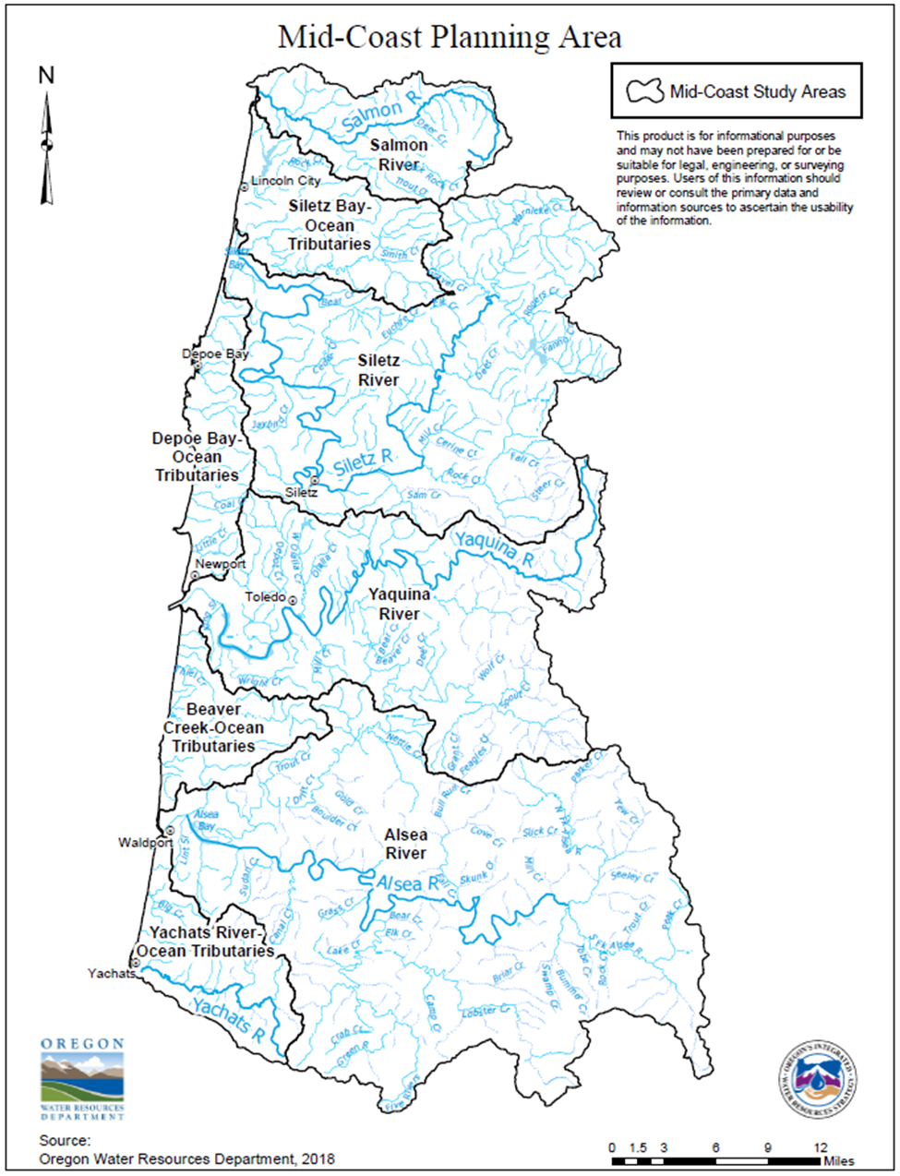
Figure 2. Sub-areas in the Mid-Coast Planning Area used for planning purposes.

Guiding Principles
The Partnership followed the guiding principles in the Integrated Water Resources Strategy and also identified the following key values to guide how its members would work together as a partnership to achieve goals.
- Partnership. We recognize different perspectives and seek common ground to develop strategies that meet our collective needs.
- Transparency. We create an inclusive process to openly share information and interests, invite curiosity, and encourage dialogue.
- Innovation. We bring our best ideas and information to the table and explore innovative, out-of-the-box solutions.
- Commitment. We act in good faith to support the success of the Partnership in developing strategies that are in the best interests of the region.
- Flexibility. We are open to new ideas and approaches that will adapt our process or approach to fit the needs of the Partners.
- Action. We seek practical near-term actions as well as longer term strategies consistent with our goals.
- Clarity. We commit to expressing all of our findings in the simplest and clearest form possible.
Figure 3 illustrates some of the common elements of a successful strategic planning process.
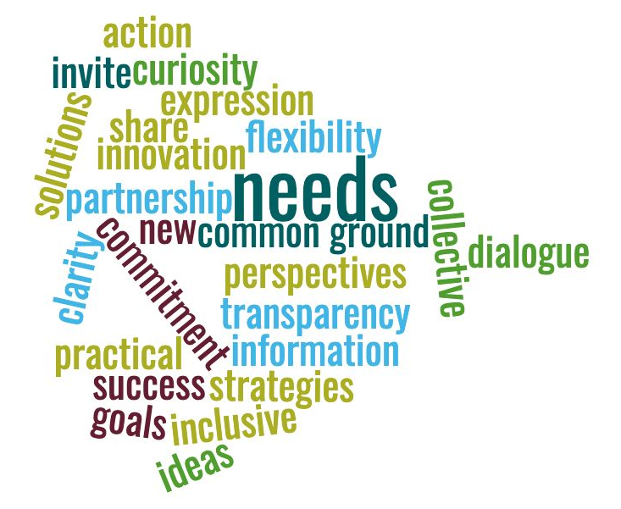
Figure 3. Word graphic illustrating the elements of a successful planning process based on sound guidance principles.

Relation to Other Regional Planning Efforts
This action plan is intended to achieve water resource protection objectives critical to the watersheds of the Mid-Coast as well as the people who live, work, and recreate in the Mid-Coast. It is also intended to supplement, complement, and support numerous other planning efforts currently underway in the region, especially those that address water issues foundational to the Mid-Coast Water Planning Partnership (see Appendix E for a crosswalk of these efforts with this plan) (Figure 4). These regional planning efforts include, but are not limited to, the following:
- Final Endangered Species Act Recovery Plan for Oregon Coast Coho Salmon (2016) (Oncorhynchus kisutch). The goal of this plan is to improve the viability of Oregon Coast Coho, and the ecosystems upon which it depends, to the point that they no longer require Endangered Species Action protection. The recovery direction for Oregon Coast Coho Salmon is to protect and restore the freshwater and estuarine rearing habitats that support juvenile survival and overall productivity.
- Lincoln County Multi-Jurisdictional Natural Hazards Mitigation Plan (2015, revised 2017). This plan describes priority natural hazards of concern to the Mid-Coast region, including coastal erosion, drought, earthquakes, floods, landslides, tsunamis, wildfire, windstorms, and winter ice. Although there is no direct relationship to the actions within the Mid-Coast Water Planning Partnership Water Action Plan, any efforts that reconnect floodplains, restore stream flow, and restore riparian areas will enhance resilience of the Mid-Coast region to climate change stressors and several natural hazards. In addition, three actions within this plan have a nexus with natural hazards.
- Lincoln County Climate Action Plan (2020). This plan emphasizes water supply resiliency measures that reduce water use by developing focused, interrelated water conservation measures, regulations, education, and incentives.
- Oregon Coast Coho Conservation Plan for the State of Oregon (2007). This plan is intended to conserve and enhance Oregon Coast Coho and other native fish and wildlife species through on-the-ground, non-regulatory work by community-based entities and individuals.
Oregon Coast Coho Business Plan (Siletz; ongoing). This plan intends to conserve Oregon Coast Coho by working with local communities for voluntary habitat protection and restoration projects that will help recover threatened and endangered coho populations.

- Coastal Multispecies Conservation and Management Plan. This plan describes the fish management needs for the conservation and use of anadromous salmonids along much of the Oregon coast.

- Lincoln County Comprehensive Land Use Plan.
- Community Water System Plans (including Water System Master Plans, Capital Improvement Plans, Water Management and Conservation Plans, Emergency Response Plans).
- Oregon Department of Agriculture Water Quality Management Plan. The Oregon Legislature passed the Agricultural Water Quality Management Act in 1993, which requires the Oregon Department of Agriculture to prevent and control water pollution from agricultural activities. ODA worked with local advisory committees to develop Water Quality Management Plans and Rules throughout the state.
- Oregon’s Nonpoint Source Program Plan (2014): Oregon’s Nonpoint Source pollution control and drinking water protection programs are based on a wide range of tools (planning, voluntary actions, prevention, restoration, etc.) including other government agencies’ programs to address water quality issues associated with multiple land uses or legacy conditions. These issues require the participation of multiple Sectors to protect or improve water quality and restore watershed ecological function (e.g., through WA Section 319 watershed-based plans).
- Oregon’s Coastal Nonpoint Pollution Control Plan (CNPCP), Many Actions in this Plan support achieving the objectives of Oregon’s CNPCP, including implementation of several “management measures” that have not yet received federal approval.
- Newport’s Long-Range Water Supply Report (2001).
- Rocky Creek Regional Water Supply Project (2001).
- Rocky Creek Report (1999).

Figure 4. Graphic illustrating key outcomes of the Oregon Mid-Coast Water Action Plan and the interconnectedness of people, water infrastructure, and natural systems.

Perceptions and Values of Mid-Coast Regional Stakeholders
During 2018, Oregon’s Kitchen Table, a program of the National Policy Consensus Center in the College of Urban and Public Affairs at Portland State University, engaged 680 people that frequently visit, or work, live, or own a business in the Mid-Coast in a project to better understand Mid-Coast Basin perceptions and values. Participants were asked about their knowledge and values, interests, or concerns, about the future of water in the region, and tradeoffs to consider as the MCWPP develops strategies to address key water issues and priorities (Oregon’s Kitchen Table 2019). Engagement strategies consisted of an online and a paper-based survey (in both Spanish and English), as well as direct mailings to Confederated Tribes of Siletz Indians households. A series of listening sessions were held with non-English speakers (both Spanish and Mam). A total of 505 people completed the online survey, 112 responded using the paper survey, 89% of participants self-identified as English speaking, and 11% self-identified as Spanish speaking. A total of 38 individuals identifying as members of the Confederated Tribes of Siletz Indians participated.
The following commonly held values and beliefs were derived across all engagements (Figure 5):
Figure 4. Snapshot of the environment, natural resources, and economy of Oregon's Mid-Coast.
- The majority of participants listed health as the issue they think about either most, or next to most. A total of 43% of participants listed water as the issue they think about most, or next to most, and 41% listed environment or ecology. The other issues lagged behind those three.
- Most participants obtain their water from either a city or a water district.
- A total of 95% of participants use water for personal or home use (such as drinking, cleaning, and more).
- A total of 78% of participants indicated that they enjoy water “in a scenic way,” and 73% use it to grow food or plants. Far fewer participants reported that they use it for business or industrial use (13%).
- A majority (57 %) of participants said their water costs are “about right”. About a third of participants believed that their water costs too much (26%), or far too much (7%).
- The people who responded to the survey frequently thought about water use across the region. More than 40% thought about water use most of the time, whereas 17% thought of it all of the time. By contrast, less than 10% of respondents thought about it rarely or never. A total of 44% of respondents knew nothing about the Partnership, or very little (32%) about it before the survey.
- If survey participants could give 100 gallons of water to various uses, they said they would give the most water (32.6 gallons) to residential water supply for year-round residents. Water for fish and wildlife was listed second (23.7 gallons). Water for tourist lodging and tourist attractions would receive 7.6 gallons.
- When asked about ensuring if there is enough water for people, business, and nature, the results were split across concern for household use, infrastructure, and fish and wildlife. A total of 28% of respondents reported that their primary concern is making sure there is enough safe water to drink and use for cleaning, whereas 23% reported their greatest concern was making sure that the region’s water structures (pipes, pumps, etc.) are in good condition to withstand time and a major event, such as an earthquake or tsunami. A total of 22% said their greatest concern was making sure there is enough water to support fish and wildlife. Far fewer people (1%) are most concerned about having enough water to support business and industry. Likewise, very few (1%) feel the biggest concern is that the water be safe for recreation.
- When asked to evaluate ways to help ensure that there is enough water for all needs, participants assigned points to various solutions. Watershed restoration or protection (protecting or improving the forests and lands the region’s water flows through) received the most points (19.8 points out of 100 possible points). Water storage systems (such as reservoirs) received 18.3 points, and conservation received 16 points. Sharing water among communities received the fewest points (7.2 points).
Figure 5. Key values and perspectives of Mid-Coast stakeholders in 2018 survey.
From late 2021 to early 2022, the Partnership teamed up with Oregon’s Kitchen Table to conduct a public engagement project to achieve the following goals: 1. to hear from specific sectors as well as specific community groups in the Mid-Coast; 2. to identify the actions in the plan that those sectors and community members were most interested in; 3. to discover any additional ideas related to those actions that the Partnership may not be aware of; and 4. to return to people who participated in the 2018 public engagement effort and get their reactions to the strategies and solutions that the Water Action Plan laid out (Oregon’s Kitchen Table 2022). This community outreach project was composed of a combination of facilitated small group discussions and an online survey. There were targeted outreach efforts put towards soliciting input from participants from the 2018 survey, members of the Confederated Tribes of Siletz Indians, Latinx and Spanish speaking community members and local business owners and industry representatives (tourism, hospitality etc.). Although the Partnership has been diligent in efforts to engage these groups, they were underrepresented in the planning process, so this was an opportunity to engage with them before the plan was finalized.
Over 175 people took part in the various engagement opportunities from November 2021 - January 2022. 80 participants took the survey online and 76 submitted their responses via paper survey. 74 paper surveys came from enrolled members of the Confederated Tribes of Siletz Indians which was double the number of surveys that were received in response to the 2018 survey. Approximately 20 people participated in interviews and small group discussions focused on people in tourism, hospitality, business, or industry sectors (Oregon’s Kitchen Table 2022).
Across all forms of engagement, the following commonly held values and beliefs emerged:
- While people care about water and expressed interested in how water planning intersected with issues like climate change and the region’s economy in the Mid-Coast, water planning is not currently a top priority for many people at this moment in time.
- Different sectors and communities throughout the region value water as an important component of many facets of life and as a resource to be protected and cared for.
- Most people we heard from either were unfamiliar with the Mid-Coast Water Planning Partnership or knew only a little bit about it (74% of people responding to the paper and online survey).
- People from a wide variety of backgrounds have concerns about water rates, whether they were an emerging or new business trying to get started or individuals paying for water at their homes.
- Recent droughts, particularly in 2021, as well as concerns about aging infrastructure were often mentioned as concerns for the region and communities.
- People were interested in learning more about how they or their businesses might be able to participate in water storage. We heard this both in small group discussions and participants shared this via the surveys as well.
The results of the 2022 engagement project provide a sense of the values and beliefs held by those who participated at the time around the draft plan. They also reveal some of the different individual priorities and concerns that people have regarding their water uses and concerns. Across the different forms of engagement, some areas of agreement did emerge. Common areas of interest like water storage offer future opportunities for the Partnership to build relationships and facilitate solutions for the region’s water needs. The final report from this community engagement project can be viewed on the Partnership’s website and under Appendix B.

Environment, Natural Resources, and Economy of Oregon’s Mid-Coast

(Note: This section is a summary from Step 2 of the planning process. For citations, please refer to the actual technical reports produced in 2018 (Appendix B). All data and information provided in this section originate from these 2018 reports unless more recent numbers are available).

General Overview
About 50,000 people currently live within the Mid-Coast Planning Area of Oregon. Population projections indicate that the region will grow by almost 10,000 people during the next 40 years. The projected demographic shift is slowly toward an older population.
Land use is primarily private, state, and federal forests (87%). Other land uses include agriculture (primarily livestock grazing), rural residential development, industrial, commercial, and urban development, primarily along the Highway 101 corridor.
Tribal Nations. The Lincoln County population has a higher percent Non-Hispanic Indian or Alaskan Native than the state average (OHA, 2018). The Confederated Tribes of Siletz Indians is a federally recognized confederation of over 30 bands, that occupies a 3,666-acre reservation located in Lincoln County. The Siletz Tribe has a well-established Tribal government to manage its resources, oversee and implement the many services and programs offered to Tribal members. The Siletz Tribal Natural Resources Department is responsible for management of all natural resource programs. The Tribe's management approach is that of wise use and stewardship of the Tribe’s timber lands, waterways, wetlands, prairies, and other natural resources now and in the future.
The Tribe has multiple conservation properties with three of these being in the Siletz Basin. These total over 4,500 acres. Each property has a conservation easement and conservation management plan associated with it. These lands as well as private waterway and wetland properties in the Mid- Coast Basin area are of cultural importance to the Siletz Tribe. The Natural Resources Department also works with private landowners to make improvements on their own properties in effort to restore the land. Other restoration efforts that the Tribe has implemented include but are not limited to projects to restore streamflow, banning the trapping of beavers to promote their presence, and establishing wider riparian buffers on rural, commercial, and ag lands. The Tribe is also working on infrastructure upgrades to make the Tribe’s facilities and structures more efficient and implement water conservation measures such as low flow toilets and reduced lawn watering. In recent years, the Tribe has partnered with the U.S. Fish and Wildlife Service and the Mid-Coast Watersheds Council to work collaboratively to implement waterway and wetland habitat projects and find funding.

The economy is comprised of personal income, pensions, investments, tourism, and natural resources. The natural resources economy consists of commercial fishing (40%), tourism (33%), commercial timber (26%), and to a lesser extent agriculture (1%).
Demographics. Ethnicity, income, education. Based on OHA data, Lincoln County residents are currently older, more Caucasian, represent a higher percentage on social security/retirement income, and there is a slightly higher overall poverty rate than the state average. Over 12% of Lincoln County identifies as Hispanic, which is higher than the average for Oregon.
Stream flows are rain-dominated and are fed by shallow groundwater when it is not raining. Most precipitation occurs November–March, and dry conditions occur in the summer, often extending into late October. Most groundwater aquifers generally have low yield and poor storage capacity. Groundwater is recharged by rain during the wet season and groundwater levels and spring discharge generally declines during the dry season.
Out-of-stream water use and rights. There are about 1,637 water rights in the Mid-Coast planning area allocated to 29 different uses. Domestic use has the greatest number of water rights (n=703) followed by irrigation (n=419), instream (n=110), and municipal (n=82). Figure 2 displays the estimated number of water rights by type. The largest water use category (amount of water used) in the planning area is for self-supplied industrial use, followed by water used by hatcheries and water provided by community water systems for domestic and industrial use. The largest water users in the region all draw water from the Siletz River and have water rights that are senior to the instream water right.
Instream water needs and rights. Fifty-one streams have existing instream water rights, but these instream rights inadequately capture the full range of flows needed to protect current instream ecosystems. Summer streamflows are insufficient in some areas of the Mid-Coast (see Water Quantity Report from Step 2 & OWRD Water Rights Summary (October 2021) – Appendix B) to meet the instream water needs of fish and wildlife. Low streamflows contribute to water quality impairments (e.g., high temperatures and reduced dissolved oxygen) that negatively affect fish and wildlife. Climate change impacts and increased demand from municipal and rural water users are expected to further limit available water in the summer for all uses.
Conservation Opportunity Areas. Of the 206 designated Conservation Opportunity Areas (COAs) in Oregon, seven of them are within Oregon’s Mid-Coast region: Siletz Bay-Ocean COA, Siletz River COA, Depoe Bay Area COA, Yaquina Bay COA, Beaver Creek COA, Alsea Estuary-Alsea River COA, and Yachats River Area COA (Oregon Department of Fish and Wildlife 2020). Conservation Opportunity Areas are places where broad fish and wildlife conservation goals can best be met. Focusing investments in these areas can increase the likelihood of long-term success, maximize effectiveness over larger landscapes, improve funding efficiency, and promote cooperative efforts across ownership boundaries.
Estuaries. There are five estuaries classified as major estuaries by the Oregon Department of Land Conservation and Development in the Mid-Coast Planning Area: Salmon River, Siletz Bay, Yaquina Bay, Alsea Bay, and Depoe Bay. Big Creek is classified as a “natural” estuary, whereas Beaver Creek and Yachats are classified as conservation estuaries (DLCD).
Figure 6 provides a snapshot of the environment, natural resources, and economy of Oregon’s Mid-Coast Planning Area.
Figure 6. A snapshot of the environment, natural resources, and economy of Oregon's Mid-Coast.

Understanding Water Resources Quantity, Quality, and Ecological Issues
During Step 2 of the planning process, a series of reports were developed characterizing water quantity, water quality, ecology and built systems of the Mid-Coast region (see Appendix B). This section of the document summarizes the information presented in those reports.

Surface Water Quantity
Water resources (Figure 7) in the Mid-Coast support multiple uses, including providing drinking water, supporting fisheries and wildlife, supporting industry and commercial operations, providing recreational opportunities, and supporting estuaries that provide habitat for a diversity of native fish and wildlife species. Water uses have changed through time. Today, water resources in the Mid-Coast are increasingly valued for providing recreational opportunities and habitat for aquatic species.
All of the major river drainages in the Mid-Coast planning area, with the exception of the Yachats River, originate at the crest of the Coast Range in Polk and Benton Counties and extend to the coast. The planning area is divided into eight different sub-areas, which encompass the following waterways: Salmon River, Siletz Bay-Ocean Tributaries, Siletz River, Depoe Bay-Ocean Tributaries, Yaquina River, Beaver Creek-Ocean Tributaries, Alsea River, and Yachats River. See Figure 7 for relative water supply for each sub-area, which can also be accessed and explored online. Many streams in the Mid-Coast are tidally influenced ocean tributaries, meaning that they drain directly into the ocean rather than draining to a river. The zone of tidal influence in these streams depends on the discharge of the stream and the tidal stage.
Water quantity and its management in the Mid-Coast region was summarized during Step 2 of the planning process as shown in the bulleted list below. The entire report on water quantity can be accessed in Appendix B.
- Streams in the Mid-Coast have high natural streamflow during the winter months (January-March) and low natural streamflow during the summer/Fall months (August-October) as a result of seasonal precipitation patterns.
- Streams in the Mid-Coast are rain-dominated and responsive to precipitation, reaching high flows during rainstorms. Groundwater inputs contribute base flows in streams during late summer and Fall months.
- The Mid-Coast has eight active real-time streamflow gage locations (Salmon River below Slick Rock Creek, Siletz River at Siletz, Sunshine Creek near Valsetz, Yaquina River near Chitwood, Alsea River near Tidewater, Drift Creek near Waldport, East Fork Lobster Creek, and Yachats River above Clear Creek).
- Information from river gages and water availability models help the Oregon Water Resources Department determine whether to issue new water rights. The water availability models consider estimates of supply and demand, and account for both instream and out-of-stream water rights to determine if water is available for new out-of-stream uses.

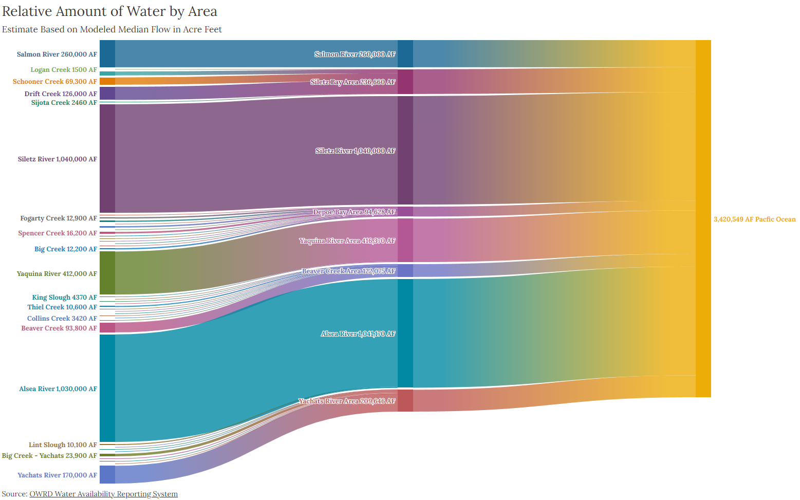
Figure 7. Total estimated average annual natural streamflow volume (in acre-feet) of surface water in streams and rivers in the Mid-Coast based on a 1958-1987 period of record. Note that these volumes do not reflect diversions for out-of-stream uses.

Groundwater Quantity
Geology in the Mid-Coast limits available groundwater resources. Mid-Coast geology is generally composed of marine sedimentary rocks with minor volcanic deposits. The aquifer systems these rocks host can be characterized as low-permeability and low-storage capacity aquifers. The Tyee Formation makes up roughly 57% of the Mid-Coast area and consists of sandstone and siltstone deposits that do not hold or convey much water, except through fractures (USGS, 2022). See Figure 8 for an image of the Tyee Formation. Other parts of the Mid Coast are composed of sedimentary rocks that post-date the Tyee Formation and in a few places, volcanic rocks can be found. These formations host aquifers that are, on average, slightly more productive but are limited in areal extent. There are a few areas of the Mid Coast where sand and gravel dominate the geology and aquifers hosted by these rocks tend to produce more water, but they mostly are limited to river channels and the coast margin. Aquifers close to river channels are typically hydrologically connected to surface water. Areas significantly close to the coast may be at risk of saltwater intrusion if the hydraulic head or pressure is not maintained in the freshwater deposits but the high amounts of precipitation in the Mid Coast likely reduces this risk. Additional information on the relative yields of various units can be found in the Mid-Coast Water Resources Characteristics: Water Quantity report (GSI, 2018).
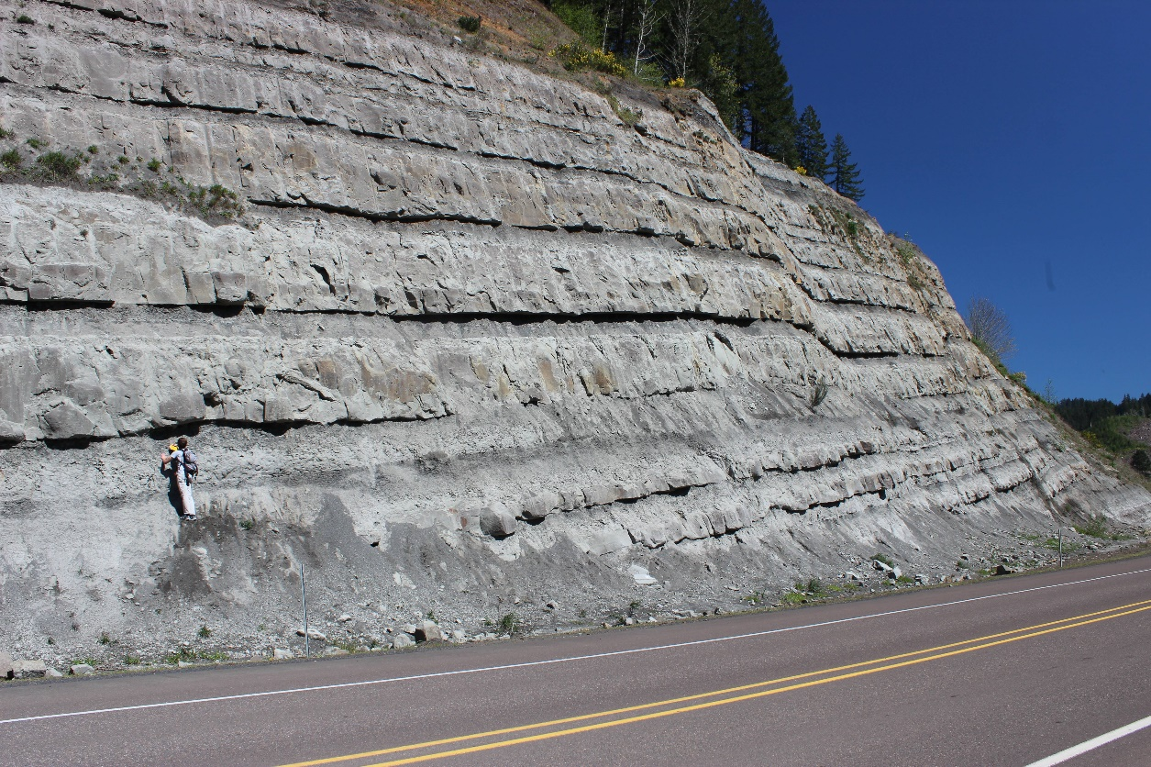
Figure 8. Photograph of the Tyee formation. Photo Credit: Stanford Project on Deepwater Depositional Systems (https://spodds.stanford.edu/tyee-basin-oregon)
Aquifers in this region are predominantly fractured rock aquifers, where groundwater moves through tiny fractures within the rocks, and which are characterized by low storage and low well yields. A conceptual diagram of a fractured rock aquifer as well as a map showing the well density and average well yield by section can be found in the Water Use Summary for the Mid-Coast Place-Based Planning Area (OWRD, 2021). The aquifer system recharges with precipitation and discharges continuously to springs, streams, and wells that are pumped. Groundwater is the primary source of water that sustains baseflows in streams and rivers when it is not raining.
According to an analysis performed by the Oregon Water Resources Department, the median well yield in the planning area is 6 gallons per minute (OWRD, 2021). Generally, the well yield, especially those producing from fractured rock aquifers, is low and may only produce enough water to support rural domestic and livestock uses. Well yields in many areas may be insufficient to support uses with higher water needs, such as for irrigation or industrial use, which can limit future development. Well yield will generally decrease during the dry season as groundwater drains out of the aquifer and water levels drop in wells. Wells with higher yields are likely to be in areas where there is a greater hydraulic connection to surface water, such as near rivers.
There are three OWRD Observation Wells in Lincoln County that have been used to collect static water level data since the early 1960s. One well (LINC 1138) is located near the City of Toledo, a second (LINC 444) is located near the unincorporated community of Otis, and a third (LINC 820) is located near the City of Siletz. Measurements for the observation well near the City of Toledo (LINC 1138) ended in 2015 due to concerns over well construction issues that may lead to measurements that do not accurately represent the aquifer. A new observation well (LINC 52601) on Weyerhaeuser property within the Coast Range was added to the network in 2019 thanks to new relationships formed and opportunities identified through the planning effort.
The hydrographs for the observation wells with the longest periods of record generally show annual discharge and recharge cycles. It should be noted that some of the data in the hydrographs below represent pumping levels (water levels that are measured when the well is on, or shortly after it has been turned off and represent water level in the well) rather than static water levels (water levels that are stationary and represent the water level in the aquifer). Both LINC 444 and LINC 820 show little overall change in aquifer levels since monitoring has begun.

Water Quality
Water quality status and regulation in the Mid-Coast region was summarized during Step 2 of the planning process as shown in the bulleted list below. The entire report on water quality can be accessed in Appendix B. However, some of the water quality status information is outdated.
- Water quality affects the extent to which water bodies can support beneficial uses, such as drinking water, industrial, agricultural, fish and aquatic life, and wildlife.
- Numerous government agencies manage water protection programs in the region (within the parameters established by the 1972 Clean Water Act), including:
  - Oregon Department of Environmental Quality, which establishes water quality standards for Oregon's surface waters in accordance with the Clean Water Act, issues discharge permits, and develops TMDLs, or watershed plans for controlling nonpoint source pollution.
  - Oregon Department of Agriculture regulates agricultural practices to prevent water pollution and meet water quality standards in accordance with the Agricultural Water Quality Management Act.
  - Oregon Department of Forestry regulates forestry operations to prevent water pollution and meet water quality standards in accordance with the Forest Practices Act.
  - Oregon State Parks manages potable water supply in state parks.
  - Oregon Health Authority implements regulations to ensure drinking water standards are met in accordance with the Safe Drinking Water Act.
  - Oregon Department of State Lands manages the removal-fill program and coordinates in-water work permitting with the U.S. Army Corps of Engineers and Oregon Department of Environmental Quality’s water quality certification program.
  - US Forest Service and US Bureau of Land Management implement the aquatic conservation strategy of the Northwest Forest Plan.
  - Lincoln County manages the onsite wastewater (septic) permitting program for most of the planning area.
  - Lincoln County has a riparian protection ordinance to reduce impacts of rural residential development and certain other land uses on near-stream conditions.
- Oregon’s 2018/2020 Integrated Report and Assessment Database identifies Mid-Coast water bodies that are water quality limited for not meeting one or more water quality parameters, such as temperature, dissolved oxygen, or E. coli.
- The Oregon Health Authority issues health advisories for multiple beaches in the Mid-Coast during the past decade for elevated enterococcus levels, which can cause illness from contact recreation, such as swimming.
- Surface water is the primary source of drinking water for nearly all of the municipal and community water providers in the Mid-Coast.
- Several water providers in the Mid-Coast use groundwater. Common groundwater contaminants that are monitored include arsenic, lead, nitrates, and fecal coliform bacteria.
- Several organizations and various private entities conduct periodic water quality monitoring activities in the Mid-Coast.
A combination of state and federal statutes and implementing regulations direct the management of water quality in Oregon. Oregon Department of Environmental Quality administers the following water quality: Oregon’s Groundwater Quality Protection Rules, Underground Injection Control Rules, National Pollutant Discharge Elimination System (NPDES) and Water Pollution Control Facility (WPCF) Permits Program Rules, Reclaimed Water Program Rules, Hazardous Waste Management Program, Underground Storage Tank Program, Municipal Solid Waste Program, the Oregon Groundwater Quality Protection Act of 1989, and ​Biosolids.

Water Quality Monitoring
The Mid-Coast Watersheds Council, Siletz Watershed Council, and the Yaquina Watershed Council collaborate with the Lincoln County SWCD, which periodically conducts water quality monitoring in the Mid-Coast. The Siletz Tribes has an established water quality monitoring program. Also, the Alsea Watershed Study is a paired watershed study that assessed the impacts of private forest practices on water quality, aquatic habitat, and salmon.
The Oregon Department of Environmental Quality monitors and evaluates water quality via the Ambient Monitoring Network and Oregon Water Quality Index, watershed monitoring Total Maximum Daily Loads (TMDLs), toxics monitoring, biomonitoring, Oregon Beach Monitoring Program, Volunteer Water Quality Monitoring, Groundwater Monitoring, and National Aquatic Resource Surveys. Information about all of these programs and the water quality database can be found here. Water Quality Assessment/303d list information from DEQ can be found here. And a collection of DEQ’s ambient water quality, watershed and groundwater monitoring project reports can be accessed here.

Water Quality Impaired Streams in the Mid-Coast
Oregon’s 2018/2020 Integrated Report and Assessment Database identifies the following classes of Assessment Units (AUs) for categorizing water quality status, including impaired waters not consistently meeting state standards for a specific water quality parameter:
- Rivers and Streams Assessment Units: The AUs for river/stream segments are 5th order and above streams. Impaired segments are summarized in Table 1 (below) by drainage basin.
- 50 river/stream AU segments are categorized as impaired for one or more parameters and/or pollutants and beneficial uses (366 stream miles);
- 46 river/stream AU segments are categorized as temperature impaired (357 stream miles)
- Watershed Assessment Units: AUs based on USGS 12-digit HUCs that include 1st through 4th order streams.
- 24 of 35 Watershed AUs within the Mid-Coast planning area exhibit one or more impairments;
- 21 Watershed AUs are categorized as temperature impaired

- Waterbody Assessment Units: Estuaries, lakes, and reservoirs with area > 20 hectares.
- 14 of 19 Waterbody AUs within the Mid-Coast planning area exhibit one or more impairments.
- Coastline Assessment Units: These AUs are linear features along the coast (beaches, rocky shorelines). 29 Coastline AUs are categorized as impaired based on shellfish consumption or recreational contact advisories issued by the Oregon Health Authority.

DEQ’s interactive mapping application is the most effective method to search and view water quality status for areas of interest. Detailed AU definitions are found in DEQ’s Integrated Report Assessment Methodology (DEQ, 2018): https://www.oregon.gov/deq/wq/Documents/irMethodologyF1820.pdf
The Clean Water Act requires that Total Maximum Daily Loads (TMDLs) (or alternate pollution control plans) be developed for all water quality-limited waters. TMDLs set specific criteria for pollutant amounts in stream reaches that are water quality limited. DEQ is currently preparing the 2022 Integrated Report and will release that information for public review when it is ready. That Report will supersede the information in this Section.
Table 1. Summary of water quality limited streams by drainage basin.
Location | Limitation
Salmon River Drainage Area | 20.9 miles of water quality limited streams
Siletz River Drainage Area | 84.4 miles of water quality limited streams
Yaquina River Drainage Area | 62.2 miles of water quality limited streams
Beaver Creek-Ocean Tributaries | 17.1 miles of water quality limited streams
Alsea River Drainage Area | 165.3 miles of water quality limited streams
Yachats River Drainage Area | 15.2 miles of water quality limited streams
Beaches  Coastline, lower estuaries | 1.7 miles (based on health advisories for water contact recreation)  73.9 miles (based on shellfish consumption advisories for toxins/inorganic arsenic)

Groundwater Quality
Several public water providers and multiple private residents in the Mid-Coast use groundwater as domestic water supply (see Water Quantity Report from Step 2 of the planning process – Appendix B). Many residents on private wells, or springs, have septic systems to manage wastewater. Owners of residential domestic wells are not required to conduct routine water quality testing or to treat contaminants. Testing is only required by owners during real estate transactions (e.g., the sale of a property) and is limited to arsenic, bacteria, and nitrate. There is limited understanding of groundwater quality in the Mid-Coast, which represents a data gap. Oregon’s Domestic Well Safety Program (DWSP) partners with local health departments and water providers to promote proper maintenance and safety of domestic wells and improve local and state capacity to assess and manage risks associated with private wells. Lincoln County recently used a DWSP grant to perform well water testing.

Ecology
The ecology in the Mid-Coast was summarized in a report (Appendix B) as part of Step 2 of the planning process and was described as follows:
- The Mid-Coast supports a variety of habitats, with aquatic habitats being of particular interest because of their connection to human population water supply needs. Aquatic habitats include streams and springs, lakes, riparian areas, wetlands, and estuaries.
- The Oregon Conservation Strategy (OCS) identifies species of interest and areas of ecological importance in the different regions of the state. The Strategy identified 12 streams or estuary habitats as areas of ecological importance in the Mid-Coast because of the diverse habitats and species they support. For example, the Siletz Watershed has the only coastal origin population of summer Steelhead in Oregon.
- Aquatic species of interest and concern in the Mid-Coast include seven species of anadromous salmonids ((coho, Chum, Chinook (fall-run and spring-run), Steelhead (winter-run and summer run); sea-run Cutthroat Trout)), Green and White sturgeon, beaver, and three species of Lamprey (Pacific, Western River, and Western Brook). Oregon Coast Coho Salmon are listed as threatened under the Endangered Species Act, and large portions of the Mid-Coast are designated as critical habitat for coho. Green Sturgeon also are listed as threatened within the Southern Distinct Population Segment, which includes Yaquina Bay.
- Salmon are a keystone species in the Mid-Coast because of their influence on other plant and animal species. Salmon are an indicator species for habitat health because they require diverse quality habitats throughout their lifecycle that other species also require.
- Sources of habitat degradation include stream channel simplification and incision, warm stream temperatures, altered streamflow timing and watershed function, fine sediment and turbidity related to peak streamflow, and toxic and non-toxic pollutants.
Aquatic habitat restoration efforts occur in the Mid-Coast to increase stream channel complexity and off-channel habitat, reduce fine sediment inputs and summer water temperature, address fish passage barriers, and encourage beaver dams, or similar structures.​

Species and Habitat Needs
The Mid-Coast has many species that spend at least part of their life cycle in freshwater and are listed by state or federal agencies for protection or monitoring and/or are identified by the Oregon Conservation Strategy (OCS) as a “species of interest.” Salmonids require unimpeded access to adequate amounts of cold water, large woody debris, deep pools, and spawning gravels to adequately support the various stages of their life cycle. Factors negatively impacting salmonids are low water availability (particularly in late summer and fall), impaired water quality (e.g., elevated stream temperatures), reduced stream complexity, and fish passage barriers (e.g., undersized culverts). Green and White Sturgeon are also species of interest in the Mid-Coast. Sturgeon are especially sensitive to estuary conditions, where they congregate during summer and fall.
Several species of lamprey (Pacific, Western River, and Western Brook) are also species of interest and require many of the same habitat characteristics as salmonids, yet have a very different life history.
Beavers are a species of interest because of their ability to build dams and create ponds that can store water, provide habitat for other wildlife, promote nutrient cycling, moderate flows, and recharge shallow alluvial aquifers, among other benefits. Beavers are also considered pests by many landowners, and beavers are a constant topic of dispute. Consequently, the Oregon Department of Fish and Wildlife convened a beaver management workgroup.
Other species of interest are invasive species, which are non-native species that have a disproportionate effect on the ecosystem that is typically negative, such as outcompeting and displacing native species and reducing species diversity.

Aquatic Habitats

Streams
Healthy stream habitats have adequate streamflow throughout the year, cool temperatures, high dissolved oxygen, low turbidity, riparian vegetation, and stream channel complexity. Stream health benefits from watersheds that store precipitation in springs, wetlands, beaver ponds, and in the streambanks/floodplains. In healthy streams, streamflow often overtops streambanks during flood events. When this occurs, floodwaters are slowed by streamside vegetation, providing refuge for aquatic species from high flows. Finer sediments, larger cobble, and boulders suspended in floodwaters are deposited in floodplains and store water that is later released into the stream channel. Stream health also benefits from a diversity of disturbances in the watershed, such as fire, debris slides, windstorms, and floods that increase habitat diversity. Floods move large substrate and large woody debris from upper reaches and tributaries to lower reaches within the watershed.
Stream temperature affects water chemistry and species survival. Shade, cool groundwater discharges into the stream, and water quantity moderate stream temperatures. Temperature and dissolved oxygen concentration are linked, and both parameters are critical to the reproduction and survival of resident and anadromous fish. Stream temperature affects biological triggers for salmon migration, spawning, and egg hatching. High stream temperatures and low dissolved oxygen as well as high turbidity can threaten fish survival at various life stages.

Riparian Habitats
Riparian habitat is at the interface between land and a river or stream. Plant and animal species may use all riparian habitats, or may specialize on a particular geomorphic surface within the riparian area. Rivers are constantly changing, eroding surfaces, and depositing material to create new surfaces. Similarly, vegetation communities in riparian areas change as they become inundated by floodwater, dried out because of a shift in channel location, or fall into the stream channel from bank erosion. Riparian habitat influences instream health, and upstream health influences downstream characteristics.

Estuary Habitats
Although the focus of this plan is on fresh water, the connection between freshwater and estuary habitats is critical to the life history of many fish and wildlife species in Oregon’s Mid-Coast.
The Mid-Coast has two types of estuaries: (1) drowned river mouth estuaries—river valleys that flooded about 10,000 years ago from sea level rise; and (2) tidally restricted coastal creek estuaries — streams that discharge directly into the ocean and experience inputs of ocean water during high tides. Mid-Coast estuaries, with the exception of the Depoe Bay Estuary and Yachats Estuary (which are small), are moderate in size and have large areas of salt marsh, eelgrass, and tidal flat habitat.
Estuaries provide a transition zone between freshwater and saltwater, and contain unique habitats that support a diversity of plants and animals adapted to a balance of saltwater and freshwater. Estuaries also filter pollutants, stabilize shorelines, and buffer human communities from storm surges. Estuaries are especially important for salmon during key points in their lifecycle. Estuary habitats are influenced by watershed size, geology, ocean tides, and freshwater-saltwater mixing. Although estuaries are dynamic systems that change with high tide and low tide, they are also sensitive to changes. Plant and animal communities in each estuary are adapted to a specific range of salinity. Changes to sea level, ocean currents, or freshwater inputs from streamflow can alter the balance of saltwater and freshwater and sediment dynamics, impacting plant and animal communities.
For more information about different types of estuaries, click here and here. The Coastal Atlas Estuary Data Viewer can be accessed here. For more information about individual estuary management plans, click here. During the initial development of this plan, several of Oregon’s estuary management plans were being updated.
Wetland Habitats
The main types of wetlands in the Mid-Coast are aquatic beds, marshes, peatlands, wet prairies, scrub swamps, and forested swamps. One of the most important benefits that wetlands provide is their capacity to maintain and improve water quality. Water quality is supplied to downstream environments in several ways. By spreading out and slowing down flows, wetlands reduce erosion and prevent sediment being transported downstream where it might affect the ecology and productivity of other environments, in particular estuaries, seagrasses, and reefs. When healthy, wetland soils and vegetation can capture, process, and store nutrients and/or contaminants, and if the natural rhythms and flows of the wetland are undisturbed, the release of potential stressors, such as sediments, nutrients, acids, and/or metals from the soil can be prevented. Healthy wetlands can assist in removing harmful bacteria, and wetlands can also be important in the management of urban stormwater and effluent by improving the removal of nutrients, suspended material, and pathogens from water prior to its return to the environment.
There are only several natural lakes in the Mid-Coast Planning Area. Devil’s Lake (a natural lake near Lincoln City), Olalla Reservoir (formed by Olalla Dam on Olalla Creek), and Big Creek Reservoir (formed by Big Creek Dam on Big Creek). Valsetz Lake, which was formed by Valsetz Dam, was removed in 2012 on the South Fork Siletz River.
Wetlands are areas where water covers the soil, or is present either at or near the surface of the soil all year or for varying periods during the year, including during the growing season. Wetlands can be influenced by local geologic conditions that provide the parent material for soils, influence groundwater chemistry, and affect wetland vegetation. Wetlands in the Mid-Coast have either organic soils (muck, mucky peats, fibrous peats, or combinations of these) that are saturated perennially or mineral soils (sand, silt, and silty loams, sandy loams, or clay loams) that may be flooded in the winter and moist or dry in the summer. The main types of wetlands in the Mid-Coast, each with unique soils and vegetation communities, are aquatic beds, marshes, peatlands, wet prairies, shrub swamps, and forested swamps.

Mid-Coast Areas of Ecological Importance
ODFW established the Oregon Conservation Strategy (OCS), which identifies areas of ecological importance, or Conservation Opportunity Areas, where broad fish and wildlife conservation goals would best be met. The areas of ecological importance in the Mid-Coast, including the important habitat that exists in each location, are shown in Table 2.
Table 2. Areas of ecological importance.
Location | Important habitat
Alsea Estuary-Alsea River | Overwintering habitat for migrating waterfowl and rearing habitat for coastal salmonids
Beaver Creek | Diverse habitat from beach to old-growth forests
Depoe Bay Area | Productive rocky shore for fish and wildlife use
Devil’s Lake | Peat marsh near mouth of Rock Creek, an important coho rearing stream
Salmon River Estuary-Cascade Head | Diverse habitats; includes Cascade Head Scenic Research Area; Habitat for three threatened and endangered species
Siletz Bay | Siletz estuary provides diverse and complex habitat
Siletz River | Sandstone/basalt river system with flashy winter river flow and private forestland
Yachats River Area | Narrow river channel with wide shallow mouth at ocean; steep coastal mountains
Yaquina Bay | Eelgrass beds, intertidal and subtidal shellfish beds, native oyster beds, and nesting eagles and ospreys along estuary

In addition to Conservation Opportunity Areas, ODFW is currently pursuing the development of a system of prioritization for streamflow protection and restoration. The assessment involves classifying stream reaches and watersheds based on current and future instream flows, summer water temperatures, degree of human impact, and species use. The prioritization system is expected to be completed in Spring 2022 and can be utilized to refine flow restoration and protection actions.

Effects of Land Use Activities on Aquatic Habitat
Human-induced factors, such as habitat degradation, water diversions, and land use practices have contributed to the decline of Coho Salmon as well as other species. Salmon populations in streams with water quantity or water quality limitations, or simplified stream channels, are more sensitive to further habitat degradations that result in additional stress. Factors influencing regional habitat quality and salmon abundance include fluctuating ocean conditions, periodic droughts and floods, land use practices, and landslides. Land management practices can affect the rate at which fine sediments from the landscape are transported via runoff to streams and also can affect the magnitude of peak flows, which may combine to increase turbidity to levels that negatively affect aquatic species and impair water treatment for human consumption. The main effects to aquatic habitats from past land use activities in the Mid-Coast include:
- Reductions in stream complexity (e.g., channel simplification and incision from historically channelizing streams or removing riparian vegetation and large woody debris);
- Impairments or barriers to fish passage;
- Sedimentation (e.g., excess turbidity at periods of peak streamflow);
- Reduced water quality (e.g., warm stream temperatures from lack of riparian vegetation, reduced streamflow, and stream channel simplification); and
- Reduced water quantity or alterations in streamflow (e.g., altered timing and watershed function resulting from land management practices and streamflow withdrawals, both of which affect how water moves through the landscape).
The uncertainty that there is an adequate combination of voluntary and regulatory mechanisms to ensure success is limiting recovery of aquatic habitats. However, habitat and flow restoration projects are occurring throughout the Mid-Coast to improve habitat conditions and reduce further degradation. These projects include adding large woody debris into streams, increasing fish rearing areas off the main channel, supporting gravel substrate used for spawning and deep pools, increasing streamflow during key times of the year for fish species and in the summer to reduce settling of fine sediment inputs, maintaining riparian vegetation for shading (avoiding solar heat gain) and filtering, improving roads to reduce sediment inputs, and encouraging beaver dam formation.
Appendix C provides information on key locations and issues within each of the eight drainage basins in the Mid-Coast region.

Built Infrastructure in the Mid-Coast
Potable (drinking) water, wastewater, and stormwater systems are critical for the health of humans and the economy. Built Systems in the Mid-Coast region was summarized during Step 2 of the planning process. The entire report on water quality can be accessed here.
- ​The Mid-Coast has 52 potable water providers, 31 of which are required to have certified water treatment plant (WTP) operators. These 52 water providers include cities, water districts, RV and mobile home parks, and state parks.
- Few interconnections exist between water providers.
- Many cities and water districts implement water conservation measures, and nine have developed Water Management and Conservation Plans (WMCPs).
- The Mid-Coast has 14 entities (cities, resorts/hotels, and industries) with National Pollutant Discharge Elimination System (NPDES) permits to discharge treated wastewater.
- Discharge locations are the Pacific Ocean, Yaquina River and Bay, Siletz River and Bay, Schooner Creek, and Lint Slough. The discharge locations on streams are all downstream of potable water intakes.
- Information about wastewater systems and, particularly stormwater systems, is lacking.
- Cities are likely the only water providers managing stormwater systems.
- The Mid-Coast, like much of the rest of the United States, has aging infrastructure and insufficient revenue to address many needed upgrades. Consequently, water systems in the Mid-Coast must be managed for resiliency and recovery.
- Self-supplied water users across the planning area utilize a diverse range of supply, treatment, and distribution systems for handling domestic, agricultural, and industrial uses. Characterizing Self-Supplied infrastructure status and needs in the planning area is difficult because of the diversity of systems. Each of these systems is variably vulnerable to supply or treatment disruption, either through infrastructure failure, lack of maintenance, hydrologic extremes, or natural disasters. Residents and service providers in the region indicate a wide range of water infrastructure challenges for residents, agriculture, and industry.

Water Uses and Needs in the Mid-Coast
(Note: This section is a summary from Step 3 of the planning process. For citations, please refer to the actual technical reports produced from 2019 to 2021 (Appendix B. All data and information provided in this section originate from the Oregon Water Resources Department Water Use Summary report from 2021 reports unless another source is specified).

During Step 3 of the planning process, three working groups learned about current and future water needs and challenges of three categories of water users and uses: instream/ecological water needs, municipal and special district water providers, and self-supplied water users (self-supplied rural residents, agricultural producers, and industries). Agency partners provided presentations, technical memos, and other information to inform the Step 3 proceedings. This section of the document summarizes the information assembled to support Step 3. All materials developed in support of Step 3 including the Water Use Summary (OWRD 2021) and Water Right Summary (OWRD 2021) can be accessed in an online folder.

Water Law and Water Rights
Under Oregon law, all water belongs to the public. With some exceptions, cities, irrigators, businesses, and other water users must obtain a permit or license from the Water Resources Department to use water from any source — whether it is underground, or from lakes or streams. Generally speaking, landowners with water flowing past, through, or under their property do not automatically have the right to use that water without authorization from the Department.
Oregon’s water laws are based on the doctrine of prior appropriation — the first person to obtain a water right on a stream is the last to be shut off in times of low streamflows. In water-short times, junior users in a basin may be “regulated off” by the State to maintain flows for more senior users. Many Mid-Coast rivers and streams have “instream” water rights held by State agencies for fish and wildlife habitat, recreation, navigation, or other uses. Those rights have an effective priority date like any other water right. Generally, Oregon law does not provide a preference for one kind of use over another. If there is a conflict between users, the date of priority determines who may use the available water.
You can find more information on Oregon’s water laws and water rights in a primer developed and maintained by the Oregon Water Resources Department.

Overview of Instream Water Uses, Needs, and Challenges
Instream water — water left in rivers and in the ground — provides immense value to the Mid-Coast region by supporting natural watershed processes, water quality, habitat needs of fish and wildlife, recreational opportunities, navigation, and aquaculture opportunities (e.g., oyster farms and fish hatcheries). Instream water also provides cultural, spiritual, and aesthetic values. Instream water is vital to maintaining healthy commercial, recreational, and tribal fisheries, which are socially, culturally, and economically important to the region. For example, instream resources are of express cultural significance to the Confederated Tribes of the Siletz Indians. Public surveys conducted by Oregon’s Kitchen Table also identified that residents and visitors place a high value on water needed to support Mid-Coast ecosystems.
The Partnership prioritizes the sustainability of healthy ecosystems that support the economic, social, and cultural values of the Mid-Coast region. Supporting healthy freshwater and nearshore ecosystems provides benefits beyond those important to fish and wildlife. Therefore, an integrated approach to managing water resources must consider the flows necessary to maintain all these benefits, and consider impaired flows, reduced water quality, and diminished fish and wildlife as potential warning signs of impacts to public benefits.

Ecological Values and Instream Water Rights
Instream flows are critical for maintaining many ecological functions and supporting aquatic species. Aquatic species evolved in response to the variability, both seasonal and inter-annual (across years) in stream systems and rely on the full range of flows represented by a natural hydrograph to meet their needs. “Streamflow quantity and timing are critical components of water supply, water quality and the ecological integrity of river systems. Indeed, streamflow, which is strongly correlated with many critical physiochemical characteristics of rivers, such as water temperature, channel geomorphology, and habitat diversity, can be considered a ‘master variable’ that limits the distribution and abundance of riverine species and regulates the ecological integrity of flowing water systems” (Poff et al., 1997). For example, NOAA-NMFS’s 2016 Final ESA Recovery Plan for Oregon Coast Coho identified reduced streamflows as one of many interrelated factors affecting the health and viability of Oregon Coast Coho, which will likely be exacerbated by climate change. Reduced streamflows also result in increased water temperature, which is a significant limiting factor for fish and wildlife. According to the Recovery Plan, “in freshwater habitats, lower summer flows, higher summer stream temperatures, and increased winter floods, would affect Coho salmon by reducing available summer rearing habitat, increasing potential scour and egg loss in spawning habitat, increasing thermal stress, and increasing predation risk (NMFS, 2016, 3-32).”
Under Oregon water law, rivers, streams, and springs do not automatically have a legal right to their own water. Instream water rights may be established to protect instream values and are subject to the system of prior appropriation. Allocations for instream water cannot take away or impair any legally established water right having an earlier priority date. This means that, like all water rights, they are subject to curtailment to meet senior out-of-stream water rights.
When water is not legally protected instream in important reaches and flow targets are not established using ecologically based methods, there are many possible consequences to streams, including:
- Water may be allocated to out-of-stream uses, leaving limited water instream during times of water shortage.
- Flow targets established by instream water rights inadequately capture the full range of flows needed to protect current instream ecosystems, especially for flows during winter months.
- Without ecologically based flow targets, it is difficult for collaborative efforts to act in the interest of the stream.
In Oregon, three agencies (the Oregon Department of Fish and Wildlife, Department of Environmental Quality, and Oregon Parks and Recreation Department) are legally allowed to apply for instream water rights that are then held by the Oregon Water Resources Department in trust to support public uses such as recreation, pollution abatement, navigation, and maintenance and enhancement of fish and wildlife and their habitats. Furthermore, individuals or organizations may lease water from water rights holders for instream public beneficial uses. Those leases are generally considered additive to existing instream water rights.
Facts about ISWRs in the Planning Area:
- There are 133 instream water rights covering 11% of river miles, or about 450 of 4,070 total river miles.
- There are 3,620 river miles without instream water rights, which includes most of the ocean tributaries.
- Fifty-one streams have existing instream water rights.
- The instream water rights have priority dates in 1966, 1974, 1976, 1983, 1991, 1992, and 2018.
- The amount of water specified in instream water rights varies by month and by reach.
- Many of the earlier instream water rights were minimum perennial streamflows that were converted to instream rights by the Oregon Water Resources Department.
- All of the other instream water rights were filed by the Department of Fish and Wildlife to support fish and wildlife and their habitats.
- No instream rights have been filed to support pollution abatement, recreation, or navigation.
The Partnership recognizes that current instream water rights neither fully represent nor protect ecological values or other instream values, and there is a need to develop a more comprehensive understanding and approach to protecting and restoring these values, especially in light of climate change impacts. Understanding instream needs for the full range of flows needed to support multiple instream needs and values is a significant data gap that should be prioritized to aid in future planning and project prioritization. Cooperative voluntary actions, such as instream leases and instream flow transfers, are rarely utilized in the Mid-Coast and may present an opportunity for future streamflow restoration and protection activities. You can explore the instream water rights by sub-area in the Mid-Coast StoryMap (under “Is There Enough Water For All?”).

Current and Future Instream Water Needs for Fish and Wildlife
All aquatic species have water needs related to the timing, amount, and quality of water that provide habitat and support different life stages. Late summer is a time when flows are critical to the survival of many plants, animals, and fish species and it is also the time when precipitation is lowest and competition for human uses is highest. Winter is a time when seasonally elevated flows contribute to ecologically important habitat maintenance and formation (e.g., pool development, gravel recruitment, etc).
There is relatively little information available on instream needs or demands, though like other demands, there is a range of ways of describing instream needs. Oftentimes, instream water rights are used as a proxy for instream needs even though they are based on older studies and likely do not fully account for new data or the full range of ecological flows. Other approaches to describing instream needs assume that the natural flow regime of the system, essentially the streamflow present before water was diverted, is most protective of the stream ecosystem. From that lens, a description of natural streamflow and the timing and location of critical biological and ecological functions is important for understanding instream needs.
The full range of natural flows of rivers has been altered over time through diversions for out-of-stream uses, groundwater pumping, infrastructure (e.g., dams, road crossings, etc), land development (e.g., channelization, removal of wetlands and riparian vegetation, disconnecting rivers from historic floodplains, etc.) and various management practices. Water diverted from streams for municipal, agricultural, industrial, and domestic uses reduces the water available instream for fish and wildlife and other instream values. This is most evident in areas with significant out-of-stream water use relative to natural streamflows. According to the 2001 Mid-Coast Watersheds Council Sixth Field Watershed Assessment (Garono and Brophy, 2001, 14), “stream flow restoration is a high priority for 6th field watersheds in the Schooner/Drift Creek sub basin, and in the lower Yachats basin.”
In the Siletz River watershed, there are multiple out-of-basin diversions that divert water from the Siletz River to other basins. It is an increasingly common summer occurrence for Siletz River flows to dip below the instream water right allotment, triggering curtailment of junior users. Some of the largest water users, including the City of Newport, City of Toledo, and Georgia Pacific have rights that are senior to the instream water right, which may limit the effectiveness of the instream water right to support instream uses.
In the Step 3 discussions, the Partnership requested assistance from ODFW in performing a preliminary analysis of instream needs (see the Water Use Summary (OWRD 2021) in Appendix B for more information). The analysis included a summary of existing instream water rights in the Mid-Coast Planning Area, along with a draft analysis of how often existing instream water rights are likely to be met. The analysis revealed that the majority of the ISWRs are on mainstem channels in rivers (third, fourth, and fifth order streams). ISWRs on the mainstem channels provide some level of de facto protection to the upstream tributaries that provide water to the mainstem, but they do not quantify or protect the habitat needs in those particular tributaries nor do they prevent water from being removed in those areas in excess of those habitat needs. Most of the streams in the study area are first order streams – these are the headwater streams in a stream network. First and second order streams may be critical areas for rearing and or spawning for fish species, and may also be critical habitat when temperatures in lower, mainstem channels (third, fourth, and fifth order) are too high.
For the few ISWRs that had an associated gage, draft analysis revealed that these ISWRs are more often met in the late fall, winter, and spring (November through May) than in the summer (June through August) or fall (September and October). Gage locations where instream water rights were met most infrequently were Five Rivers near Fisher (discontinued gage), the North Fork Alsea River at Alsea (discontinued gage), the Yaquina River near Chitwood, and the Siletz River at Siletz. Unfortunately, this analysis was limited due to the fact that many of the instream water rights lack an established stream gage to track flows over time. It is important to note that, in some instances, the instream water right or flow target may actually exceed the natural flow in a reach or a basin.
To understand how extensive the existing ISWRs are at covering fish spawning, rearing, and migration habitat, ODFW performed a preliminary analysis of the overlap between target species’ habitat locations and existing instream water rights. Using the known habitat distributions for spring and fall Chinook, Coho, and summer and winter Steelhead, ODFW identified the overlap between instream water right reaches (miles) and species habitat (miles) for each stream size type (i.e., stream order) within the study area. Overall, more than 50 percent of identified Chinook, Coho, and Steelhead spawning, rearing, and migration habitat analyzed is covered by ISWRs.
Unfortunately, additional data is needed for a more complete understanding of instream needs. Using instream water rights as a proxy for instream need has limitations because they do not necessarily represent the actual water needed by aquatic species, or the full range of ecological flows, and do not necessarily consider the important relationship between flows and water temperatures needed to sustain healthy fisheries. Assessing instream needs based on ISWRs alone underestimates current instream needs, and projected instream water needs were not assessed for this report.
The Partnership recognizes that, while instream water rights help protect and maintain natural flows for public beneficial uses, that climate variability and the exercise of existing rights may lead to streamflow patterns unsatisfactory to support some of the most sensitive instream uses and ecosystems. Collaborative, coordinated efforts based on ecological flow targets and out-of-stream needs would best address the complex systems being regulated by instream water rights.
The Partnership recognizes the value of instream flows and is committed to acquiring information to fill data gaps identified in Step 3, including a more comprehensive understanding of ecological water needs and how various practices impact observed flows (see Appendix H for ODFW’s letter regarding instream demand). That information can be used to plan, implement, and monitor projects in high-priority areas as advised by ODFW and other agencies. The Partnership is interested in taking an ecosystem-based approach to increasing water supply, meeting the needs of fish and wildlife, and improving water quality for all users.

Critical Issues for Instream Needs
The working group that examined instream and ecological water needs identified the following key issues for strategy development:
- The need to develop a more comprehensive understanding of instream needs that considers the full range of ecological flows, with the intent of establishing more legal protections where needed and developing flow targets to guide restoration efforts;
- The need to protect and enhance riparian vegetation that shades streams and provides other ecological benefits;
- The need to restore and protect beavers and their habitat to support reestablishment of natural processes in watersheds;
- The need to address water quality impairments that negatively impact instream values, with a focus on addressing elevated water temperature and low dissolved oxygen levels associated with low flows and high turbidity associated with high flows;
- The need to promote and encourage management activities on public and private lands that provide multiple ecological benefits;
- The need to prepare for and mitigate the impacts of climate change on streamflows, water temperature, and other ecological functions;
- The need to improve streamflow monitoring efforts to track streamflow conditions and protect instream water rights and instream values.
The working group identified as a priority limiting future out-of-stream allocations on rivers and streams with high ecological values and where out-of-stream uses are significant, partnering with users to reduce out-of-stream uses and restoring streamflows to protect aquatic species and ecological functions.

Overview Out-of-Stream Water Uses, Needs, and Challenges
Table 3 provides an overview of the out-of-stream water uses in the Mid-Coast planning area.
Table 3. Estimated quantity of use by type of use for Lincoln County based on the 2015 water use estimates produced by the US Geological Survey in gallons per day.
Type of Use | Estimated Amount Diverted (gpd) | Percent of Water Diversions
Self-Supplied Industrial | 10,960,000 | 34%
Self-Supplied Aquaculture | 9,390,000 | 29%
Public Supplied Domestic | 6,010,000 | 19%
Public Supplied Industrial | 2,640,000 | 8%
Self-Supplied Agriculture | 2,010,000 | 6%
Self-Supplied Domestic | 790,000 | 3%
Self-Supplied Golf Courses | 200,000 | <1%
Self-Supplied Mining | 40,000 | <1%
Self-Supplied Livestock | 40,000 | <1%
Total | 31,810,000

Self-supplied industrial water use represents 34% of water use in the planning area, which is the largest water use category. The Georgia Pacific pulp mill in Toledo represents the single largest water use in the planning area. During the winter, this water is provided from Olalla Creek and Olalla Reservoir. During the summer months when streamflow in Olalla Creek is low, water for the mill is provided from the Siletz River and Olalla Reservoir. In addition to providing water to the mill, Olalla Reservoir, which is managed and maintained by Georgia Pacific, is an important recreational site in the Mid-Coast. Water diverted from Olalla Creek and the Siletz River are discharged to the Pacific Ocean and are not returned to the system for instream or out-of-stream uses.
Water for hatcheries represents 29% of water use in the planning area, which is the second largest use category. Although hatcheries divert a significant amount of water, this water use is considered to be non-consumptive because diverted water is assumed to be returned to the system without being depleted. The Oregon Department of Fish and Wildlife maintains two hatcheries, one in the Salmon River sub-area and one in the Alsea River sub-area. The Confederated Tribes of the Siletz maintains a hatchery on in the Siletz River sub-area.
Public supplied water represents 27% of water use in the planning area. A total of 19% of the water is used for domestic purposes and 8% is used for industrial purposes. The three largest municipal community water systems are the City of Newport, City of Toledo, and the City of Lincoln City. The City of Newport has the largest public supplied industrial water use, primarily for fish processing plants. The three largest non-municipal community water systems are Kernville-Gleneden-Lincoln Beach Water District, Seal Rock Water District, and Southwest Lincoln County PUD.
Self-supplied agricultural use represents a relatively small amount of water use in the Mid-Coast region (6%) as well as self-supplied domestic use (3%).
Water use for all water user groups increases during the summer months due to increased industrial production as well as increased demand from tourists and irrigation.
The distribution of water uses varies considerably among sub-areas. You can explore the major water uses in each sub-area in the Mid-Coast Storymap (under “Is There Enough Water for All”) or via an interactive online graphic.
Several major water users - Georgia Pacific, City of Newport, City of Toledo, City of Siletz, and Seal Rock Water District - rely on water from the Siletz River during the summer months and most discharge water to the ocean or bays, thus the treated water is not available for other instream and out-of-stream uses downstream of their diversion points. The water rights for each of these users is senior to the instream water right on the Siletz River, though Georgia Pacific agrees to cease pumping when flows reach 75 cfs at the above stream gage and City of Newport managers have tried to strategically utilize reservoir storage to defer withdrawals during expected lowest flows. Seal Rock Water District has developed alternative supplemental summer water sources. Nonetheless, the most senior instream water right on the Siletz River at the gage is 100 cfs and summer flows are increasingly dipping below that level. View this interactive online graphic to see the competing demands on the Siletz River.

Overview of Water Uses, Needs, and Challenges of Community Water Systems
There are seven municipal community water systems serving an estimated 16,188 connections and an estimated residential population of 40,313. There are 22 non-municipal community water systems serving 7,901 connections and an estimated resident population of 17,407.
Governmental organizations, including municipal water systems and public non-municipal water systems, are required to measure and report monthly water use to the Oregon Water Resources Department on an annual basis. The water use reported by these entities is represented in Figures 8 and 9. As shown in these graphics, water use generally increases in the summer months in response to increased industrial activity as well as increased use by residents and visitors. Private or cooperatively owned non-municipal community water systems are not required to measure and report their water use to the state, therefore their actual water use is not precisely known for purposes of this planning effort.
Municipal and large non-municipal community water systems customarily develop estimates of current water use and projected future demands as a part of their water planning efforts. These estimates may be contained in Water Management Conservation Plans, Water System Master Plans, or other planning documents. Smaller non-municipal water systems (e.g., smaller water districts and water corporations) may not routinely develop and maintain estimates of current water use or future demand projections.
The only water system currently reporting insufficient supply to meet demand is the City of Yachats. As documented in the Oregon Water Resources Department Water Use Summary most other water providers report having sufficient water rights to meet 20-year demands. Some community water systems indicate that demands beyond the 20-year planning
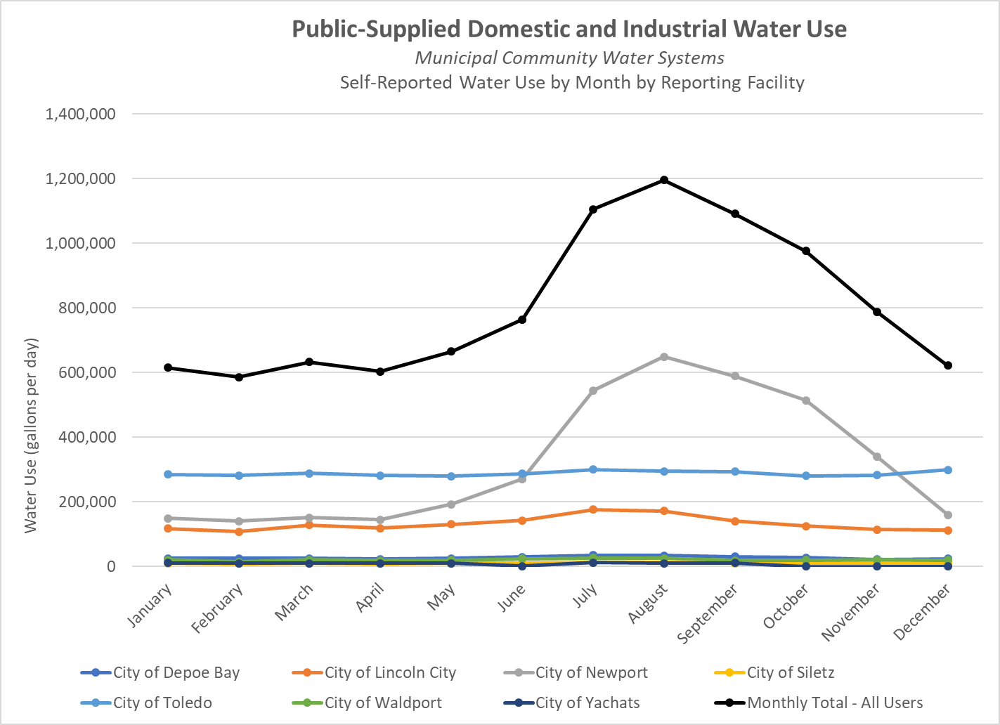
Figure 9. Monthly diverted water used by municipal community water systems in the Mid-Coast.
horizon may not be met with current water rights and there is a need to think about and plan for long-term water supply solutions beyond existing water rights and sources (OWRD, 2021).
The Rocky Creek Regional Water Supply Project planning effort was undertaken in 2002 by the Central Coast Water Council, which was made up of the City of Lincoln City, the City of Newport, the City of Toledo, the City of Waldport, the City of Yachats, Kernville-Gleneden Beach-Lincoln Beach Water District, Southwest Lincoln County Water District, and the City of Siletz. The City of Newport conducted a Study of Newport’s Water Supply and the Potential for Future Regionalization of Water Supplies in 1997. The projected demands contained in these reports are not consistent with more recent findings from Water Management Conservation Plans developed by individual entities and may overestimate projected future demands.

There is a need to develop updated defensible projected future demands for community water systems in the region using a consistent, agreed upon methodology. accounting for the future instream needs and the needs of other out-of-stream users. This should be accompanied by an assessment of whether community water systems will likely be able to meet projected demands with current sources, as well as an estimate of potential future deficits with consideration given to instream needs and the needs of other out-of-stream users. The analysis should account for the potential for reductions in water supply resulting from climate change impacts as well as conservation opportunities. Understanding projected future supplies, demands, and deficits will help community water systems determine actions to meet water needs for their individual service areas as well as the region as a whole.

The work group identified a need to develop an updated defensible projected future demand for community water systems in the region, along with an assessment of their ability to meet those demands with current sources and potential future deficits. The analysis should account for the potential for reductions in water supply resulting from climate change impacts and other development. Understanding projected future supplies, demands, and deficits will help community water systems determine actions to meet water needs for their individual service areas as well as the region as a whole. Oregon State University is currently working to develop a model that can be used to forecast future demands under various climate change scenarios.
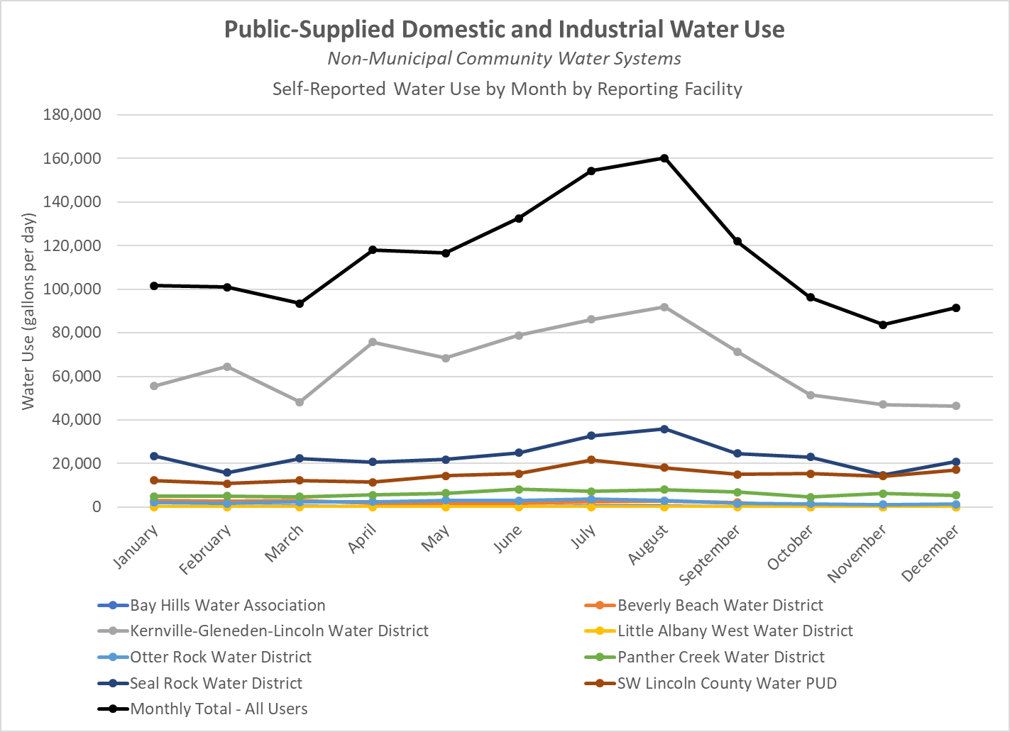
Figure 10. Monthly diverted water used by non-municipal community water systems in the Mid-Coast.
Small community water systems lack the capacity to engage in lengthy planning processes. As a result, the specific needs and challenges of these water users is not sufficiently captured in this plan. Lincoln County did an assessment of the water needs of small community water systems in 1997. It would be beneficial to update this assessment and identify the specific needs of these small, but important water users.

Critical Issues of Community Water Systems (Municipal and Non-Municipal)
The working group that examined the water needs and challenges of municipal and non-municipal community water systems identified the following key issues for strategy development:
- The need for increased access to funding to address current and legacy infrastructure issues and invest in resilient infrastructure that can withstand natural hazards and help communities adapt to climate change impacts;
- The need to coordinate conservation efforts between community water systems;
- The need to develop water supply redundancies and interconnections that would allow communities to access quality water in case of emergencies or shortages;
- The need to sustain efforts that increase coordination and collaboration between community water systems;
- The need to better understand and address the water needs and challenges of small community water systems that were not able to participate in planning;
- The need to address current and potential future water shortages by implementing water conservation measures and exploring future water supply options;
- The need to address water quality limitations posed by low streamflows in the summer and high turbidity in the winter;
- The need to improve coordination on shared water systems like the Siletz River in order to minimize ecological impacts.

Overview of Water Uses, Needs, and Challenges of Self-Supplied Water Uses

Rural Residents
A significant number of people in Lincoln County supply their own water for use in and around their home. It is estimated that 13,075 people, or about 30% of the population in Lincoln County, supply their own water from groundwater, springs, or streams. This is a very important water use for the region, even though the estimated water use is relatively small when compared to other uses.
It is difficult to estimate current water use and future water needs of rural residents. See Table 4 for a breakdown of wells and water rights by sub-area as well as estimated water use. Based on this information, rural domestic water users are distributed throughout Lincoln County. The majority of self-supplied domestic water users are in the Alsea and Yaquina River Basins.
Table 4. Estimated self-supplied rural domestic water users and demand by sub-area.
Sub-Area | Estimated Water Rights | Estimated Wells | Estimated Population Served | Estimated Use (gpd) based on 76-145 per capita per day | Estimated Consumptive Use (gpd)
Salmon River | 78 | 548 | 1,402 | 106,552–203,290 | 21,310–40,658
Siletz Bay – Ocean Tribs | 46 | 511 | 1,248 | 94,848–180,960 | 18,970–36,192
Siletz River | 129 | 532 | 1,480 | 112,480–214,600 | 22,496–42,920
Depoe Bay – Ocean Tribs | 55 | 552 | 1,360 | 103,360–197,200 | 20,672–39,440
Yaquina River | 143 | 1,754 | 4,249 | 322,924–616,105 | 64,585–123,221
Beaver Creek – Ocean Tribs | 37 | 224 | 585 | 44,460–84,825 | 8,892–16,965
Alsea River | 178 | 892 | 2,397 | 182,172–347,565 | 36,434–69,513
Yachats River – Ocean Tribs | 37 | 121 | 354 | 26,904–51,330 | 5,380–10,266
Total | 703 | 5,134 | 13,075 | 993,700–1,895,875 | 198,740–379,175

Rural residents that supply their own water for domestic use are responsible for ensuring that their own water is safe for drinking. Anecdotal reports from residents and survey results from Oregon’s Kitchen Table survey indicate that there is considerable concern about the drinking water quality for those who obtain their domestic water from streams, springs, and wells. There is generally insufficient data to determine the quality of source water for all self-supplied users in the planning area.
Water use of rural residents responsible for supplying their own water was estimated for this report, but is not well known. The current water use and water security of self-supplied rural residents is not well understood and should be further assessed. Anecdotal reports from pump installers, well drillers, the watermaster, and rural residents indicate that late in the dry season, rural residents experience declining water quantity from their springs or wells, especially during drought years. Water providers report increasing demands for bulk water from rural residents, and have begun to track those demands.
As the population in Lincoln County increases, especially from people seeking refuge from hotter climates, there may be increased pressure on water resources in unincorporated areas.
The potential for increased development in unincorporated areas that are not served by community water systems is not well known. Oregon land use laws and economic barriers limit development of agriculture and forest conservation land to other uses. Proactively identifying the potential impact of increased development on localized streams, springs, and groundwater would be beneficial.

Irrigated Agriculture
The 2017 US Department of Agriculture estimates 2,818 actively harvested cropland acres, and 441 irrigated acres. The Oregon Water Resources Department reports that 6,141 acres have irrigation water rights. Estimates of water use for irrigated agriculture vary significantly, and there is not a standardized approach to estimate water use (Table 5).
It is expected that irrigators in the Mid-Coast region have had much of their crop needs met by precipitation. As the dry season extends in length and as temperatures increase, more landowners in the Mid-Coast may rely on irrigation to meet their crop water needs. Farmers who are junior to instream, municipal, or industrial water rights may also have an increasingly difficult time meeting their water needs. The future needs and vulnerabilities of irrigators are not well understood in this region.
Current irrigation water use is not well understood in the Mid-Coast, and estimates vary greatly. Because of the limited data, it is difficult to know how water use trends are changing over time. Satellite-based monitoring of evapotranspiration using tools such as OpenET may be able to help fill this data gap, though data may be limited due to a limited number of clear, cloudless days on the coast.
Few farmers and irrigated agriculture landowners were directly involved in the planning effort. Effort should be made to better understand how the water needs and practices of farmers are changing over time.
Table 5. Estimated irrigation water users and amount of water use by sub-area.
Sub-Area | Estimated Number of Water Rights (Irrigation/Livestock) | Estimated Irrigated Acres | Estimated Irrigation Diversions (gpd) | Estimated Consumptive Use (gpd)
Salmon River | 45 (40/5) | 156 | 348,170 gpd | 174,085 gpd
Siletz Bay – Ocean Tribs | 23 (18/5) | 359 | 801,683 gpd | 400,841 gpd
Siletz River | 94 (76/18) | 1,187 | 2,649,659 gpd | 1,324,830 gpd
Depoe Bay – Ocean Tribs | 11 (11/0) | 52 | 116,057 gpd | 58,028 gpd
Yaquina River | 87 (77/10) | 1,177 | 2,627,341 gpd | 1,313,224 gpd
Beaver Creek – Ocean Tribs | 14 (14/0) | 82 | 183,012 gpd | 91,953 gpd
Alsea River | 176 (159/17) | 2,964 | 6,615,221 gpd | 3,307,610 gpd
Yachats River – Ocean Tribs | 26 (24/2) | 164 | 366,024 gpd | 183,012 gpd
Total | 703 | 6,141 | 13,705,380 gpd | 6,852,690 gpd

Industry
There are very few self-supplied industrial water users throughout the planning area and self-supplied industrial water use generally accounts for a small amount of the authorized water use in most of the hydrologic sub-areas. The major exception to this is Georgia Pacific’s pulp mill in Toledo, which has the largest authorized withdrawals in the entire planning area (totaling 35 cfs).
The projected future needs or demands of self-supplied industrial users has not been estimated. The largest industrial water users (both self-supplied and public-supplied industrial water use) in the planning region represent a significant source of jobs and economic development. Most industrial water use in the region relies on diversions from the Siletz River as well as storage (Olalla Reservoir and Big Creek Reservoirs). Drought conditions in 2015, 2018, and 2021 have likely revealed water insecurities for self-supplied industrial users. A 1997 study of Newport’s water supply and the potential for future regionalization of water supplies noted that “Georgia Pacific’s water supply is generally adequate to meet the needs of the mill at its present capacity to produce paper. However, to avoid shutting down in past water short years the mill had to practice water conservation measures that are detrimental to equipment and are economically acceptable for short period. A study was made in 1990 to investigate alternatives for increasing their water supply. The study concluded that a 10-foot, 420,000,000-gallon addition to Olalla Dam would be the preferred alternative to expand their supply” (Fuller and Morris, 1997).
Industrial water users did not consistently participate in the planning effort, though others within the group consulted with them through the process and sought to represent their interest. Their specific needs and vulnerabilities are not well known. Effort should be made to better understand their water use, their projected future needs, and vulnerabilities and find ways to engage and support them in efforts to increase their water security and increase efficiency in their operations.

Critical Issues for Self-Supplied Water Users
The working group that examined the water needs and challenges of self-supplied water users identified the following critical issues for strategy development:
- The need to better understand the status of water infrastructure used by self-supplied water users as well as provide resources to upgrade and maintain this infrastructure;
- The need to better understand water quality needs for the various self-supplied uses and ensure safe drinking water for self-supplied rural residents;
- The need to better quantify and track water shortages faced by all self-supplied water users and increase water security;
- The need to connect self-supplied water users with information and resources to increase water conservation and efficiency in and around the home and on the farm;
- The need to assess opportunities for water conservation and efficiency and water security for self-supplied industrial water users.

Water Availability and Future Needs
Patterns of development vary greatly over the planning area, with some areas experiencing high demands on available water resources and some areas experiencing no demands on water resources. These demands generally correspond with land use and management in the area, with water systems that are fully or over-appropriated to out-of-stream uses in and around communities along the US-101 corridor.
Table X provides a high-level overview of the supply and development in each of the eight different sub-areas. Appendix X provides a more detailed summary for each sub-area. Generally speaking, the Water Availability Reporting System maintained by the Oregon Water Resources Department shows that there is limited water available for new out-of-stream appropriations in the summer months. Remaining water availability generally corresponds with the level of existing development of water for out-of-stream uses for community water systems and industry as well as the presence and absence of instream water rights. In sub-areas with instream water rights, water availability is more limited for new out-of-stream appropriations during the summer. In most sub-areas the Water Availability Reporting System shows that there is still water available during the winter for new storage appropriations.
Areas where some water may be available for new out-of-stream appropriations generally encompass ocean tributaries, or streams lower in river drainages. These systems generally have very limited summertime flows and may also be tidally influenced, which could prevent them from being used for most out-of-stream uses. These are also the areas where additional demand is likely to occur given the proximity to US-101 and the desirability of living near the Ocean. Ocean tributaries also generally do not have instream water rights protecting instream values. The ecological value of ocean tributaries should be considered in future allocation decisions.
The status of water allocation can also be viewed in the Mid-Coast Storymap (under “Is There Enough Water For All?”).
As conditions become drier and warmer during the late spring, summer, and early fall, water supplies often fall short of aggregate water right allocations. Additional water is generally not available to meet new out-of-stream needs when it is most needed and new uses will need to be met via water rights transfers, water conservation, water reuse, additional storage, or other novel water supply strategies.
Table 6. Water Supply and development by sub-Area.
Sub-Area | Natural flow in September (at 50% exceedance in cubic feet per second) | Estimate of natural flow and percent natural flow consumed by out-of-stream uses in September across all WABs discharging to bays or the ocean | Percent of WABs fully or over-allocated to out-of-stream uses (does not account for instream) / Percent of WABs with <1% allocated | Percent of WABs with instream water rights | Percent of WABs with water available in any months / Percent of WABS with water available in 12 months | Percent of WABs with no water available in any months (at 80% exceedance) / in September | Percent of WABS with storage available (at 50% exceedance)
Salmon River Sub-Area | 47.9 cfs | <1 cfs / 2% | 0% / 11% | 100% | 33% / 0% | 67% / 100% | 100%
Siletz Bay-Ocean Tributaries Sub-Area | 57.9 cfs | >32.3 cfs / >55% | 22% / 11% | 22% | 67% / 44% | 33% / 56% | 78%
Siletz River Sub-Area | 159.1 cfs | 68 cfs / 43% | 0% / 88% | 89% | 53% / 6% | 47% / 94% | 100%
Depoe Bay-Ocean Tributaries Sub-Area | 32.4 cfs | 15.5 cfs / 48% | 38% / 23% | 0% | 92% / 67% | 8% / 38% | 100%
Yaquina River Sub-Area | 41.8 cfs | 8.3 cfs / 20% | 6% / 33% | 89% | 50% / 6% | 50% / 89% | 78%
Beaver Creek – Ocean Tributaries Sub-Area | 40.4 cfs | 7.1 cfs / 18% | 17% / 67% | 0% | 100% / 83% | 0% / 17% | 100%
Alsea River Sub-Area | 150.1 cfs | 8.9 / 6% | 0% / 71% | 81% | 91% / 10% | 10% / 81% | 100%
Yachats River – Ocean Tributaries Sub-Area | 42.2 cfs | 12.7 / 30% | 8% / 50% | 50% | 83% / 42% | 17% / 58% | 100%
 | 571.8 cfs | 153.8 / 27% | 10% / 50% | 59% | 72% / 28% | 28% / 69% | 95%

The Water Availability Reporting system is based on a period of record from 1958 to 1987. Because three of the most significant drought years occurred in the past decade, the period of record for the Water Availability Reporting System may not accurately represent current streamflow conditions and may overestimate water supply and availability. There is a need to update the period of record to get a better understanding of water use and availability relative to available supply.

Groundwater Use and Development
There are very few permitted water uses that have groundwater as their source. Groundwater is a source of water for Permit-Exempt uses, such as for domestic and livestock uses (ORS 537.545). Local domestic water users, well drillers, and pump installers have all shared anecdotal reports of seasonal water shortages in domestic wells, especially during recent years where much of the west has been experiencing drought. Given the limited storage of the groundwater system, water users on wells may need to consider alternate means of storage or alternate sources of water late in the dry season, especially if dry conditions persist.
Proliferation of permit-exempt wells for future self-supplied domestic uses or other permit-exempt uses will impact streamflows in the long term, but the timing and significance will depend on the local hydrogeology and patterns of development. The current impact of permit-exempt wells on surface water flows has not been assessed and is not known but is expected to be small. Overall consumptive use from rural domestic wells, and household use in general, is very low, as much of the water removed from the aquifer is returned via drain fields. Although permit-exempt uses are very small at a basin scale, there may be important localized impacts from groundwater pumping on streams. The relationship between groundwater and surface water has not been adequately assessed in the Mid-Coast planning area.

Climate Vulnerability in the Mid-Coast
The Oregon Climate Change Research Institute (2019) produced a report describing future climate conditions for the Mid-Coast relative to temperature, precipitation, snowpack, floods, droughts, wildfire, sea level, and coastal ocean conditions. Future projected conditions were based on at least 10 global climate models and numerous scenarios of global greenhouse gas emissions, and were made locally relevant by combining the outputs from the global models to historical observations, achieving a resolution of 2.5 miles x 2.5 miles on the landscape. Projections were made for mid-21st century, the 2050s, late 21st century, and the 2080s.
The report authors considered both lower and higher emissions scenarios based on available data and published literature. Lower emissions scenarios represent modest efforts to reduce global greenhouse gas emissions by mid-21st century whereas the higher emissions scenarios represent “business-as-usual” practices, i.e., greenhouse gas emissions continuing to increase through the 21st century (Oregon Climate Change Research Institute 2019).
The Army Corps of Engineers also produced a report on hydro-climatic vulnerability, which confirmed many of the findings from the Oregon Climate Change Research Institute Report (Army Corps of Engineers, 2020).
The following are a few highlights (Figure 10) from that report that describe the likelihood of projected changes in environmental parameters important to the Mid-Coast region.
Climate change will exacerbate challenges that the Mid-Coast region already experiences. As a result of these changes, the Mid-Coast region needs to prepare for the following climate change impacts:
- Decreasing summertime streamflows and increased frequency of drought conditions will impact fish and wildlife, recreational opportunities, and the ability for cities and industry to meet their summertime water needs (which is generally when demand is highest).
- Increasing drinking water insecurity for community water systems and rural residents who draw water from streams, groundwater, and springs, as water supplies decrease with a hotter and longer dry season.
- Increasing stressors on fish and wildlife as they adapt to a changing hydrograph (more water in the winter and less water in the summer), elevated water temperatures and decreasing water quality conditions linked to low streamflows and elevated temperatures.
- Increasing impacts of extreme storms and flooding on community infrastructure.
- Increasing turbidity of drinking water during the winter months due to increased storms and erosion caused by higher precipitation events.
- Increasing potential for wildfire to affect water quality and water infrastructure.
- Increasing reliance on irrigation water to grow crops since crop water needs are less likely to be met by precipitation.

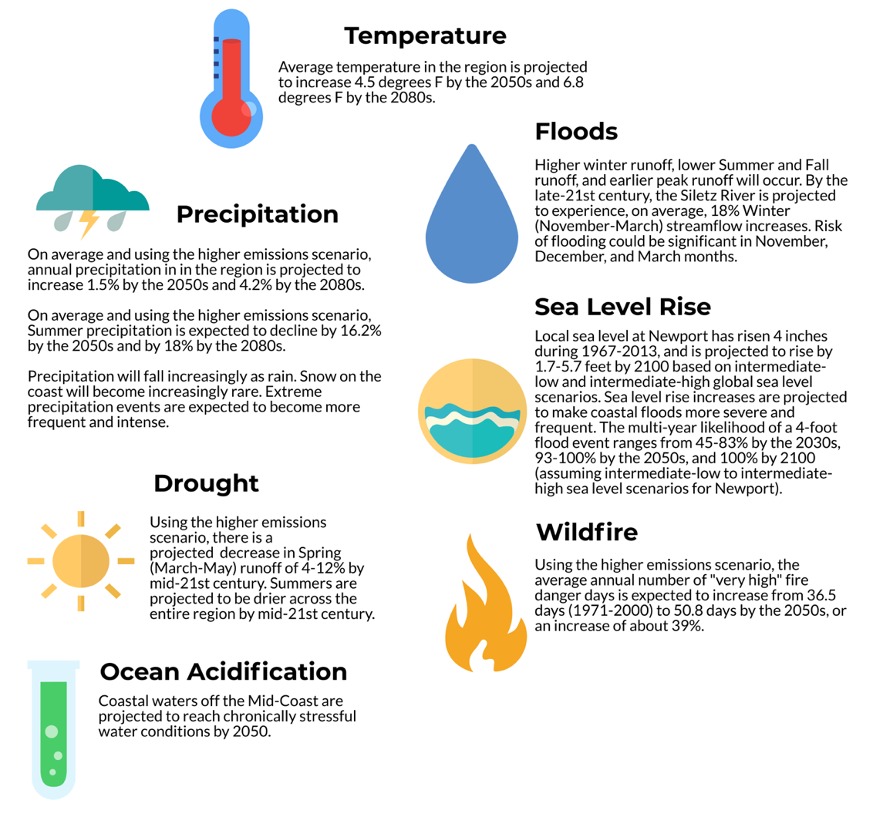
Figure 11. Projected climate change impacts to important parameters in the Mid-Coast region.

Action Plan

Action Plan Development
The development of the action plan was guided by key water issues and drivers.

Critical Water Issues
During Step 3 of the planning process, the Partnership achieved consensus on a total of 18 key issues in eight categories:
Water Conservation
- The Mid-Coast needs a coordinated water conservation initiative/strategy that focuses on reducing water use, educating stakeholders, promoting incentives, and effectively using limited water supplies, especially in times of water shortage.
- Rural residents and businesses need improved access to information, incentives, funding, and resources to help them implement water conservation measures.
Natural Hazards, Vulnerabilities, and Emergency Preparedness
- The majority of water providers need redundancy, water system interconnections, and alternative sources to ensure access to safe drinking water in case of emergencies or shortages. Natural hazards that can impact systems include earthquakes, wildfire, landslides, debris flows, and others.
Climate Change Impacts
- Climate change is having profound impacts on the ecosystem, which affects the health and well-being of coastal communities. Although we may not fully understand nor be able to accurately predict climate change effects, we can and should proactively adapt to climate change impacts at a regional scale.
Local Capacity and Regional Collaboration
- Mid-Coast water providers share the need for system resilience and reliable source water quantity and quality. Regular coordination and collaboration among water providers can improve access to resources and funding to support this need.
Water Quantity for Instream and Out-of-Stream Uses
- Summer streamflows are insufficient in some areas of the Mid-Coast (see Water Quantity Report from Step 2 of the planning process – Appendix B) to meet the instream water needs of fish and wildlife. Low streamflows contribute to water quality impairments (e.g., high temperatures and reduced dissolved oxygen) that negatively affect fish and wildlife.
- Many streams in the Mid-Coast lack: 1) legal protections (e.g., instream water rights) to protect streamflows for the full range of ecological flows, and 2) streamflow targets to guide instream flow restoration efforts where there are already significant out-of-stream uses.
- Some municipal and special district water providers are currently facing water shortages late in the summer into the fall and during dry years.
- Rural residents and landowners, agricultural irrigators, and industrial water users currently experience chronic seasonal water scarcity due to limited water availability.
- Some watershed systems, such as the Siletz, have insufficient water to meet the needs of all uses (both instream and out-of-stream) (see Water Quantity Report from Step 2 of the planning process – Appendix B) leading to ecological impacts on the rivers, insecurity for water users, and the potential for conflict.​
Watershed Health
- Opportunities exist in the Mid-Coast for enhancing beaver habitat and management to increase water storage, improve stream health, and support the recovery of key native fish species.
- Degraded riparian areas throughout the Mid-Coast negatively affect water quality, wildlife habitat, and overall watershed health. Opportunities exist to improve these areas.
Water Quality for Instream and Out-of-Stream Uses
- Multiple river and stream segments consistently do not meet Oregon and federal water quality standards (see Water Quality Report from Step 2 of the planning process – Appendix B): high temperature and low dissolved oxygen threaten fish, and elevated turbidity affects the ability to treat and use water.
- Low stream flow and high temperatures in the summer months, and high turbidity due to winter storms, pose challenges for drinking water suppliers to meet state and federal regulations to provide safe drinking water. In addition, these conditions pose challenges for native fish populations.
- Self-supplied rural residents are increasingly concerned about drinking water quality and seek adequate and timely data to assess regional, local, or site-specific water quality contamination issues that may pose a health risk.
Infrastructure
- The degradation of aging public water infrastructure used to divert, store, treat, and convey water can lead to water loss and water quality issues, and poses a threat to the health and safety of communities.
- Infrastructure to manage water for self-supplied uses (rural residences and agricultural operations) is oftentimes undocumented, old, inefficient, and may fail to meet current construction and quality standards, which negatively affects water security and source water quality throughout the region.
- Multiple sources of funding are needed to address current and legacy infrastructure issues and to design and build resilient infrastructure that can withstand natural hazards and help communities adapt to climate change.

Overview of the Strategic Action Imperatives
Stakeholders developed cross-cutting and action-oriented imperatives (below) to organize and characterize key basin issues and the strategies proposed to address them. Each of these recognizes that water issues crosscut many geologic, biological, legal, and cultural contexts. The trust and collaborative spirit nurtured in the planning process reflect the commitments and approach of Oregon’s 2017 Integrated Water Resources Strategy (IWRS), were critical in reaching consensus on Plan imperatives and potential actions, and will be equally important during the implementation and assessment phases of the Plan.
As we approach the 50th anniversary of the establishment of Oregon’s current land use governance system, we recognize both the opportunities and the challenges of working within state-wide planning goals. The IWRS acknowledged that many localities' comprehensive plans have not been updated since the 1990s. Clearly things have changed since then, especially trends in climate and demands on water. The Mid-Coast exemplifies many of these land use challenges. The descriptions of needs and the strategies to address them in this plan will be helpful in both navigating the current system and improving the ways by which Oregon’s state agencies, community partners, and community members work together on the IWRS identified Critical Issue: Water and Land Use. The high-level Imperatives and more specific actions below are proposed as starting points in that deeply collaborative work. As the actions developed through this collaborative effort move towards implementation, awareness and understanding of the multiple layers of regulatory oversight is essential. Working with private entities and non-profits, cities and county to understand how the proposed actions align with the local comprehensive plans and land use ordinances is the first step in moving through the regulatory processes locally and at the state level. It is hoped that the priorities and imperatives identified here will be considered in updated comprehensive planning by all water stakeholders. Developing projects within the existing frameworks while encouraging innovation is critical to ensuring success.
Cross-Cutting Imperatives
Regional Capacity, Coordination, and Collaboration. All strategies and actions will benefit from increased regional capacity, coordination, and collaboration. Each strategy and action will also have specific needs regarding capacity, coordination, and collaboration.
Public Awareness and Support. All strategies and actions will benefit from an improved understanding throughout the region about water conditions and challenges, with communication and outreach tailored to the interests and values of different audiences. All strategies/actions will also need various levels of public awareness and support, especially where the success of the action is contingent upon public support. A well-informed and engaged public will be more connected to water providers, water and watershed managers, and each other and will be better prepared for a changing climate, natural hazards, and other emergencies.
Monitoring and Data Sharing. All strategies and actions will benefit from improved monitoring, data collection and sharing. Specific strategies and actions will benefit from more specific data collection and monitoring efforts to track progress and impacts. The scale of data collection and monitoring efforts will be informed by the desired goal. Data collection and monitoring efforts will generally benefit from increased Capacity, and improved coordination and collaboration. Implementation of the Water Action Plan will generally benefit from increased transparency and accessibility of data for all partners. Recognizing resource constraints, recommendations to improve and enhance data collection and monitoring will need to be prioritized to focus on the highest needs identified in the plan (finding a balance between tracking status and trends of water-related conditions and monitoring the impacts of actions).
Funding and Investments. All strategies and actions will benefit from increased funding and improved coordination of funding. Each strategy and action will have specific needs and structures regarding funding. Partners recognize that, generally, historical investments in water planning, conservation, and infrastructure (both natural and built) have lagged development and demands upon the resource. Federal funding may have the greatest potential impact, but is often difficult for local communities to access and direct. Similarly, there is a patchwork of potential funding from state and local public and private entities that can be difficult to inventory, access and coordinate, especially for partners with limited capacity. The strategies and actions assume the imperative of greater collaboration and coordination to develop, access, and administer funding for water investments to achieve plan goals and maximize returns on those investments.

Action Oriented Imperatives
Water Conservation, Efficiency, and Reuse. Due to limited water availability for new out-of-stream uses across the Mid-Coast region as well as the need to restore and protect instream values, water conservation may be one of the most cost-effective ways to meet future water needs of the region while increasing water security and resiliency for all users. All conservation and reuse actions will assist with preparing for and adapting to reduced summer supplies resulting from climate change and increasing summer demand due to population and tourism and industrial water needs. All conservation and reuse actions are assumed to help with water quality issues associated with run-off/discharge. All conservation and reuse actions will help stretch limited supplies which may prevent or prolong the need to secure/develop additional supplies of water. Conservation and reuse actions should seek to target the biggest water users first and/or water users in the most ecologically significant places. There are three major strategies for achieving water conservation and efficiency:
- Maintaining and upgrading infrastructure to prevent leaks, rapidly identify and address leaks, and/or maximize efficient use of water.
- Training water technicians, managers, and water users to improve and optimize operations in their water systems so that no water diverted is wasted.
- Reducing demands and consumption of the end users/consumers via incentives, pricing of water, and encouraging the use of more efficient appliances and practices (e.g., xeriscaping, installing low flow toilets).
All water conservation, efficiency, and reuse actions should consider equitable access to water for disadvantaged community members (including considerations of the cost of water), near-term and long-term water security for the users, and how water savings will provide instream or ecological benefits.
Ecosystem Protection and Enhancement. Watershed ecological processes are complex and interconnected. Investments in ecological restoration and protection can have benefits for multiple other imperatives, including source water protection (drinking water quality), resilient infrastructure, water supply and storage, and preparing for natural hazards and emergencies. These functions, or benefits, are referred to as “ecosystem services.” Whenever possible, watershed ecological restoration and protection should be focused on the areas that have the highest potential to yield ecological benefits and are identified in existing assessments or plans, such as the Coho Recovery Plan or Coho Business Plan. Creative partnerships that link downstream beneficiaries (e.g., cities, residents, businesses) to the benefits of a healthy watershed should be explored, including consideration of creative funding mechanisms. Ecosystem-based management is critical to the restoration, enhancement, and maintenance of aquatic systems in the Mid-Coast.
Resilient Water Infrastructure. Sustaining and planning for adequate collection and distribution systems, treatment plants, and other associated critical infrastructure requires strategies that address aging infrastructure, support resiliency, ensure future water demands are met, and advance training and professional development to ensure the availability of skilled water technicians. Investments in water infrastructure should seek to provide multiple benefits whenever possible and mitigate impacts to the ecosystem. Infrastructure design should take into consideration opportunities for conservation, efficiency and reuse and also “green infrastructure” or ecosystem services that reduce the need for, increase the effectiveness of, or prolong the life of built or “grey infrastructure.” New or upgraded infrastructure should seek to be as resilient as possible, by accounting for natural hazards and emergencies (e.g., floods, earthquakes, fires, drought, etc.). For now, this imperative focuses on infrastructure associated with individual water providers and users. Depending on analyses performed to explore regional water supply options, this imperative may be modified to account for regional water infrastructure.
Source Water Protection. Source water includes the rivers, streams, lakes, reservoirs, springs, and groundwater that deliver water to public drinking water supplies and private wells. Protecting source water reduces treatment costs, protects water quality for fish, wildlife, and human uses, and helps ensure the availability of water. Strategies to protect source water depend on the source, and include protection of riparian habitats, stream bank stabilization, land protection/easements, best management practices for agricultural, forestry, and other activities, local ordinances to limit activities in source water or wellhead protection areas, emergency response plans, and outreach and education. Source: Environmental Protection Agency.
Water Supply Development. Water conservation is the highest priority action for stretching limited water supplies and improving water security, but the Partnership also recognizes the current and future need for additional supplies, which may come from storage, water reuse, or other novel water supply options. The City of Yachats is currently facing water shortages, especially during drought years. There are also increasing reports of current water insecurity for self-supplied water users, which includes water for rural residents, irrigators, livestock, and self-supplied industry. This includes increasing anecdotal reports of wells going dry earlier in the summer and increased demand for bulk water and water deliveries. Georgia Pacific is the largest single water user in the region, and they are beginning to experience shortages, especially during drought years. Within the next 50 years, it is projected that municipalities may experience future water shortages due to decreasing summer supplies and increasing summer demand.

Performance Metrics
Developing performance metrics, or indicators, to assess progress made implementing any plan is critical to success. The first key step in the development of metrics was establishing criteria used to inform the metrics. Relevance to management goals and objectives, sensitivity to stressors, high “signal-to-noise” ratios (i.e., significant changes to an indicator are caused by changes in stressors versus stochastic variability), quantifiability, accuracy, precision, ability to monitor, cost-effectiveness of monitoring, and measurements that can be interpreted unambiguously, are key criteria that have been used to indicate watershed health (City of Portland Bureau of Environmental Services 2019), and are foundational to all of the imperatives and their associated actions in this plan. Because all actions identify potential lead organizations, it will be incumbent on those leads to ensure that appropriate performance and tracking metrics are developed and used.

Implementing the Water Action Plan
The next portion of the Mid-Coast Water Planning Partnership Water Action Plan includes implementation tables that describe a suite of strategies designed to achieve the water objectives and priorities in the Mid-Coast region of Oregon in phases during the next 10 years, from 2022–2032. This plan should be reviewed and updated every five years, considering progress, emerging issues, and changes in demographics and other factors likely to occur in the Mid-Coast. The specifics within the implementation table focus on the highest priority actions that should be initiated within the next 10 years to achieve a secure water future for people and environments in the Mid-Coast.
Prioritizing Actions
There is no intended order to the categories of actions, as all of the actions are considered Tier 1, or high priority actions by the Partnership. Tier 2 and Tier 3 actions, which are lower priority actions, were not incorporated into the tables. Charter signatories established criteria to prioritize actions:
- High (Tier 1): A critical action without which the objective(s) is not achievable. An action that absolutely must be completed to fully achieve the objective.
- Medium (Tier 2): A necessary, but deferrable, action that makes the plan/objective less workable, but functional. An action that is necessary, but potentially deferrable.
- Low (Tier 3): A productive action to implement if the resources exist, but the plan/objectives can be achieved without implementing. An action that adds value and would be completed under ideal circumstances, but is not essential to achieve the objective(s).
Initially 150 “raw” draft actions were created by charter signatories to address the 18 key issues. The signatories then volunteered to rank the actions per agreed upon criteria, followed by all partners being given the opportunity to comment on priority rankings. Any redundancies across actions were eliminated, and language associated with each action was refined. The set of tables in this plan represent all of the high priority actions identified by charter signatories. Tier 2 and Tier 3 strategies, which were not incorporated, can be reviewed on the Partnership website on the Water Action Plan page.
No additional prioritization occurred during the planning process other than describing the phase (1, 2, or 3) in which a specific strategy could likely be implemented. While general feasibility was an implicit driver of consensus support, and often discussed in Partnership conversations, the proposed actions have not been fully considered in light of current State or local laws, or from the perspective of a cost-benefit analysis. Because of the highly specific and technical nature of the potential projects under the proposed actions, individual project Partners, in consultation with the relevant State agencies and local governments, are best equipped to evaluate the feasibility of projects within the tables.
The Partnership recognizes that estimated implementation “costs” for many Actions or Strategies do not reflect the benefits, (or return on investment) for ecosystem services, infrastructure risk reductions, or system efficiencies. Calculating these is technically, socially, and economically complex. However, the Partners agreed to examine ecosystem services and other expected outcomes as part of a comprehensive approach to evaluating Plan implementation and investment strategies utilizing available methods, tools, and references.
The Partnership anticipates that each of the entities involved in the development of this plan and actions, and other community partners, can identify the role they may play in implementing one or more of the actions in the table, and that all will continue to work collaboratively to further prioritize and assess implementation progress. Water Action Teams (Figure 12) will be formed to maintain communication and coordination around the six action-oriented imperatives. The Partnership will, at a minimum, meet on a quarterly basis to support coordination of work between partners. The Partnership will focus its efforts on increasing regional capacity, coordination, and collaboration, building public awareness and support, increasing funding and access to funding, and improving monitoring and data sharing to more effectively implement each of the six action-oriented imperatives. The Partnership will also strive on an annual or bi-annual basis to convene a Regional Water Summit to track and report progress on plan implementation and celebrate successes.
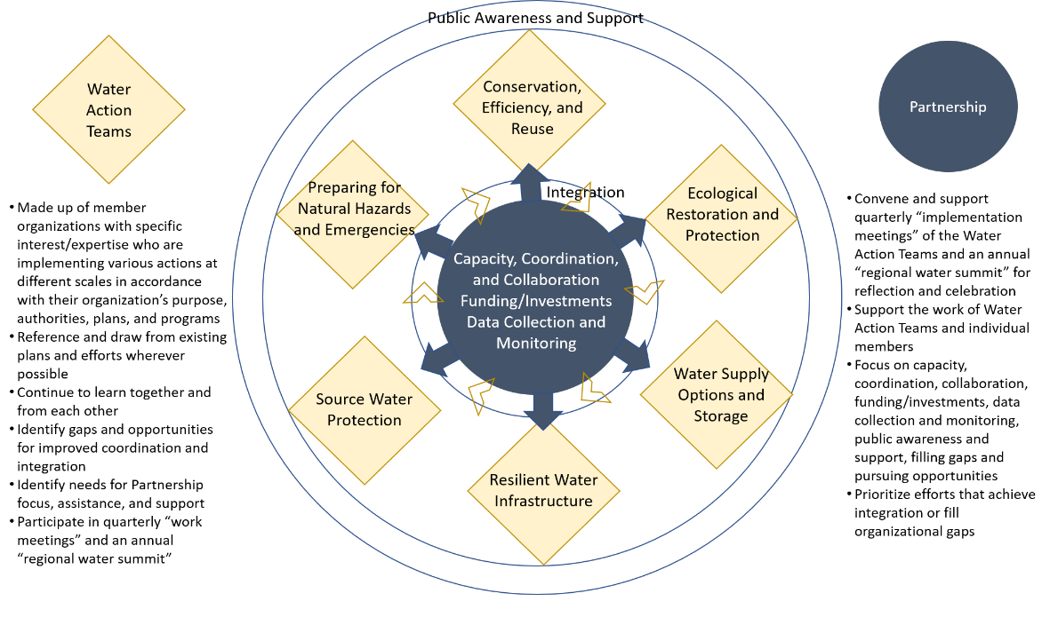
This plan is intended to be used by the many partners, organizations, and individuals that live and work in the Mid-Coast Planning Area to achieve the goals, objectives, and actions described herein. In some instances, a watershed council could use the plan to justify funding for an aquatic habitat restoration project. In other instances, a municipal water district could use the plan to identify high priority infrastructure projects, and seek funding to support a specific action. It is anticipated that many of the actions in each phase of this plan will be implemented simultaneously, as resources and capacity exist.
Figure 12. The nexus among water action teams and the Partnership, with the water action teams focusing on the action-oriented imperatives, and the Partnership focusing on the crossing-cutting imperatives.

The Oregon’s Kitchen Table public engagement that took place from November 2021 – February 2022 gave the Partnership an idea of the priorities and areas of concern of the broader community for implementation. Two of the action areas people wanted to see the Partnership start work on first were protecting water sources and ecosystems of watersheds in the area. Replacing and/or improving the region’s systems that collect and supply water as well as water treatment plans, so they are efficient and secure was another action area that people chose as one of the top three action areas they wanted to see the Partnership take on first. During the engagement activities we asked people for future engagement suggestions and how they saw themselves as part of implementing the plan these are the common themes that the Partnership heard.
- They want to investigate and understand better what options or solutions might be possible and to be proactive in taking actions to increase water conservation.
- They also want to learn more about water collection or storage approaches, 70% of those who own land indicated on the survey that they would be interested in learning about ways to improve water quality on own land.
- They would also like help in cross-sector efforts to collaborate on water issues.
- For future engagement it was suggested that the Partnership focus on in-person opportunities that provide information/resources about what has been done successfully in the region or what they can be doing when it comes to water conservation and catchment.
The Partnership will be factoring in the input from the Oregon’s Kitchen Table public engagement efforts to further prioritize the actions for implementation.

Anatomy of the Mid-Coast Water Action Plan Implementation Table

Imperatives: Categories that address key water issues in the Mid-Coast region.

Objectives: High-level statements that outline what the Partnership seeks to achieve.

Actions: Specific activities that help achieve objectives.

Desired Outcomes: Specific changes that will occur as a result of implementing an action.

Potential Lead and Participants
Potential Lead: List of potential entities responsible for implementing actions.
Potential Participants: List of potential participants that will collaborate with the leads to implement actions.

Timeline:
- Phase 1 = Action is expected to begin implementation within1-3 years.
- Phase 2 = Action is expected to begin implementation within 3-5 years.
- Phase 3 = Action is expected to begin implementation within 5-10 years.

Initial Estimated Investment: Preliminary estimated costs to implement the plan over 10 years.

Performance Metrics: How the actions will be measured to track progress and determine if the action has been successfully implemented.

Metric Methodologies: Ways in which the performance metrics can be calculated.

Imperative 1. Public Awareness and Support
Public awareness of water issues in the Mid-Coast region of Oregon is critical to achieving the long-term goals the region has for delivering water sustainably for people and native fish and wildlife.

Objectives
- Promote tools and information for water conservation.
- Foster a culture of water conservation.
- Build capacity of constituents to advocate for state and federal resources and funding.
- Support training and professional development to ensure the availability of skilled water technicians.

Action Details
Action |  | Desired Outcomes | Potential Lead & Participants | Timeline | Initial Estimated Investment | Potential Funding Sources
1. | Develop and implement a public awareness and engagement campaign aimed at supporting the imperatives and actions in the Mid-Coast Water Action Plan, including raising awareness and understanding of regional water issues. Includes the following: | Mid-Coast Planning Area residents, industries, and visitors are aware of and practicing water conservation measures. Public and private water suppliers are participating in water management and conservation planning and outreach to communities. There is uniform region-wide messaging about water use and conservation. | Lead: Education (all levels), interpretive facilities (Oregon Coast Aquarium, Hatfield Marine Science Center), regional water providers (private and public), Oregon Water Resources Department, Oregon State University Extension Service, Mid-Coast Watershed Council, Lincoln County Soil and Water Conservation District  Participants: Water use industries, tourism industry, water rights holders | PHASES 1-2 | $250,000 | - Oregon Health Authority Drinking Water Source Protection Grants & Loans.  - Oregon Community Foundation's Oregon Natural Resources Education Fund.  - Autzen Foundation.  - OWEB Partnership Stakeholder Outreach Grant. Georgia-Pacific Environment Grant Program.  - U.S. Economic Development Administration (EDA).  - EPA's Environmental Education (EE) Grants.  - Siletz Tribal Charitable Contribution Fund.  - Spirit Mountain Community Fund.  - Starker Forests Grant.  - Three Rivers Foundation.
 | Conservation:  a. Promote water conservation at local events, on the Mid-Coast Water Planning Partnership website and the websites of regional partners and entities, in news articles, in water bills, via social media, and through outreach materials to businesses, particularly in the hospitality industry.  b. Develop drought declaration and audience-specific (e.g., self-supplied industrial water users) water conservation and curtailment messages. | a. and b. Consistent messaging throughout the Planning Area associated with drought and water curtailment is developed and distributed. | Lead: Mid-Coast water providers (e.g., Mid-Coast Water Conservation Consortium), Lincoln County Board of Commissioners  Participants: OWRD, regional colleges and universities | PHASE 1 | a. $50,000  b. $40,000 | a)  - Georgia-Pacific Environment Grant Program.  - Business Oregon Drinking Water Source Protection Fund.  - U.S. Economic Development Administration (EDA).  - EPA's Environmental Education (EE) Grants.  - Spirit Mountain Community Fund.  - Starker Forests Grant.  - Three Rivers Foundation.  b)  - OWEB Partnership Stakeholder Outreach Grant.  - Business Oregon Drinking Water Source Protection Fund.  - U.S. Economic Development Administration (EDA).
 | Regional Collaboration:  c. Coordinate watershed and water system tours to increase awareness and understanding of regional and local water issues. | c. Increased understanding of regional and local water issues. | Lead: Mid-Coast Water Planning Partnership | PHASES 1-3 | $100,000 | - Meyer Memorial Trust Grant.  - OWEB Partnership Stakeholder Outreach Grant.  - Georgia-Pacific Environment Grant Program.  - Business Oregon Drinking Water Source Protection Fund.  - National Communication Association Advancing the Discipline Grants.  - EPA's Environmental Education (EE) Grants.  - NFWF Five Star and Urban Waters Restoration Grant Program (Watershed only).  - U.S. Department of Housing and Urban Development Sustainable Communities Regional Planning Grant.  - Gray Family Foundation Environmental Education Grant.  - Siletz Tribal Charitable Contribution Fund.  - Spirit Mountain Community Fund.  - Starker Forests Grant.  - Three Rivers Foundation.  - Oregon Health Authority Source Water Protection Grants
 | Infrastructure:  d. Develop a regional initiative/training to improve coordination and provide education to water providers on infrastructure financing and funding. | d. Water providers receive information on infrastructure financing and funding. | Lead: Water providers, Mid-Coast Water Conservation Consortium, Fund Managers  Participants: Business Oregon, Rural Community Assistance Corporation, Oregon Association of Water Utilities | PHASE 1 | $50,000 | - Meyer Memorial Trust  - Oregon Community Credit Union (OCCU) Foundation.  - Georgia-Pacific Environment Grant Program.  - National Communication Association Advancing the Discipline Grants.  - U.S. Economic Development Administration (EDA).  - U.S. Department of Housing and Urban Development Sustainable Communities Regional Planning Grant.  - Siletz Tribal Charitable Contribution Fund.  - Spirit Mountain Community Fund.  - Starker Forests Grant. Three Rivers Foundation.
 | Education:  e. Provide an internship program, hands-on training, and certification training for water technicians, which includes technician training on updating and implementing water management. | e. Each water provider has an updated water management and conservation plan that they are implementing. | Lead: Water providers, Oregon Coast Community College (OCCC)  Participants: Samaritan Hospital | PHASE 2 | $250,000 | - Meyer Memorial Trust  - Oregon Community Credit Union (OCCU) Foundation.  - Georgia-Pacific Environment Grant Program.  - National Communication Association Advancing the Discipline Grants.  - U.S. Economic Development Administration (EDA).  - U.S. Department of Housing and Urban Development Sustainable Communities Regional Planning Grant.  - Siletz Tribal Charitable Contribution Fund.  - Spirit Mountain Community Fund.  - Starker Forests Grant.  - Three Rivers Foundation.
 | f. Identify or develop curriculum and materials/information for students and the public (community education) about their water sources, water management, and water conservation. | f. Students are learning about their water supply and the importance of water conservation, and they share that information with family members. | Lead: Mid-Coast Water Conservation Consortium, Lincoln County School District education (all levels), interpretive facilities (Oregon Coast Aquarium, Hatfield Marine Science Center), water providers, Oregon Water Resources Department, Oregon Coast Community College Community Education, Lincoln County Department of Health  Participants: Educators and students, Lincoln County schools, general public | PHASE 2 | $75,000 | - Georgia-Pacific Environment Grant Program.  - National Communication Association Advancing the Discipline Grants.  - EPA's Environmental Education (EE) Grants.  - Gray Family Foundation Environmental Education Grant.  - Siletz Tribal Charitable Contribution Fund.  - Spirit Mountain Community Fund.  - Starker Forests Grant.  - Three Rivers Foundation.
 | Voluntary actions:  g. Conduct outreach to encourage implementation of voluntary, incentive-based actions throughout the region, consistent with existing plans, such as the Mid-Coast Agricultural Water Quality Management Area Plan. | g. Voluntary, incentive-based actions effectively help to deliver on the goals on regional plans, including the Mid-Coast Agricultural Water Quality Management Area Plan. | Lead: Lincoln SWCD, OSU Extension, Mid-Coast Water Conservation Coalition, Oregon Water Resources Department, Self-supplied water users, MidCoast Watersheds Council  Participants: All water users | PHASES 1-3 | $50,000 | - EPA's Environmental Education (EE) Grants.
 | Source Water Protection and Development:  h. Inform self-supplied and public water users and residents and businesses within public water supply areas about water supplies and water protection measures, including proper well construction and maintenance, septic system maintenance, and proper use of landscape and other chemicals. | h. Self-supplied and public water users can access available water quality information concerning source water, implement measures to reduce impacts on source water quality, conduct regular inspection, maintenance, and repairs (as needed) of septic systems, and understand how to access and use available water quality data. | Lead: Oregon Health Authority, Oregon State University Extension, County, Oregon Department of Environmental Quality (for public water users and self-supplied users within public water supply areas), water providers | PHASES 1-3 | $50,000 | - Business Oregon Drinking Water Source Protection Fund.  - U.S. Economic Development Administration (EDA).  - EPA's Environmental Education (EE) Grants.  - Siletz Tribal Charitable Contribution Fund.  - Spirit Mountain Community Fund.  - Starker Forests Grant.  - Three Rivers Foundation.
 | i. Work with partners and agencies (e.g., Oregon State University Extension Service) to deliver information on safe pesticide application practices and vegetation management practices that reduce or eliminate pesticide use. Provide outreach on water quality impacts of pesticides and fertilizers associated with lawn management near streams and ponds. Share methods that reduce impacts and identify alternatives. | i. Pesticides are applied minimally and safely throughout the region. Options are developed that reduce impacts and provide alternatives to pesticides. | Lead: Oregon Department of Agriculture, Oregon Health Authority  Participants: Organizations and individuals dedicated to reducing impacts from pesticides on soil and water resources. | PHASES 1-3 | $50,000 | - OWEB Partnership Technical Assistance Grant.  - Georgia-Pacific Environment Grant Program.  - Business Oregon Drinking Water Source Protection Fund.  - U.S. Economic Development Administration (EDA).  - EPA's Environmental Education (EE) Grants.  - Siletz Tribal Charitable Contribution Fund.  - Spirit Mountain Community Fund.  - Starker Forests Grant.  - Three Rivers Foundation.  - OSU Extensive Service and Oregon Integrated Pest Management Center at OSU.
 | j. Conduct education in source water areas (including to those that may not be customers of the water provider) about drinking water sources, risks, choices, and strategies. | j. The public is aware of and supports source water protection measures. | Lead: Education (all levels), interpretive facilities (Oregon Coast Aquarium, Hatfield Marine Science Center), regional water providers (private and public), Oregon State University Extension Service, Oregon Department of Environmental Quality, Oregon Health Authority Drinking Water Programs  Participants: 4-H programs, Samaritan Health Education | PHASES 1-3 | $50,000 | - Georgia-Pacific Environment Grant Program.  - Business Oregon Drinking Water Source Protection Fund.  - National Communication Association Advancing the Discipline Grants.  - U.S. Economic Development Administration (EDA).  - EPA's Environmental Education (EE) Grants.  - NFWF Five Star and Urban Waters Restoration Grant Program.  - Siletz Tribal Charitable Contribution Fund.  - Spirit Mountain Community Fund.  - Starker Forests Grant.  - Three Rivers Foundation.
 | k. Connect private landowners with resources and information about best management practices to improve water quality and quantity. | k. Landowners are connected with resources and information about BMPs to improve water quality and quantity. | Lead: Local stewardship foresters, local Soil and Water Conservation District staff, and USDA Natural Resources Conservation Service, Oregon State University Extension Service, Oregon Department of Forestry  Participants: All interested landowners | PHASE 1 | $50,000 | - Business Oregon Drinking Water Source Protection Fund.  - National Communication Association Advancing the Discipline Grants.  - EPA's Environmental Education (EE) Grants.  - Siletz Tribal Charitable Contribution Fund.  - Spirit Mountain Community Fund.  - Starker Forests Grant.  - Three Rivers Foundation.
TOTAL |  |  |  |  | $1.65M

Performance Metrics
- Annual increase in engagement with residents, visitors, water providers, and industry about water resources.
- Residents, visitors, and industries are aware of and are practicing a culture of water conservation and efficient use.
- Public and private water suppliers are participating in water resources outreach to communities.
- There is uniform region-wide messaging about water use and conservation and efficient use.

Metric Methodology
- Determine baseline data by assessing 1) existing outreach and engagement with the public on water-related issues 2) the effort of water suppliers to engage in outreach with the public, and 3) the uniformity of messaging about water use and conservation. A follow-up assessment is conducted 3-5 years later to determine increase in public engagement efforts and uniformity of messaging.
- Baseline data is determined by conducting a social survey with members of the public to assess their awareness and practices relative to water conservation.

Imperative 2. Regional Capacity and Collaboration
Regional collaboration enhances the resilience and capacity of the water delivery system and helps ensure reliable source water quality and quantity. Strategies to enhance regional collaboration may include pooling regional resources, providing technical information to landowners, and improving access to resources and funding.

Objectives
- Cultivate active coordination and collaboration among all regional water providers to improve access to resources and funding that enhance system resilience and reliable source water quantity and quality.
- Expand water conservation planning programs and initiatives.

Action Details
Action |  | Desired Outcomes | Potential Lead & Participants | Timeline | Initial Estimated Investment | Potential Funding Sources
2 | Regional Collaboration: Support the creation of a feasible 50-year county-wide water supply plan. Incorporate regionally integrated plans that improve water system resiliency and adequately plan for future water supply development in the face of natural and human-caused disasters. | Conduct an updated analysis of supply and demand (use OSU Study), evaluating both instream and out-of-stream needs, coupled with an alternatives analysis of potential strategies to reduce demand and/or increase supply (conservation, pricing, storage, reuse, new sources, etc.). Water providers collaborate to develop risk and resilience assessments and emergency response plans that are inter-connected where feasible. | Lead: Lincoln County, Regional Solutions, Lincoln County Water Systems Alliance (LCWSA), OHA regional engineers, water providers  Participants: All Lincoln County water suppliers, regional stakeholders, OWRD and other state agencies), EPA, Rural Community Assistance Corporation | PHASES 1-3 | $200,000 | - Business Oregon/Infrastructure Finance
3 | Regional Collaboration: Support the development of organizational procedures for the Mid-Coast Water Conservation Consortium (MCWCC) and the Lincoln County Water Systems Alliance (LCWSA) that will facilitate the prioritization and funding of projects throughout the region. | Explore organizational options for Mid-Coast Water Conservation Consortium that would enable entity to prioritize and fund projects throughout the region on behalf of members. | Lead: Mid-Coast Water Conservation Consortium, Lincoln County Water Systems Alliance  Participants: Independent, governmental, and industrial water suppliers and users | PHASE 2 | $50,000 | - Meyer Memorial Trust Capacity Building Grant.  - Business Oregon Drinking Water Source Protection Fund.  - Special Public Works Fund (SPWF).  - U.S. Economic Development Administration (EDA).
4 | Regional Collaboration: Strengthen/support the Mid-Coast Water Conservation Consortium to enhance water conservation, increase resiliency during shortages and emergencies, and pool resources of multiple water providers. Support enhanced coordination with state and federal entities outside of the Mid-Coast. | Water suppliers have a strengthened ability to address water conservation issues, increase resiliency, and pool resources. | Lead: Mid-Coast Water Conservation Consortium, Lincoln County Water Systems Alliance  Participants: Water providers | PHASE 1 | $50,000 | - Georgia-Pacific Environment Grant Program.  - Business Oregon Drinking Water Source Protection Fund.  - U.S. Economic Development Administration (EDA).
5 | Regional Collaboration: Support and advocate for planning and development that minimizes impacts to floodplains and riparian areas, promoting Green Infrastructure (GI) methods and Low Impact Development (LID) practices. | Natural storage (e.g., beaver protection) is supported, and open zoning regulations that promote marshland migration are encouraged. Planning and development minimize impacts to floodplains and riparian areas through the implementation of GIM and LID practices. | Lead: County planners, Department of Land and Conservation Development, municipal planning departments  Participants: US Forest Service, Oregon Department of Environmental Quality, Oregon Department of Fish and Wildlife, Oregon Department of Forestry | PHASES 1-2 | $50,000 | - Bureau of Reclamation Cooperative Watershed Management Grant (Phase I).  - OWEB Stakeholder Outreach and/or Technical Assistance Grant.
6 | Conservation: Develop and update water management and conservation plans for the Mid-Coast regional municipal and self-supplied direct water systems. | Each water provider on the Mid-Coast has a recently updated water management and conservation plan appropriate in scale for the size of their customer accounts and demand. | Lead: Water providers and water users, all municipalities | PHASE 2 | $100,000 | - Business Oregon Drinking Water Source Protection Fund.
7 | Conservation: Coordinate water curtailment plans among water providers. | Water providers coordinate water curtailment plans and messaging to the extent practicable, particularly those sharing water systems and sources. | Lead: Entities with shared water systems/sources, Mid-Coast Water Conservation Consortium  Participants: Oregon Water Resources Department | PHASES 1-2 | $15,000 | - U.S. Economic Development Administration (EDA).
8 | Ecosystem Protection and Enhancement: Encourage municipalities to update/complete required stormwater management control plans to incorporate GI/LID practices, using statewide LID technical design guide, and update codes and ordinances that are barriers to implementing these practices. Assist smaller communities, that are not currently required, in voluntarily developing similar stormwater management plans and technical design guides. | Municipal stormwater management control plans are updated and completed. | Lead: Municipalities | PHASE 3 | $100,000 | - U.S. Economic Development Administration (EDA).  - U.S. Department of Housing and Urban Development Sustainable Communities Regional Planning Grant.  - OWRD Water Projects Grants and Loans.  - ODEQ grants and technical assistance.
9 | Natural Hazards: Advocate for Emergency Response Plans (required for public water systems) address water system needs and specific vulnerabilities, and are interconnected to create a regional network during emergency situations. | Public water system suppliers develop comprehensive plans that address the full suite of emergency measures needed locally and regionally. | Lead: Oregon Health Authority, Lincoln County, Oregon Department of Environmental Quality, water providers | PHASE 2 | $50,000 | - ODEQ Supplemental Environmental Projects (SEP) Program.  - USDA Rural Development Emergency Community Water Assistance Grant.  - NOAA Coastal Resilience Grants Program.
10 | Natural Hazards: Collaborate with emergency operations planners to identify highest priority water needs and develop alternative systems and plans. Identify opportunities and access for shared water available for addressing emergency interconnections. | Water vulnerabilities are clearly articulated in updates to the Natural Hazard Mitigation Plan. | Lead: Water providers, Mid-Coast Water Conservation Consortium | PHASE 1 | $125,000 | - ODEQ Supplemental Environmental Projects (SEP) Program.  - Business Oregon Drinking Water Source Protection Fund.  - Special Public Works Fund (SPWF).  - USDA Rural Development Emergency Community Water Assistance Grant.
11 | Natural Hazards: Support the development tiered communication trees to address: a) typical support needs b) response to localized emergencies affecting one or multiple Public Water Systems; and c) Cascadia Subduction Zone quake, volcanic eruption, regional wildfire. Provide communication alternatives for inoperable phone/internet (HAM resources; meeting locations and days/times). | Ensure a mutual aid network exists on the coast to communicate and respond effectively during emergencies. | Lead: Lincoln County, water providers, MCWCC | PHASE 2 | $50,000 | - ODEQ Supplemental Environmental Projects (SEP) Program.  - Georgia-Pacific Environment Grant Program.  - USDA Rural Development Emergency Community Water Assistance Grant.  - NOAA Coastal Resilience Grants Program.
12 | Source Water Protection and Development: Develop regionally integrated Drinking Water Protection Plans to ensure that strategies and implementation plans are in place to minimize threats to water supply sources throughout the Mid-Coast. Advocate for funding to support the development and plan implementation. | Drinking Water Protection Plans are developed to minimize contaminants from entering source waters. | Lead: Water providers, Lincoln County, water districts, municipalities, Oregon Department of Environmental Quality, Oregon Health Authority | PHASES 1-3 | $100,000 | - ODEQ clean water drinking/source water protection program.  - Georgia-Pacific Environment Grant Program.  - Business Oregon Drinking Water Source Protection Fund.  - OHA Safe Drinking Water Act Loans/Grant Funds.
13 | Source Water Protection and Development: Create a Source Water Protection Plan, or multiple source-specific plans, to reduce, or minimize contaminants from entering source waters. Advocate for funding to support the development and implementation of these plans. | A source water protection plan, or multiple plans, include actions that minimize contaminants entering source waters. | Lead: Lincoln County, water districts, city, Oregon Department of Environmental Quality, Oregon Health Authority | PHASE 2 | $2,000,000 | - ODEQ clean water drinking/source water protection program.  - Georgia-Pacific Environment Grant Program.  - Business Oregon Drinking Water Source Protection Fund.  - OHA Safe Drinking Water Act Loans and Grant Funds.
TOTAL |  |  |  |  | $2.89M

Performance Metrics
- Water conservation projects are implemented and have measurable outcomes that aim to achieve the greatest return on investments.
- Updates to the Natural Hazard Mitigation plan clearly articulate water vulnerabilities.
- A mutual aid network is created along the coast, and water providers sign up for ORWARN.
- A 50-year county-wide water supply plan is created.
- Mid-Coast public water providers have up-to-date drinking water protection plans that are regionally integrated.

Metric Methodology
- A social survey is conducted to assess the extent to which Mid-Coast land managers understand and are applying Ecosystem Best Management Principles and Practices. A social survey is conducted 3-5 years later to assess increases in awareness, understanding, and implementation.
- Spatial analyses are conducted, and locations on the landscape are identified to implement conservation projects that achieve the greatest return on investment
- A mutual aid network is created and tested, confirming its capacity to respond effectively during emergencies.

Imperative 3. Monitoring and Data Sharing

Objectives
- Improve our baseline understanding of water conditions in the region. Improve the coordination and effectiveness of water quality, quantity, and habitat monitoring programs throughout the region.
- Assess the levels and presence/absence of contaminants in Mid-Coast waters and describe negative effects to human health or aquatic life.
- Sample throughout the Mid-Coast to accurately identify the quantity and type of toxics entering source waters to assess potential risks to both drinking water quality and aquatic life.
- Provide self-supplied water users with adequate and timely data to determine regional, local, or site-specific water quality contamination issues that may pose a health risk.

Action Details
Action |  | Desired Outcomes | Potential Lead & Participants | Timeline | Initial Estimated Invested | Potential Funding Sources
14 | Implement more efficient advanced metering infrastructure to enable faster identification of leaks and shortages, and support best practices for water providers to meet industry standards for documenting water loss. | Real-time information on water use and water loss is documented to better manage water and engage everyone in water conservation. | Lead: Water providers, Mid-Coast Water Conservation Consortium  Participants: Oregon Water Resources Department | PHASES 1-3 | $3,000,000 | - USDA Rural Development Water and Waste Disposal Loan and Grant Program.
15 | Recommend installation and use of flow meters to gain a more accurate estimate of water use in the region. | Installation of flow meters on withdrawals is prioritized using an established set of criteria. | Lead: Local Soil and Water Conservation District (with resources), Oregon Water Resources Department |  | $100,000 | - OWEB Monitoring Grant.  - OWRD Water Measurement Cost Share Program
16 | Fully fund, install, and monitor real-time stream gauging stations throughout region in priority locations and times of year when they are needed most to accurately assess source water and enable innovative demand-reduction actions during periods of critical ecological need. | Identify sites for highest priority gages. Funding and staff secured to maintain monitoring network. An updated basin study that addresses water uncertainties in the Mid-Coast region (improved granularity of measurements). Exploration of newer AI technologies is supported by the partnership. Real-time river monitoring/gauging is conducted in priority locations. | Lead: US Geological Survey, Oregon Water Resources Department, private landowners, Oregon Watershed Enhancement Board, watershed councils, organizations, water providers, municipalities, Lincoln County  Participants: Oregon Department of Fish and Wildlife | PHASE 1 | $200,000 | - OWEB Monitoring Grant.  - USGS National Streamflow Information Program (NSIP).  - OWRD (General Funds: Water Measurement Cost Share Program)
17 | Develop and implement a coordinated long-term water quality monitoring program throughout the region (e.g., source water, streams, estuaries) to improve understanding of current conditions and event-caused conditions (i.e., storm, low-flow) for nutrients, bacteria, temperature, dissolved oxygen, pH, turbidity and other specific contaminants identified by DEQ, including those that contribute to harmful algal blooms (HAB)s. Collect water samples to identify pollutant sources (location, source, practices influencing input, transport and fate of pollutants). Advocate for additional sampling in headwaters (where herbicides and pesticides are applied) and at municipality intakes. | A coordinated long-term water quality monitoring program is developed for the region that meets the objectives described.  Real time data sharing occurs among municipalities, and there is frequent testing of source waters. Samples are taken in headwaters and public drinking water intakes at the frequency needed to track source water quality status. Outreach and incentive programs reach landowners who then modify practices and implement best management practices. | Lead: Oregon Department of Environmental Quality, Oregon Health Authority, US Forest Service, Oregon Water Resources Department, Counties, cities, Mid-Coast Water Conservation Consortium, Lincoln County Water Systems Alliance, state and private forestry sector (Oregon Department of Forestry), Agricultural sector (Oregon Department of Agriculture lead), Oregon Department of Fish and Wildlife, Mid-Coast Watershed Council | PHASES 1-2 | $1,000,000 | - Oregon Health Authority Drinking Water Source Protection Grants & Loans.  - ODEQ Supplemental Environmental Projects (SEP) Program.  - ODA water quality funds provided to SWCD.  - OWEB Monitoring Grant. U.S. Economic Development Administration (EDA).  - Oregon Watershed Enhancement Board
18 | Conduct comprehensive and ongoing water testing, and use results to guide best management practice implementation, restoration, etc. to address water quality impairments. | Ongoing and comprehensive water testing is conducted, and the results are used to guide land and resource management activities. Education and outreach and testing are conducted on private wells on a regular basis. | Lead: Oregon Department of Environmental Quality, Oregon Health Authority, US Forest Service, Lincoln Soil and Water Conservation District, Lincoln County | PHASES 1-3 | $100,000 | - ODA water quality funds provided to SWCD.  - ODEQ Supplemental Environmental Projects (SEP) Program.  - U.S. Economic Development Administration (EDA).
19 | Develop a coordinated network of people conducting stream flow monitoring and water quality monitoring to share resources and data. Explore cost-effective ways to incorporate volunteers in data collection to complement gauging network. | A robust coordinated network of volunteers is conducting stream flow and water quality monitoring and sharing that information via a Mid-Coast network. | Lead: Lincoln County  Participants: Mid-Coast Water Conservation Consortium, Soil and Water Conservation District, Oregon Water Resources Department, Oregon Department of Environmental Quality, Oregon Department of Fish and Wildlife, Oregon Watershed Enhancement Board, Salmon-Drift Creek Watershed Council, US Forest Service | PHASE 2 | $100,000 | - ODA funding to SWCD.  - OWEB Monitoring Grant.  - U.S. Economic Development Administration (EDA).
20 | Support the aggregation and update of current self-supplied water system databases, including system description, system status, and system needs. Determine what exists from current databases. Track wells going dry via self-reporting. NOTE: Oregon Explorer database group will be discussing. | There is comprehensive regional knowledge of self-supplied water system information in the Mid-Coast Region. | Lead: Lincoln County  Participants: Private well drillers, private septic companies, Oregon Water Resources Department well log database | PHASE 1 | $125,000 | - Oregon Health Authority Domestic Well Safety Program (DWSP)
21 | Develop a water monitoring database for data entry and access by multiple entities. | A water monitoring tool that consolidates water data for the public and water managers to access and use. The Mid-Coast serves as a pilot to demonstrate water quality and quantity database sharing. | Lead: Inter-agency Stream Team  Participants: Local, State, and Federal agencies, and private citizens | PHASE 1 | $100,000 | - OWEB Monitoring Grant.  - U.S. Economic Development Administration (EDA).
TOTAL |  |  |  |  | $4.725M

Performance Metrics
- 75% of municipal connections in the Mid-Coast region have meters/associated infrastructure (apps, online platform) within 5 years.
- Water providers are reporting unaccountable water loss on an annual basis as well as progress made.
- By 2030, all water providers in the Mid-Coast region demonstrate systems have 10% or less unaccountable water loss.

Metric Methodology
- Percent of connections in the region that have meters. Five years later, the percent of connections is reassessed.
- Baseline data is collected to ensure water providers are documenting unaccountable water loss. Ten years later, an assessment is conducted to ensure all water providers in the region has 10% or less unaccountable water loss.
- Baseline data is created by conducting a social survey to assess awareness and understanding of water information by the public. A follow-up survey is conducted 3-5 years later to monitor changes in awareness and understanding.

Imperative 4. Water Conservation, Efficiency and Reuse
Water conservation is the beneficial reduction in water loss, waste and/or use that results in businesses and people changing behaviors by conserving, recycling and re-using water. Water efficiency minimizes the amount of water used to accomplish a function, task, or result, and relies on water rates that reflect the true value of water. Water conservation incorporates water treatment, recycling, and well-engineering products, and fixtures (Source: Water Footprint Calculator). Indoor water conservation actions may include turning off running water while brushing teeth and operating washing machines and dishwashers only when loads are full. Outdoor water conservation actions may include watering lawns only when necessary, watering lawns during the cool part of the day, mulching trees, and rainwater catchment for non-potable uses. Examples of water efficient actions include using metering faucets and low-flow showerheads and toilets. Due to limited water availability for new out-of-stream uses across the Mid-Coast region as well as the need to restore and protect instream values, water conservation may be one of the most cost-effective ways to meet future water needs of the region while increasing water security and resiliency for all users. The ultimate goal of Imperative 4 is to provide water users with improved access to information, incentives, funding, audits, and resources to help them appreciate the value of water, make conservation a part of everyday life, and to create an ethic that embraces the value of the conservation of water.

Objectives
- Effectively use limited water supplies, especially during times of water shortage. Reduce water use.

Action Details
Action |  | Desired Outcomes | Potential Lead & Participants | Timeline | Initial Estimated Investment | Potential Funding Sources
22 | Improve understanding of Oregon’s existing water reuse regulations, and the opportunities and barriers (e.g., health issues) to using recycled and gray water for all allowed uses.  Encourage development of comprehensive water reuse programs at appropriate scales. | Local stakeholders evaluate current water reuse regulatory programs and options; identify local issues and barriers, and develop pilot/model projects or programs to assess and implement realistic, safe local or regional options for the use of recycled water. | Lead: Oregon Department of Environmental Quality, Oregon Water Resources Department, Oregon Health Authority, water providers, Lincoln County  Participants: Homeowners and businesses, potentially other state agencies, Oregon Department of Fish and Wildlife | PHASE 2 | $150,000 | - Business Oregon Drinking Water Source Protection Fund.  - OWRD Water Projects Grants and Loans.
23 | Investigate and share information on methods of reusing treated sewage plant water and water at water treatment plants (e.g., backwash) and regional industries for potable, agricultural, and industrial uses. | Potable and industrial water users receive information on successfully implemented innovative strategies to meet water needs through reuse. Lower levels of solids are achieved in pre-treatment programs (e.g., side stream; potential energy sources) to maintain infrastructure longer. Reuse of backwash water is encouraged. | Lead: Mid-Coast Water Conservation Consortium, Water providers  Participants: OR DEQ, OHA, OWRD, Clean Water Services (Hillsboro, Oregon - cleanwaterservices.org), Water Reuse (https://watereuse.org) | PHASE 1 | $100,000 | - Georgia-Pacific Environment Grant Program.  - Business Oregon Drinking Water Source Protection Fund.  - OWRD Water Projects Grants and Loans.
24 | a) Incentivize commercial and industrial facilities to conduct water audits, identifying water loss and implementing conservation, recycling, and re-use strategies and technologies.  b) Evaluate and potentially revise water pricing strategies commensurate with actual delivery costs as well as other strategies to stimulate water conservation and re-use while raising revenue for water conservation investments (e.g., improved efficiency at commercial facilities). | 24a: Commercial and industrial water users complete water audits resulting in improved efficiency and reduced water use. Where possible, these users implement water reuse approaches.  24b: Completion of a comprehensive rate study that considers tiered rate methodology tied to achieving the actual value of investments in water conservation, recycling, and re-use compared to the cost of developing new water sources. Assure a fair allocation of costs between residents and businesses. Results of analysis/study are shared with the public. | Lead: Water providers, commercial and industrial water users  Participants: Oregon Water Resources Department, Oregon State University | PHASE 1 | $150,000 | - Georgia-Pacific Environment Grant Program.  - Business Oregon Drinking Water Source Protection Fund.  - Special Public Works Fund (SPWF).  - U.S. Economic Development Administration (EDA).  - U.S. Department of Housing and Urban Development Sustainable Communities Regional Planning Grant.
25 | Work with the NRCS to develop a Conservation Implementation Strategy to provide incentives and technical support to agricultural irrigators interested in making improvements, such as increased efficiencies to minimize evaporation losses. | Agricultural irrigators that are able to access incentives and other cost-share opportunities to conserve water, enhance efficiencies, and replace aging systems. | Lead: Natural Resources Conservation Service, Lincoln Soil and Water Conservation District, Oregon Department of Agriculture  Participants: Agricultural irrigators (engage in development and implementation of strategy), McKenzie River Trust | PHASES 1-2 | $1,500,000 | - USDA NRCS CIG Grant.  - OWRD Water Projects Grants and Loans.  - Clean Water State Revolving Fund (CWSRF).  - USDA SEARCH - Special Evaluation Assistance for Rural Communities and Households Program.  - OHA's Safe Drinking Water Revolving Loan Fund (SDWRLF).  - Business Oregon Community Development Block Grant (CDBG) Program.  - USDA Rural Development Water & Waste Disposal Direct Loan & Grant Program.  - EPA Nonpoint Source Section 319 Grants.  - USDA Home and Waste Water Loan and Grant Programs (Septic Systems Repair/ Replacement).  - WaterSMART Water and Energy Efficiency Grants.
26 | Identify and develop voluntary incentives for water conservation. | Develop and implement incentives (rebates on equipment, tax breaks, monthly water bills, free water-saving items, recognition (awards or labels) for businesses to stimulate voluntary water conservation. | Lead: Oregon Health Authority, Water providers  Participants: Oregon Water Resources Department, water users, Oregon Department of Environmental Quality, EPA | PHASES 2-3 | $100,000 | - Georgia-Pacific Environment Grant Program.
27 | Using the Water Management Economic Assessment Model, develop a suite of adaptation measures (e.g., storage investments, conservation rebate programs, and new pricing models) to address existing and predicted water shortages in the region. | Updated analysis of supply and demand (use OSU Study) coupled with an alternatives analysis of potential strategies to reduce demand and/or increase supply (conservation, pricing, storage, reuse, etc.). Watershed Management Plans are developed that incorporate water source strategies. Document updated supply and demand projections for individual users and the region as a whole, including an analysis of alternatives and costs/benefits to meet current and future needs. | Lead: Oregon State University, Oregon Water Resources Department  Participants: Mid-Coast Water Planning Partnership | PHASES 1-2 | $25,000 | - OWRD Feasibility Study Grants.  - BOR WaterSMART Basin Studies.  - Business Oregon Drinking Source Protection Fund.  - Special Public Works Fund (SPWF).  - Safe Drinking Water Revolving Loan Fund (SDWRLF).  - EPA Drinking Water State Revolving Fund (DWSRF).
TOTAL |  |  |  |  | $2.025M

Performance Metrics
- Measurable increase in the amount of recycled water derived from domestic and industrial sources for beneficial purposes and gray water used by water consumers in the Mid-Coast region.
- Increase in the availability and use of water conservation incentives among all stakeholders.
- A culture of water conservation is furthered through developers as well as municipal water providers (planning and public works departments/committees) embracing and incorporating water saving technologies and design strategies.
- By 2023, an RCPP (RCPP – Regional Conservation Partnership Program) is established in the region, incorporating existing global technologies to enhance irrigation efficiencies.

Metric Methodology
- Baseline data is collected via a survey and assessment to determine levels of gray water and recycled water produced and used by consumers, to document existing water conservation incentives, and to assess understanding and implementation of water saving technologies and design strategies by water providers. In 3–5 years, the assessment and survey are repeated to track progress.

Imperative 5. Resilient Water Infrastructure
Sustaining the collection and distribution systems, treatment plants, and other infrastructure that collects, treats, and delivers water requires strategies that address aging infrastructure, support a more resilient infrastructure, and advance training and professional development to ensure the availability of skilled water technicians.

Objectives
- Create more resilient infrastructure.
- Replace and upgrade aging infrastructure with more resilient infrastructure.
- Create redundancy, water system interconnections, and alternative sources of water to ensure access to safe drinking water in case of emergencies.
- Build capacity of partners to advocate for and secure state and federal resources and funding for infrastructure.

Action Details
Action |  | Desired Outcomes | Potential Lead & Participants | Timeline | Initial Estimated Investment | Potential Funding Sources
28 | Support upgrading and maintaining water metering system infrastructure, where possible. Note: Automated read systems (not SMART) can be installed at reduced cost. | Install smart water grid systems in Mid-Coast communities. Achieve water balance in community systems (Stream to Tap). | Lead: Water providers, MCWCC | PHASE 2 | $1,500,000 | - OWRD Water Projects Grants and Loans.  - OHA's Safe Drinking Water Revolving Loan Fund (SDWRLF).  - Business Oregon Community Development Block Grant (CDBG) Program.  - Business Oregon Special Public Works Fund (SPWF).  - Business Oregon Water/Wastewater Funding Program.  - Rural Community Assistance Corp.  (RCAC) Loan Fund.  - USDA Rural Development Water & Waste Disposal Direct Loan & Grant Program.  - WaterSMART Water and Energy Efficiency Grants.
29 | Use the latest technologies (e.g., In system monitoring and controls, pumping efficiency, automating, and controlling potential zone isolations) available when retrofitting, or replacing, water infrastructure. | Isolations are implemented in emergencies. | Lead: Water providers | PHASE 3 | $200,000 | - OWRD Water Projects Grants and Loans.  - Business Oregon's Community Development Block Grant (CDBG) Program.  - Business Oregon Special Public Works Fund.  - Business Oregon Water/Wastewater Funding Program.  - USDA Rural Development Water & Waste Disposal Direct Loan & Grant Program.  - USDA Rural Development Water and Waste Disposal Loan and Grant Program.  - WaterSMART Water and Energy Efficiency Grants.
30 | Address distribution system failures by installing earthquake valves in water tanks to retain water even if distribution system fails. | Expanded water system monitoring and controls are in place. | Lead: Water providers | PHASE 2 | $1,000,000 | - OWRD Water Projects Grants and Loans.  - Business Oregon's Community Development Block Grant (CDBG) Program.  - Business Oregon Special Public Works Fund.  - Business Oregon Water/Wastewater Funding Program. Special Public Works Fund (SPWF).  - Rural Community Assistance Corp. (RCAC) Loan Fund.  - USDA Rural Development Water & Waste Disposal Direct Loan & Grant Program.  - WaterSMART Water and Energy Efficiency Grants.
31 | Evaluate alternatives for both natural and built (human-made) water storage with the planning area.  For built systems, identify and perform feasibility studies needed to assess whether projects are viable using established and agreed-upon criteria (economic, environmental, regulatory, etc.).  For natural storage “systems”, identify feasibility studies needed to assess project viability using established and agreed-upon criteria. For those that appear viable, developed estimates of seasonal water storage and release. | Feasibility studies are conducted to identify viable natural and built storage projects in the planning area.  For Projects that meet agreed-upon criteria (economic, environmental, regulatory, etc.), funding proposals are developed and submitted for design, engineering, and implementation.  A combination of feasible natural and built storage systems increase in the region. | Lead: Mid-Coast Watersheds Council  Participants: US Geological Survey, state and federal agencies | PHASE 1 | $150,000 | - Business Oregon Drinking Water Source Protection Fund.  - Safe Drinking Water Revolving Loan Fund (SDWRLF).  - EPA Drinking Water State Revolving Fund (DWSRF).  - EPA Drinking Water State Revolving Fund (DWSRF).  - OWRD Water Projects Grants and Loans  - BOR WaterSMART Basin Studies.  - OWRD Water Projects Grants and Loans.  - OWEB Technical Assistance.
32 | Support the expansion of the state-supported revolving fund (including developing a new fund for self-suppliers) to accelerate water infrastructure improvements. Improve access to funding by enhancing coordination and collaboration with communities). | Funding options for individual providers and the region are well understood, and a strategy exists to upgrade and maintain critical infrastructure. Mid-Coast water providers have capital improvement plans. | Lead: Business Oregon (1-stop program) (Infrastructure Finance Authority)  Participants: Mid-Coast Water Conservation Consortium (educational role for municipalities), Oregon Water Resources Department, and other funding agencies | PHASE 3 | $4,000,000 | - OWRD Water Projects Grants and Loans.  - USDA Rural Development Circuit Rider Program.  - OWRD has a $14-20M biennial revolving fund.  - Business Oregon Community Development Block Grant (CDBG) Program.  - Business Oregon Water/Wastewater Funding Program.  - USDA Rural Development Water and Waste Disposal Loan and Grant Program.  - WaterSMART Water and Energy Efficiency Grants. Safe Drinking Water Revolving Loan Fund (SDWRLF). Special Public Works Fund (SPWF).
33 | Identify funding programs to support infrastructure enhancements that advance sustainable and secure water solutions for the region. Study how other cities and counties have funded their infrastructure improvements through time and manage water infrastructure assets. | Lincoln SWCD has a stable funding source to work with agricultural and other landowners. | Lead: Water providers | PHASE 2 | $200,000 | - OWRD Water Projects Grants and Loans.  - OHA's Safe Drinking Water Revolving Loan Fund (SDWRLF).  - Business Oregon Water/Wastewater Funding Program.  - USDA NRCS CIG Grant.  - Special Public Works Fund (SPWF).  - Rural Community Assistance Corp. (RCAC) Loan Fund.  - USDA Rural Development Water & Waste Disposal Direct Loan & Grant Program.  - USDA Rural Development Water and Waste Disposal Loan and Grant Program.  - WaterSMART Water and Energy Efficiency Grants.
34 | Establish a community revolving loan program for infrastructure improvements for septic systems. | Low interest loans are available to individual property owners on a consistent basis. | Lead: Lincoln County, Craft3, OSU Extension Well Stewardship Program  Participants: Oregon Department of Environmental Quality, Natural Resources Conservation Service, special districts and other small water providers, Lincoln Soil and Water Conservation District, Devil’s Lake Water Improvement District, Oregon Water Resources Department | PHASE 2 | $200,000 | - Craft3 Loan Program;  - DEQ CWSRF community loans
TOTAL |  |  |  |  | $7.25M

Performance Metrics
- Annual increases in the percent of aging and inefficient water infrastructure that is replaced and enhanced.

Metric Methodology
- Baseline data is collected by conducting an assessment and surveying municipalities and water providers to compile and document aging infrastructure that needs to be replaced, to assess the scope and cost of installing smart water grid systems throughout the region, to ensure water providers can isolate during emergencies, to document how other cities and counties fund their infrastructure projects, to assess the existence and extent of funding available to support infrastructure enhancements. In 3-5 years, conduct assessment/survey to evaluate progress made in creating a resilient water infrastructure.

Imperative 6. Source Water Protection
The 1972 Clean Water Act specifies three categories for protection of all water sources: The physical connectivity, the biological health, and chemicals introduced from point, or non-point sources. Source water includes the rivers, streams, lakes, reservoirs, springs, and groundwater that deliver water to public drinking water supplies and private wells. Protecting source water reduces treatment costs, protects water quality for wildlife and human uses, and helps ensure the availability of water. Strategies to protect source water depend on the source, and include protection of riparian habitats, stream bank stabilization, land protection/easements, best management practices for agricultural and forestry activities, local ordinances to limit activities in source water or wellhead protection areas, emergency response plans, and outreach and education. Source: Environmental Protection Agency.

Objectives
- Assess the levels and presence/absence of contaminants in Mid-Coast waters and describe negative effects to human health.
- Sample throughout the Mid-Coast to accurately identify the quantity and type of toxics entering source waters to assess potential risks to both drinking water quality and aquatic life.
- Provide self-supplied water users with adequate and timely data to determine regional, local, or site-specific water quality contamination issues that may pose a health risk.
- Assess the levels and presence/absence of contaminants in Mid-Coast waters and describe negative effects to human health.
- Consistently attain water quality standards that protect drinking water and other beneficial uses.
- Anticipate and prepare for the effects of climate change stressors, which are predicted to influence precipitation, temperature, coastal inundation, ecosystem function, and water quality.
- Prioritize restoration work and support land management practices that reduce contaminants of concern to drinking water.

Action Details
Actions |  | Desired Outcomes | Potential Lead & Participants | Timeline | Initial Estimated Investment | Potential Funding Sources
35 | Identify, fund, and implement high priority regional source water protection activities. | Explore and implement mechanisms for regional source water protection (e.g., carbon credits, carbon exchange, tax credits, and acquisition opportunities) are explored and implemented. | Lead: Water providers  Participants: Mid-Coast Water Planning Partnership, Oregon Department of Environmental Quality | PHASES 1-2 |  | - BOR WaterSMART Basin Studies.  - Georgia-Pacific Environment Grant Program.  - Business Oregon Drinking Water Source Protection Fund.  - EPA Drinking Water State Revolving Fund (DWSRF).  - Starker Forests Grant.
36 | Support the reduction of nutrient, turbidity, and bacteria inputs and emerging contaminants of concern (e.g., PFAS, PFOA, PFOS, pharmaceuticals, etc.) to source water from all sectors using the latest technology. | Link property owners and residents to existing programs (e.g., Craft3 for septic system replacement/repair loans, OSU Extension Service, land management workshops, etc.). Homeowners improve practices, reduced nutrient contributions from all Sectors/land uses. | Lead: Oregon Department of Environmental Quality, Oregon Health Authority (Step a).  Oregon Health Authority, Oregon State University Extension Services, Lincoln County Soil and Water Conservation District, Oregon Department of Agriculture (Step b). | PHASES 1-3 | $1,000,000 | - Business Oregon Drinking Water Source Protection Fund.  - EPA Clean Water State Revolving Fund.
37 | Enhance contamination prevention measures for reservoirs, surface water intakes, springs, and/or wellheads. | Water reservoirs in the Mid-Coast region are secure. | Lead: Water providers, Mid-Coast Water Conservation Consortium | PHASE 1 | $250,000 | - OWRD Feasibility Study Grants.  - OHA's Safe Drinking Water Revolving Loan Fund (SDWRLF).  - BOR WaterSMART Basin Studies.  - Business Oregon Community Development Block Grant (CDBG) Program.  - Business Oregon Water/Wastewater Funding Program.  - Business Oregon Drinking Water Source Protection Fund.  - OWRD Water Projects Grants and Loans.
38 | Assess and evaluate harmful algal bloom events that affect source water to identify potential contributing sources, and educate and support the reduction of nutrient inputs to source water from all sectors to prevent algal blooms (e.g., promote agricultural nutrient management plans, grants to reduce inputs, well water nitrate screening, well water and septic system education, low-input gardening). | The causes of harmful algal blooms affecting source water are investigated, and projects to education and/or reduce contributing sources are implemented. | Lead: Water providers  Participants: Land managers | PHASES 1-3 | $100,000 | - ODEQ Supplemental Environmental Projects (SEP) Program. ​  - Clean Water State Revolving Fund.  - Business Oregon Drinking Water Source Protection Fund.  - EPA Environmental Justice Small Grants Program.  - For agriculture land, ODA funds to SWCD.
39 | Advocate for integrated pest management (e.g., minimize aerial spraying in watersheds adjacent to source water; promote hand clearing in riparian zones (versus hand spraying); support notification of all water treatment facilities when and where spraying will occur), as well as notification of downstream water users who are not on municipal water systems and rely on source water for domestic use. | Agencies and OSU deliver education on safe pesticide application practices; possible formation of a Pesticide Stewardship Partnership; reduction and/or elimination of pesticide use. | Lead: Pesticide Stewardship Partnership  Participants: Oregon Department of Agriculture, Oregon Department of Forestry, Oregon State University Extension Service, Oregon Department of Environmental Quality, Oregon Health Authority, Oregon Water Resources Department US Forest Service, Lincoln County, water providers | PHASES 1-3 | $100,000 | - OWEB Stakeholder Engagement Grant.  - Georgia-Pacific Environment Grant Program.  - Meyer Memorial Trust Healthy Environment Program.  - Business Oregon Drinking Water Source Protection Fund.  - ODFW Access and Habitat Program.  - Oregon Integrated Pest Management Center at OSU.
40 | Furthering a working lands concept, advocate for incentives, and other strategies, that promote silvicultural practices that support restoration of watershed ecological function and protect drinking water source areas. | Incentives and other strategies are developed that support watershed ecological function and protection of source drinking water. | Lead: Mid-Coast Water Planning Partnership, Oregon Department of Forestry, US Forest Service, Bureau of Land Management, and any other federal land management agencies | PHASES 1-3 | $100,000 | - Oregon Watershed Enhancement Board Conservation Reserve Enhancement (CREP) TA Program.  - OWEB Small Grant Program.  - OWEB Operating Capacity Grant.  - OWEB Stakeholder Engagement Grant.  - OWEB Restoration Grant.  - Georgia-Pacific Environment Grant Program.  - Meyer Memorial Trust Healthy Environment Program.  - Business Oregon Drinking Water Source Protection Fund. ​  - Clean Water State Revolving Fund.  - USDA NRCS Emergency Watershed Protection Program.  - USFWS Landowner Incentive Program.  - NFWF Five Star and Urban Waters Restoration Grant Program.  - ODFW Access and Habitat Program.  - ODFW Wildlife Habitat Conservation and Management Program.  - ODFW Riparian Lands Tax Incentive Program.
41 | Protect critical lands within drinking water source areas through acquisition, conservation easements, or other tools that prevent degradation and/or impacts to source water quality. | Critical lands within drinking water source areas are adequately managed for water quality protection. | Lead: McKenzie River Trust, Wetlands, Conservancy, The Nature Conservancy  Participants: Mid-Coast Watersheds Council, municipalities, Mid-Coast Water Planning Partnership |  | $10,000,000 | - Bureau of Reclamation WaterSMART Cooperative Watershed Management Program (Phase I or Phase II Implementation).  - Meyer Memorial Trust Healthy Environment Program.  - Business Oregon Drinking Water Source Protection Fund.  - Business Oregon Drinking Water Source Protection Fund.  - USDA NRCS Emergency Watershed Protection Program.  - Safe Drinking Water Revolving Loan Fund (SDWRLF).  - USDA Rural Development Water and Waste Disposal Loan and Grant Program.  - ODFW Access and Habitat Program.
TOTAL |  |  |  |  | $15.5M

Performance Metrics
- Source (raw) water contains decreasing levels of nutrients, fine sediment/turbidity and bacteria, toxics (e.g., pesticides and emerging contaminants of concern) are not detected.
- Measures are taken to enhance reservoir security to protect from contamination.
- Incentives are created and promoted to restore watershed ecological function and promote protection of source drinking water areas.
- An increasing percentage of acreage in drinking water source areas is protected from land-use activities that could negatively impact water quality and natural hydrology.

Metric Methodology
- Baseline information is summarized on existing water available for summer withdrawals (accounting for instream demand/needs), current range of levels (concentration and load) of nutrients, turbidity, bacteria, and other contaminants in raw source water. Comparisons are made within 3-5 years later to assess changes in these levels.
- Municipal water providers document enhancements to reservoir security.
- Baseline information and changes are tracked through time to assess protection from contamination for reservoirs, intakes, springs, and wellheads.
- Baseline data is collected on existing incentives. Comparisons are made 3-5 years later via an assessment to document progress in creating incentives.

Imperative 7. Planning for Water Supply Development Needs (including assessment)
Streams in the Mid-Coast Planning area have high streamflow during the winter months (January-March) and low streamflow during the summer/fall months (August-October) as a result of seasonal precipitation patterns. Generally, Mid-Coast groundwater is not very productive because of low permeability and low storage capacity of the regional rock formations. Developing additional sources of water supply and storage, both human-made and natural, will create a sustainable water supply that meets the needs of people and native fish and wildlife.

Objective
- Develop a sustainable water supply for consumptive uses that also protects the environment, supports healthy watersheds, and is resilient to climate change stressors and natural hazards.

Action Details
Actions |  | Desired Outcomes | Potential Lead & Participants | Timeline | Initial Estimated Investment | Potential Funding Sources
42 | Seek additional and alternative sources of water for development in the region. | Additional sources of water that are available for development are identified in the region. | Lead: Lincoln County, Department of Land and Conservation Development, Lincoln County Water Systems Alliance  Participants: Mid-Coast Water Conservation Consortium, Oregon Water Resources Department | PHASE 1 | $100,000 | - OWRD Feasibility Study Grants.  - BOR WaterSMART Basin Studies.  - Business Oregon Drinking Source Protection Fund.  - Special Public Works Fund (SPWF).  - Safe Drinking Water Revolving Loan Fund (SDWRLF).  - EPA Drinking Water State Revolving Fund (DWSRF).
43 | Using the Water Management Economic Assessment Model, develop a suite of adaptation measures (e.g., storage investments, conservation rebate programs, and new pricing models) to address existing and predicted water shortages in the region. | Updated analysis of supply and demand (use OSU Study) coupled with an alternatives analysis of potential strategies to reduce demand and/or increase supply (conservation, pricing, storage, reuse, etc.). Watershed Management Plans are developed that incorporate water source strategies. Document updated supply and demand projections for individual users and the region as a whole, including an analysis of alternatives and costs/benefits to meet current and future needs. | Lead: Oregon State University  Participants: Mid-Coast Water Planning Partnership, Oregon Department of Environmental Quality, Oregon Department of Fish and Wildlife (OAR 690 Division 33 rules), Oregon Water Resources Department, water providers | PHASES 1-2 | $100,000 | - OWRD Feasibility Study Grants.  - BOR WaterSMART Basin Studies.  - Business Oregon Drinking Source Protection Fund.  - Special Public Works Fund (SPWF).  - Safe Drinking Water Revolving Loan Fund (SDWRLF).  - EPA Drinking Water State Revolving Fund (DWSRF).
TOTAL |  |  |  |  | $200,000

Performance Metrics
- A suite of adaptation measures is developed and implemented to address water shortages.
- Measurable increase in the amount of water stored during high flow periods (natural and built storage) for summer use.
- Reduce municipal water shortages in late summer-early fall and during declared drought periods.
- Reduce intensity and duration of streamflow shortages in late summer-early fall and during declared drought periods.
- A suite of adaptation measures is developed to address water shortages.

Metric Methodology
- The amount of water stored (natural and built storage) and available for all beneficial uses (instream and out-of-stream) on an average annual basis increases in the Mid-Coast planning area.

Imperative 8. Ecosystem Protection and Enhancement
Ensuring the health of watershed ecosystems through protection and enhancement actions helps the sustainable delivery of ecosystem services, including adequate water quality and quantity, reduced drinking water treatment and infrastructure costs, reduced flood mitigation costs, increased resilience to climate change stressors and natural hazards, opportunities to recover listed species and provide habitat for native fish and wildlife, and reduced risk for invasive species introductions and establishment.

Objectives
- Restore watershed ecological function (ridgetop to ocean approach), including restoring riparian areas and instream flow and habitat functions, values, and benefits; re-establishing hydrologic and sediment transport regimes to a more natural state; restoring natural channel morphology; protecting, maintaining, and improving water quality in the region for all beneficial uses; and implementing watershed restoration projects that (a) cool streams and improve summertime flows for sensitive species and water quality impairments, and (b) identify, meet, protect, and restore peak and ecological flows.
- Balance instream and out-of-stream water uses.
- Ensure year-round summer stream flows are sufficient to meet the instream water needs of fish and wildlife.
- Waterbodies consistently attain water quality standards that protect drinking water and other beneficial uses.
- Anticipate and prepare for the effects of climate change stressors, which are predicted to influence precipitation, temperature, coastal inundation, ecosystem function, and water quality.
- Prioritize restoration work and support land practices that reduce drinking water contaminants.
- Identify, meet, protect, and restore peak and ecological flows.
- Promote natural water storage using beavers, wetlands, and green infrastructure.

Action Details
Action |  | Desired Outcomes | Potential Lead & Participants | Timeline | Initial Estimated Investment | Potential Funding Sources
44 | Riparian Restoration; Restore Channels; Floodplain Reconnection; Restore Stream Flow: Support restoration projects that involve diverse landowners and land management goals in locations that will achieve the greatest ecological returns on investment (e.g., cooler streams and improved summertime flows for sensitive species and to address water quality impairments). | A diversity of landowners participates in the implementation of restoration projects that enhance ecological function in the region. | Lead: Mid-Coast Watersheds Council, Salmon-Drift Creek Watershed Council, US Forest Service, Bureau of Land Management  Participants: Private landowners, Soil and Water Conservation Districts, Salmon Safe, Mid-Coast Watersheds Council, Oregon Department of Fish and Wildlife, Oregon Department of Forestry, Oregon Department of Environmental Quality, volunteers, Lincoln County Department of Community Development, NOAA Fisheries, US Geological Survey, Tribal nations, Oregon Watershed Enhancement Board | PHASES 1-3 | The estimated cost to implement the full suite of restoration and improvement projects to address actions in this section and support ecological functions: $70M to $1.1.27M | - National Fish and Wildlife Foundation Resilient Communities.  - Bureau of Reclamation WaterSMART Cooperative Watershed Management Program (Phase I or Phase II Implementation).  - OWEB Partnership Technical Assistance Grant. OWEB Small Grant Program.  - OWEB Operating Capacity Grants.  - OWEB Stakeholder Engagement Grant.  - OWEB Restoration Grant.  - Jubitz Family Foundation Environmental Grant.  - Meyer Memorial Trust Healthy Environment Program.  - U.S. Fish and Wildlife Service Partners for Fish and Wildlife Program.  - USFWS Coastal Program.  - USFWS Landowner Incentive Program.  - NFWF Five Star and Urban Waters Restoration Grant Program.  - Starker Forests Grant.  - ODFW Access and Habitat Program.  - ODFW Wildlife Habitat Conservation and Management Program.
45 | Riparian Restoration; Restore Channels; Floodplain Reconnection; Restore Stream Flow: Use established methods (e.g., field assessment, remote sensing, and physical models, such as Heat Source) and local knowledge to prioritize stream reaches for riparian buffer restoration projects. Increase wooded buffer zones on priority streams. | Healthy riparian areas in priority stream reaches.  Achieve a clear understanding of locations/stream reaches where preservation of existing functional buffers would result in greatest protection against degradation of existing water quality. | Lead: US Forest Service, private landowners, Oregon Department of Forestry, Oregon Department of Environmental Quality, Oregon Department of Agriculture, Mid-Coast Watersheds Council, Salmon-Drift Creek Watershed Council  Participants: Tribal nations, private landowners, Oregon Department of Fish and Wildlife | PHASE 2 | $250,000 | - National Fish and Wildlife Foundation Resilient Communities.  - OWEB Operating Capacity Grant.  - OWEB Restoration Grant.  - Meyer Memorial Trust Healthy Environment Program.  - U.S. Fish and Wildlife Service Partners for Fish and Wildlife Program.  - NFWF Five Star and Urban Waters Restoration Grant Program.
46 | Riparian Restoration; Restore Channels: Advocate for the restoration and conservation of native riparian vegetation to facilitate large natural wood recruitment, maintain water quality, ensure ecological function, and produce habitat for aquatic species, including beavers. | Native riparian vegetation is restored and conserved to support and enhance ecological function in the region. Riparian zones, including intermittent flow stream zones, are expanded and/or restored, to levels that provide adequate ecological functions. | Lead: Oregon Department of Environmental Quality, Mid-Coast Watersheds Council, Oregon Department of Agriculture, Oregon Department of Forestry  Participants: Oregon Department of Fish and Wildlife, watershed councils, US Forest Service, Lincoln County Soil and Water Conservation District, Tribal nations, private landowners | PHASE 1 | Riparian Restoration to provide ecological functions on 357 miles of impaired streams:  Low estimate (Min CREP buffer on 1518 acres) = $7,131,746  $7M  Median (partially functioning buffer on 2818 acres) = $13,244,671 $13M  High Estimate (fully functioning buffer on 4,335 acres) =  $20,376,418  $20M | - National Fish and Wildlife Foundation Resilient Communities.  - OWEB Small Grant Program.  - OWEB Operating Capacity Grant.  - OWEB Stakeholder Engagement Grant.  - OWEB Restoration Grant.  - Jubitz Family Foundation Environmental Grant.  - OWEB Forest Collaboratives Grants (federal lands).  - Meyer Memorial Trust Healthy Environment Program.  - USDA NRCS Emergency Watershed Protection Program.  - USDA NRCS Healthy Forests Reserve Program.  - U.S. Fish and Wildlife Service Partners for Fish and Wildlife Program.  - USFWS Coastal Program.  - USFWS Landowner Incentive Program.  - NFWF Five Star and Urban Waters Restoration Grant Program.  - ODFW Access and Habitat Program.  - ODFW Wildlife Habitat Conservation and Management Program.  - ODFW Riparian Lands Tax Incentive Program.
47 | Watershed Function and Ecosystem Services: Implement more erosion control practices. | Reduced sediment delivery to regional streams. Lands are managed for multiple benefits, including ecological function and values (i.e., mimic natural watershed hydrology, sediment and nutrient processes and carbon storage). Larger proportion of road network is hydrologically disconnected from streams. Private landowners widely implement Oregon Plan voluntary measures and report project data to the Oregon Watershed Restoration Inventory (OWRI) or other databases, to track improvements. | Lead and Participants: Public and private landowners, Lincoln County, Oregon Department of Transportation, Oregon Department of Agriculture, Oregon Department of Forestry, watershed councils, Lincoln Soil and Water Conservation District, Oregon Department of Fish and Wildlife | PHASE 2 |  | - OWEB Operating Capacity Grant.  - OWEB Stakeholder Engagement Grant.  - OWEB Forest Collaboratives Grants (federal lands).  - Business Oregon Drinking Water Source Protection Fund. ​  - Clean Water State Revolving Fund.  - USDA NRCS Healthy Forests Reserve Program.  - U.S. Fish and Wildlife Service Partners for Fish and Wildlife Program.  - USFWS Landowner Incentive Program.  - NFWF Five Star and Urban Waters Restoration Grant Program.  - ODFW Access and Habitat Program.  - ODFW Wildlife Habitat Conservation and Management Program.  - ODFW Riparian Lands Tax Incentive Program.
48 | Sediment Processes: Evaluate anthropogenic sources of fine sediment from all land uses, including mass wasting and unsurfaced roads.  Prevention, Upgrades, and Repair: Seek funding opportunities to reduce shallow landslide risk and other sediment delivery hazards (e.g., undersized culverts, outdated road maintenance, legacy roads) and perform road upgrades, repair, and decommissioning. | Mass wasting (shallow landslides and debris flows), surface and hillslope erosion and road sediment are reduced from all land uses. Natural sediment processes are restored to extent possible.  A reduction in anthropogenic causes of mass wasting, culvert failures, and road sediment delivery to Mid-Coast region streams  Private forest operations widely implement Oregon Plan voluntary measures and report project data to OWRI or other database to track improvements. | Lead: US Forest Service, Bureau of Land Management, Oregon Department of Forestry, private industrial forestry, private small woodland landowners  Participants: Watershed councils, Lincoln SWCD, Oregon Department of Environmental Quality, Oregon Water Resources Department, Oregon Department of Fish and Wildlife, Lincoln County, private landowners | PHASES 1-3 | $150,000 | - Bureau of Reclamation WaterSMART Cooperative Watershed Management Program (Phase II Implementation).  - OWEB Restoration Grants.  - Meyer Memorial Trust Healthy Environment Program.  - USDA NRCS Emergency Watershed Protection Program.  - U.S. Fish and Wildlife Service Partners for Fish and Wildlife Program.
49 | Floodplain Reconnection and Wetlands: Protect beaver populations and encourage beaver pond creation, especially in critical areas with low summer flows. | A measurable increase in wetland habitat and the amount of naturally stored water in critical areas where summer flows are low. | Lead: US Forest Service, Bureau of Land Management, Oregon Department of Fish and Wildlife, Mid-Coast Watersheds Council  Participants: Oregon Department of Forestry, Oregon Department of Agriculture, Lincoln County, private landowners | PHASE 1 | $150,000 | - Bureau of Reclamation Cooperative Watershed Management Grant (Phase I).  - OWEB Operating Capacity Grant.  - Jubitz Family Foundation Environmental Grant.
50 | Riparian Restoration; Restore Channels; Restore Stream Flow: Design and implement restoration projects with partners to directly address impairments and improve conditions (e.g., erosion prevention and control, riparian and wetland buffers, urban tree protection). | Restoration projects are collaboratively implemented to address limiting factors and improve ecological function. | Lead: Watershed councils, US Forest Service, Bureau of Land Management, Lincoln Soil and Water Conservation District  Participants: Oregon Department of Agriculture, Oregon Department of Environmental Quality, Oregon Department of Fish and Wildlife, OSU Extension Service, Oregon Department of Forestry  Oregon Watershed Enhancement Board, water providers | PHASE 3 | $250,000 | - National Fish and Wildlife Foundation Resilient Communities.  - Bureau of Reclamation WaterSMART Cooperative Watershed Management Program (Phase II Implementation).  - OWEB Partnership Technical Assistance Grant. OWEB Small Grant Program.  - OWEB Operating Capacity Grant.  - OWEB Stakeholder Engagement Grant.  - OWEB Restoration Grant.  - ODEQ Supplemental Environmental Projects (SEP) Program.  - Georgia-Pacific Environment Grant Program.  - Meyer Memorial Trust Healthy Environment Program.  - Business Oregon Drinking Water Source Protection Fund. ​  - EPA Clean Water State Revolving Fund.  - USDA NRCS Emergency Watershed Protection Program.  - USDA NRCS Healthy Forests Reserve Program.  - EPA Nonpoint Source Section 319 Grants.  - U.S. Fish and Wildlife Service Partners for Fish and Wildlife Program.  - USFWS Coastal Program.  - USFWS Landowner Incentive Program.  - NFWF Five Star and Urban Waters Restoration Grant Program.  - ODFW Access and Habitat Program.  - ODFW Riparian Lands Tax Incentive Program.
51 | Restore Stream Flow: Evaluate the mechanisms and conditions for restoring hyporheic flows (the transport of surface water through sediments in flow paths that return to surface water) in the Mid-Coast using a suite of strategies (articulated in the Oregon Plan and other plans). | Channel conditions (morphology) and watershed mechanisms exist for restoring hyporheic flows. Mechanisms, conditions, and locations for restoring hyporheic flows are identified. Projects to restore hyporheic flows are developed and implemented. | Lead: Mid-Coast Watersheds Council, Salmon-Drift Creek Watershed Council, US Forest Service, Bureau of Land Management  Participants: Oregon Department of Environmental Quality, Oregon Department of Fish and Wildlife, US Geological Survey, Tribal nations |  | $150,000 | - OWEB Technical Assistance Grant.  - OWEB Restoration Grant.  - Meyer Memorial Trust Healthy Environment Program.  - OWRD Water Projects Grants and Loans.  - NFWF Five Star and Urban Waters Restoration Grant Program.
52 | Protect Stream Flow: Recommend limits on further appropriation of water on high priority streams where water available for meeting aquatic life needs (OAR Chapter 690, Division 500). | Further appropriation of water on high priority streams is limited to protect native fish and wildlife. The criteria for high priority streams is identified (e.g., streams which lack adequate summertime flow). | Lead: Oregon Department of Fish and Wildlife, Oregon Water Resources Department, Oregon Department of Environmental Quality (OAR 690-Div 33 review)  Participants: Mid-Coast Watersheds Council, Salmon-Drift Creek WC, Confederated Tribes of Siletz Indians of Oregon, water providers and municipalities, Wild Salmon Center | PHASE 2 | $150,000 | - Charlotte Martin Foundation Wildlife and Habitat Grant.  - OWEB Water Acquisition Grant. Business Oregon Drinking Water Source Protection Fund.  - OWRD Water Projects Grants and Loans.  - USDA Rural Development Water and Waste Disposal Loan and Grant Program.
53 | Restore Stream Flow: Support projects that result in increased water retention capacity in channels, floodplains, and adjacent uplands and wetlands using a variety of strategies. | Review proposed restoration and enhancement projects with this objective as one outcome.  Strategies and projects are implemented that increase water retention capacity in Mid-Coast channels, floodplains, uplands, and wetlands. | Lead: US Forest Service, Bureau of Land Management, MidCoast Watersheds Council, Salmon-Drift Creek Watershed Council, local planners  Participants: Oregon Department of Fish and Wildlife, Oregon Department of Environmental Quality, Oregon Department of Forestry, Oregon Department of Agriculture, Oregon Department of State Lands, Oregon Water Resources Department, US Geological survey, Tribal nations | PHASES 1-3 | Cost estimates included in actions 44 and 46 | - OWEB Focused Investment Partnership (FIPs).  - Bureau of Reclamation Cooperative Watershed Management Grant (Phase I or Phase II Implementation).  - OWEB Small Grant Program.  - OWEB Restoration Grant.  - USDA NRCS Agricultural Conservation Easement Program.  - OWRD Water Projects Grants and Loans.  - U.S. Fish and Wildlife Service Partners for Fish and Wildlife Program.  - USFWS National Coastal Wetlands Conservation Grant Program.  - NFWF Five Star and Urban Waters Restoration Grant Program.
54 | Restore Stream Flow: Determine ecological flows (seasonally varying flow targets and temperature-based flow targets), and identify basin-wide in-stream demands. Support development of additional instream water rights. Implement flow restoration efforts in high priority areas as determined by Instream Water Right Monitoring and other means (e.g., ODFW’s Aquatic Habitat Prioritization) (OAR Chapter 690, Division 77). | Ecological flows are identified for the highest priority waterways. Projects are identified to protect and restore instream flow. | Lead: Oregon Department of Fish and Wildlife, Oregon Department of Environmental Quality, Oregon Water Resources Department, Oregon Parks and Recreation Department  Participants: Mid-Coast Watersheds Council, Salmon-Drift Creek Watershed Council, water users, Oregon Department of State Lands, local planners | PHASE 1 | $250,000 | - OWEB Partnership Technical Assistance Grant.  - OWRD Water Projects Grants and Loans.  - U.S. Fish and Wildlife Service Partners for Fish and Wildlife Program.  - NFWF Five Star and Urban Waters Restoration Grant Program.
55 | Restore Stream Flow: Use established voluntary programs, or other tools, to convert existing water rights (e.g., irrigation, commercial use, other out-of-stream uses) to instream uses that protect critical flows needed to support fish and wildlife, water quality, recreation, and scenic attraction. | An analysis is conducted in Mid-Coast watershed basins to prioritize locations in need of instream water rights. In-stream water rights are established that protect the full suite of flows for a diversity of uses. | Lead: Oregon Department of Environmental Quality, Oregon Water Resources Department, Oregon Parks and Recreation Department (state agencies for new rights), Oregon Department of State Lands, water providers and municipalities  Participants: Oregon Department of Fish and Wildlife, Mid-Coast Watersheds Council, Oregon Water Resources Department, Oregon Watershed Enhancement Board (nonprofits for existing rights), water rights holders | PHASE 1 for analysis PHASE 2 to obtain or transfer rights | $250,000 | - OWEB Water Acquisition Grant.  - USDA Rural Development Water and Waste Disposal Loan and Grant Program.
56 | Control Invasive Weeds: Identify priority invasive species in each watershed, and seek funding to support control and management of invasives in streams and along stream corridors while encouraging establishment of native vegetation. | Priority invasive species are identified, controlled, and managed. Prevent new invasive species introductions and decrease the scale and spread of current infestations. | Lead: Mid-Coast Watersheds Council, Oregon Department of Agriculture, Soil and Water Conservation Districts  Participants: Oregon Invasive Species Council, local watershed groups, Oregon Department of Forestry, Oregon Department of Fish and Wildlife | PHASES 1-3 | $250,000 | - Oregon Invasive Species Council (OISC) Invasive Species Education and Outreach Grant.  - OWEB Operating Capacity Grant.  - OWEB Restoration Grant.  - Georgia-Pacific Environment Grant Program.  - ODA Noxious Weed Grant Program.  - ODFW's Wildlife Integrity Program.  - USFWS Coastal Program.
57 | Protect Existing Complex Forest; Strategic Thinning; Prescribed Fire; Promote Native Understory Vegetation: Advocate for implementation of the Lincoln County Multi-Jurisdictional Natural Hazard Mitigation Plan, especially as it relates to wildfire mitigation in the Mid-Coast. | Implementation of the Lincoln County Multi-Jurisdictional Natural Hazard Mitigation Plan, especially as it relates to wildfires, is supported throughout the Mid-Coast Region. | Lead: Lincoln County, US Forest Service, Oregon Department of Forestry | PHASE 1 | $150,000
58 | Easements and acquisitions: Acquire land, or obtain conservation easements, to protect critical land areas managed for water quality protection. | Critical lands are in drinking water source areas/watersheds are protected. Key areas are publicly owned and managed, or managed for conservation. An increasing proportion of acreage in drinking water source areas is protected. | Lead: Counties, water providers and municipalities, US Forest Service, Bureau of Land Management, watershed councils, non-governmental organizations, Natural Resources Conservation Service, corporations, McKenzie River Trust  Participants: private landowners, Oregon Watershed Enhancement Board | PHASES 1-2 | $10,000,000 | - Bureau of Reclamation WaterSMART Cooperative Watershed Management Program (Phase I or Phase II Implementation).  - Meyer Memorial Trust Healthy Environment Program.  - Business Oregon Drinking Water Source Protection Fund.  - USDA NRCS Emergency Watershed Protection Program. Safe Drinking Water Revolving Loan Fund (SDWRLF).  - USDA Rural Development Water and Waste Disposal Loan and Grant Program.  - ODFW Access and Habitat Program.  - OWEB land acquisition funds.
59 | Support and advocate for the compilation of a hierarchy of necessary spatial analyses and modeling to determine which conservation strategies, and locations on the landscape, will result in the greatest environmental returns on investment (ROI) (e.g., ecological function) and achieve the highest priorities in existing species recovery plans (e.g., improving winter and summer rearing habitats). Advocate for implementation of strategies in federal Coho recovery plan and Oregon coast Coho Conservation Plan (OWEB FIP Framework). | Spatial analyses are conducted/compiled to identify strategies, and locations on the landscape, to achieve the greatest environmental returns on investment (ROI) (e.g., ecological function) and actions support existing recovery plans. | Lead: Mid-Coast Watershed Council, Oregon Watershed Enhancement Board, Oregon Department of Environmental Quality, US Forest Service, Lincoln County Soil and Water Conservation District, Oregon Water Resources Department, Lincoln County  Participants: Environmental Protection Agency (Bob McKane/Visualizing Ecosystem Land Management Assessments (VELMA) modeling), US Geological Survey, Tribal nations, non-governmental organizations, Oregon Watershed Enhancement Board, Oregon Department of Fish and Wildlife | PHASE 2 | $250,000 | - OWEB technical assistance grants.
TOTAL |  |  |  |  | $99.5M– $1,169M

Performance Metrics
- Ecological function (i.e., natural watershed hydrology, sediment, nutrient and carbon processes) is enhanced throughout Mid-Coast watersheds.
- Stream habitat projects are implemented to address key limiting factors.
- Native trees and shrubs are planted in riparian areas and on floodplains.
- Invasive species are eradicated, or controlled, to desired levels.
- Lateral side-channels and floodplains are reconnected to stream channels.
- Measurable improvement in aquatic habitat condition and trends for all primary land uses in the Mid-Coast strata based on ODFW aquatic habitat inventory and Oregon Plan Habitat Monitoring methodology.
- Water rights transactions keep more water in streams and incorporate conservation and water efficiency strategies.
- No net loss in working lands acreage in the Mid-Coast region of Oregon.
- Net increase in land acquisition and easements that protect water quality.
- Natural storage (e.g., beavers, wetlands) projects are implemented.
- Land is preserved in priority areas.

Metric Methodology
- The Mid-Coast adopts a tool to assess ecosystem recovery (e.g., 5-Star Recovery System in Action), and evaluates progress in protecting and enhancing Mid-Coast ecosystems through time.
- ODFW aquatic habitat inventory & Oregon Plan Habitat Monitoring methodology is utilized and widely supported.

Literature Cited
Adger, W.N., T.P. Hughes, C. Folke, S.R. Carpenter, and J. Rockström. 2005. Social-ecological resilience to coastal disasters. Science 309:1036–1039.
Advanced Engineering and Environmental Services. 2019. Integrated Water Resource Planning and Management guide for Montana Municipalities. Prepared for Montana DNRC. 38pp. http://dnrc.mt.gov/divisions/water/management/docs/integrated-water-resources-planning-guide-for-mt-municipalities.pdf accessed September 26, 2020.
American Planning Association. 2020. https://www.planning.org/knowledgebase/watermanagement/ accessed September 26, 2020.
Borok, Aron. 2014. Oregon’s Nutrient Management Program – Oregon Department of Environmental Quality. 24pp.
Carpenter,. S.R., E.M. Bennett, and G.D. Peterson. 2006. Editorial: Special Feature on Scenarios for Ecosystem Services. Ecology and Society 11(2):32.
City of Portland Bureau of Environmental Services. 2019. Portland Watershed Health Index Summary. 18pp.
Environmental Protection Agency. 2020. https://www.epa.gov/npdes/npdes-stormwater-program accessed September 26, 2020.
Folke, C. 2006. Resilience: The emergence of a perspective for social–ecological systems analyses. Glob. Environ. Chang. 16:253–267.
Fuller and Morris Engineering, Inc. 1997. Long Range Water Supply: A Study of Newport’s
Water Supply and the Potential for Future Regionalization of Water Supplies. Prepared for the
City of Newport.
Garono, Ralph & Brophy, Laura. (2001). MidCoast Watersheds Council Sixth Field Watershed Assessment.Lincoln County Climate Action Plan.
Millennium Ecosystem Assessment. 2003. Ecosystems and their services. Chapter 2 in Ecosystems and human well-being: a framework for assessment. Island Press, Washington, D.C.
Nelson, G.C., E. Bennett, A.A. Berhe, K. Cassman, R. DeFries, T. Dietz, A. Dobermann, A. Dobson, A. Janetos, M. Levy, D. Marco, N. Nakicenovic, B. O’Neill, R. Norgaard, G. Petschel-Held, D. Ojima, P. Pingali, R. Watson, and M. Zurek. 2006. Anthropogenic drivers of ecosystem change: an overview. Ecology and Society 11(2):29. http://www.ecologyandsociety.org/vol11/iss2/art29/
NMFS (National Marine Fisheries Service). 2016. Recovery Plan for Oregon Coast Coho Salmon Evolutionarily Significant Unit. National Marine Fisheries Service, West Coast Region, Portland, Oregon.
Oregon Climate Change Institute. 2019. Future Climate Change Projections: Oregon Mid-Coast Region.
Oregon Department of Fish and Wildlife. 2016. Oregon Conservation Strategy.
Oregon’s Kitchen Table. 2019. Mid-Coast Water Planning. 22pp. https://www.oregonskitchentable.org/sites/okt/files/results/Midcoast%20Water%20Report%202019.pdf accessed September 26, 2020.
Oregon Partnership for Disaster Resilience. 2015. Lincoln County Multi-Jurisdictional Natural Hazards Mitigation Plan. Prepared for Lincoln County, Depoe Bay, Lincoln City, Newport, Siletz, Toledo, Waldport, and Yachats. 900 pp.
Poff, N. L., Allan, J. D., Bain, M. B., Karr, J. R., Prestegaard, K. L., Richter, B. D., Sparks, R. E., & Stromberg, J. C. 1997. The Natural Flow Regime. BioScience, 47(11), 769–784. https://doi.org/10.2307/1313099.

Safe Drinking Water Foundation. 2020. https://www.safewater.org/fact-sheets-1/2017/1/23/wastewater-treatment accessed September 26, 2020.
The Nature Conservancy. 2007. Salmon River Site Conservation Action Plan. 77pp.

Appendices

Appendix A. Definitions
Adaptive Capacity. The ability of systems, organizations, and individuals to (1) adjust to actual, or potential, adverse changes and events; (2) take advantage of existing and emerging opportunities that support essential functions or relationships; or (3) cope with adverse consequences, mitigate damages, and recover from system failures. Adaptive capacity is an indicator of how well a system will adjust to, or recover from, external changes, or large perturbations (e.g., severe floods or droughts). See also “resilience.”
Agricultural water use efficiency. The ratio of the amount of water required to sustain agricultural productivity to the total applied water. Efficiency is increased through the application of less water to achieve the same beneficial productivity, or by achieving more productivity while applying the same amount of water.
Annual Peak Flow. The maximum instantaneous discharge from a stream. It is the highest annual discharge and includes both groundwater contributions and direct runoff.
Anthropogenic. Of human origin or resulting from human activity.
Aquifer. A geologic formation, group of formations, or part of a formation, that contains saturated and permeable material capable of transmitting water in sufficient quantity to supply wells, or springs, and that contains water that is similar throughout in characteristics, such as potentiometric head, chemistry, and temperature.
Available groundwater storage capacity. The volume of a groundwater basin that is unsaturated and capable of storing groundwater.
Average annual runoff. The average value of total annual runoff volume calculated for a selected period of record, at a specified location, or area.
Beneficial use. As part of the nine regional water quality control boards’ basin planning efforts, up to 25 water-quality beneficial use categories for water have been identified for human and instream uses.
Biosolids. Wastewater treatment residuals, not including material removed during preliminary treatment, treated to levels that allow agronomic use in accordance with federal law.
Catchment. The area of land that catches and collects water above a reservoir, or other storage structure.
Climate change. Changes in long-term average temperature, precipitation, wind, or other variables in a specific region.
Consumed Water. Water that does not return to the system for other uses.
Contaminant. Any substance, or property, preventing the use of, or reducing the usability of, water for ordinary purposes, such as drinking, preparing food, bathing, washing, recreation, and cooling. Any solute or cause of change in physical properties that renders water unfit for a given use. (Generally considered synonymous with pollutant.)
Domestic Well. A water supply well used to serve no more than three residences for the purpose of supplying water for drinking, culinary, or household uses, and which is not used as a public water supply.
Green Infrastructure. A subset of natural infrastructure. It mimics natural systems at the neighborhood, or site scale, and can be part of an integrated approach to addressing water management challenges in residential, municipal, and industrial developments. Examples of green infrastructure include eco-roofs, green street swales, and neighborhood natural areas that filter sediment and other pollutants carried by stormwater runoff.
Hydrologic Cycle. The general pattern of water movement by evaporation from sea to atmosphere, by precipitation onto land, and by return to sea under influence of gravity.
Integrated. To make whole by bringing all parts together.
Integrated Pest Management. Integrated Pest Management (IPM) is a sustainable, science-based, decision-making process that combines biological, cultural, physical, and chemical tools to identify, manage, and reduce risk from pests and pest management tools and strategies in a way that minimizes overall economic, health and environmental risks (National IPM Roadmap Definition, updated in 2018).
Integrated Water Resource Management (a.k.a. One Water). An approach, or process, to managing water that holistically assesses the planning and management of water supply, wastewater, and stormwater systems, focusing on the water cycle as a single connected system while promoting coordinated development and management of water, land, and related resources to maximize the economic and social benefits while minimizing impacts to the environment (American Planning Association 2020).
Natural Infrastructure. The strategic use of natural lands, such as forests and wetlands, and working lands, such as farms and ranches, to meet infrastructure needs. Natural infrastructure can also mimic natural systems to achieve outcomes. Natural infrastructure can be more cost-effective than built infrastructure, and frequently provide a broader suite of environmental, economic, and community benefits.
Permeability. The ability of material to transmit fluid, usually described in units of gallons per day per square foot of cross-section area. It is related to the effectiveness with which pore spaces transmit fluids.
Prior Appropriation Doctrine. A method of allocating water rights whereby the first person to divert a quantity of water from a water source for a beneficial use has the right to continue to use the appropriate quantity of water for that beneficial use. Subsequent persons can appropriate the remaining water for their own beneficial purposes, provided they do not interfere with the rights of prior appropriators. Oregon’s Water Code is built on the prior appropriation doctrine and has been adapted to recognize instream rights that do not divert water.
Public Water System. A system for the provision to the public of piped water for human consumption, if such system has more than three service connections, or supplies water to a public or commercial establishment that operates a total of at least 60 days per year, and that is used by 10 or more individuals per day. Public water system also means a system for the provision to the public of water through constructed conveyances other than pipes to at least 15 service connections, or regularly serves at least 25 individuals daily at least 60 days of the year. A public water system is either a “Community Water System,” a “Transient Non-Community Water System,” a “Non-Transient Non-Community Water System” or a “State Regulated Water System.”
Resilience. The capacity of a resource/natural or constructed system to adapt to and recover from changed conditions after a disturbance.
Senior Water Right. Under the prior appropriation doctrine, during times of shortage, older water rights are fulfilled before more recent (junior) rights are fulfilled.
Stormwater. Stormwater runoff is generated from rain and snowmelt events that flow over land or impervious surfaces, such as paved streets, parking lots, and building rooftops, and does not soak into the ground. The runoff picks up pollutants, such as trash, chemicals, oils, and dirt/sediment that can harm our rivers, streams, lakes, and coastal waters (EPA 2020). Stormwater systems include traditional gray infrastructure, such as storm sewers, as well as green, or nature-based infrastructure.
Surface Water. Water that collects on the surface of the ground in a stream, river, lake, or wetland.
Wastewater. Wastewater is water that has been used and must be treated before it is released into another body of water so that it does not pollute water sources. Wastewater comes from a variety of sources, including home use (toilets and drains), rainwater and runoff, and agricultural and industrial sources (Safe Drinking Water Foundation 2020).
Water Conservation. Water conservation includes strategies, policies, incentives, outreach, and regulations implemented to efficiently manage water resources to ensure sustainable water supplies for current and future demand. It addresses both indoor and outdoor water usage.
Water Cycle. The hydrologic cycle that describes the continuous movement of water on, above, and below the surface of the Earth.
Water Right. A right to the beneficial use of water that travels or collects in streams, rivers, lakes, ponds, or underground, including the allocation of the water to storage for future use. Water rights are property rights, but water right holders do not own the water itself, they possess the right to use it. Depending on the type of water law doctrine, they may be attached to ownership of the land, or they may exist as a separate property right. Water rights are restricted to use at a specific place, for a specific purpose, and in a specific quantity. Water rights are recognized for out-of-stream uses and instream uses.
Water Supply. Water for human use comes from two primary sources—surface water and groundwater. Water supply systems convey, store, treat, and distribute water. Understanding water use helps to evaluate the effects of future development on water supply sources, which also support ecosystem needs.
Well. Any artificial opening or artificially altered natural opening, however made, by which groundwater is sought, or through which groundwater flows under natural pressure, or is artificially withdrawn or injected. This definition shall not include a natural spring, or wells drilled for the purpose of exploration, or production of oil or gas. Prospecting, or exploration for geothermal resources as defined in ORS 522.005, or production of geothermal resources derived from a depth greater than 2,000 feet as defined in 522.055, is regulated by the Department of Geology and Mineral Industries.

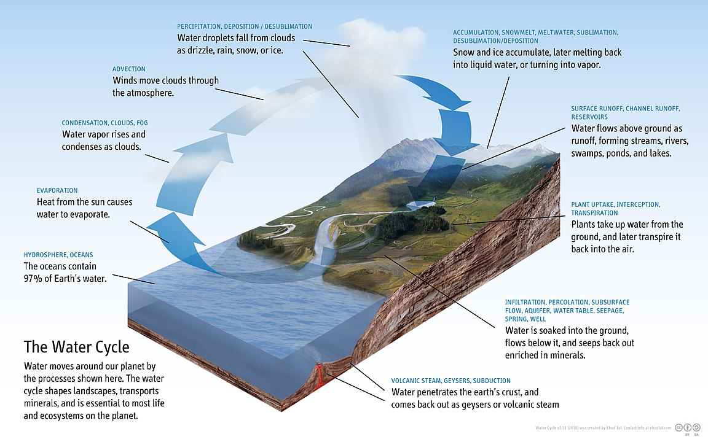
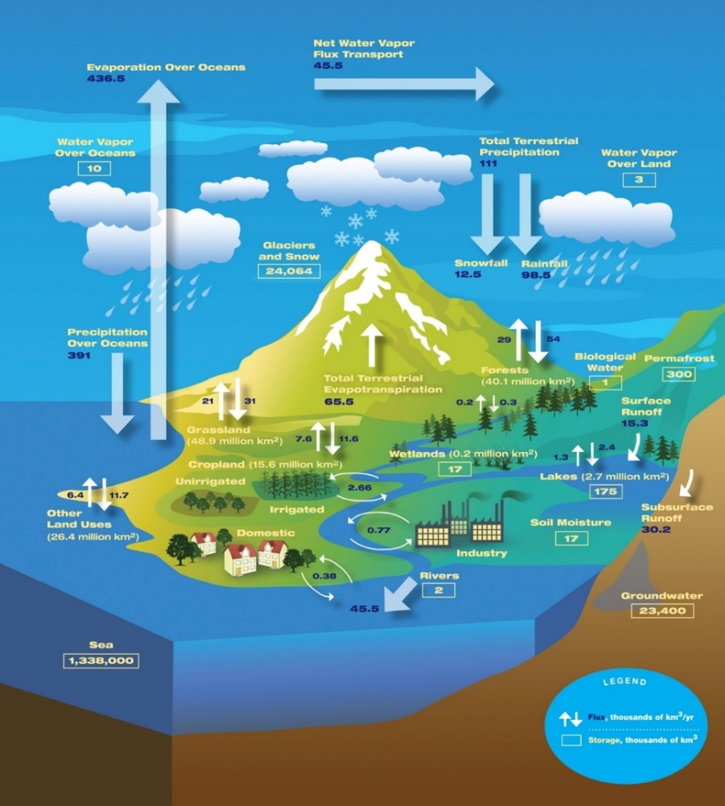
Figure A-1. Water cycle diagram. NASA/JPL Flickr (CC BY 2.0).
Figure A-2. Water Cycle diagram. Ehud Tal - Own work, CC BY-SA 4.0, https://creativecommons.org/licenses/by-sa/4.0.

Appendix B. Mid-Coast Water Planning Partnership Step Products, Process, and Participants

Step 1

Step 1 Products
Mid-Coast Water Planning Partnership Charter
Communication and Outreach Plan
Mid-Coast Water Planning Partnership Meeting Welcome Packet

Step 1 Process
The purpose of Step 1 according to the draft planning guidelines from the Oregon Water Resources Department is to build a collaborative and inclusive process. The Co-Conveners (City of Newport and Oregon Water Resources Department) assembled partners representing diverse interests to create a governance agreement (Charter) that described how the partners will collaborate and make decisions using consensus. A communication and outreach team developed a plan to ensure an open and inclusive process that fostered public participation.

Step 1 Participants
Record of Charter Signatories (2017 – 2022)

Step 2

Step 2 Products
Mid-Coast Water Resources Characteristics – Context (February 2018)
Mid-Coast Water Resources Characteristics – Water Quality (February 2018)
Mid-Coast Water Resources Characteristics – Water Quantity (February 2018)
Mid-Coast Water Resources Characteristics – Built Systems (February 2018)
Mid-Coast Water Resources Characteristics – Ecology (February 2018)
Step 2 Project Folder

Step 2 Process
The purpose of Step 2 according to the draft planning guidelines from the Oregon Water Resources Department is to gather information to develop a shared understanding of current water resources and identify gaps. The planning group assessed and described water resources in the planning area, looking at water quantity, quality, ecology and built systems. This effort included collecting and synthesizing existing information, identifying any gaps in knowledge, and working in four different study groups to generate the Step 2 reports in collaboration with GSI Water Solutions.

Step 2 Participants

Water Quality Study Group
- Jo Morgan, Oregon Department of Agriculture
- David Westgate, Lincoln Soil and Water Conservation District
- Tim Gross, City of Newport
- Cyndi Karp, Ecosystem Advocate
- Stephanie Reid, Lincoln City Public Works
- Lila Bradley, Lincoln City Public Works
- David White, Rogue Brewery
- Matt Thomas, Oregon Department of Forestry
- Leon Nelson, Beverly Beach Water District
- Martin Klinger, Panther Creek Water District
- Tyler Alexander, Oregon Farm Bureau
- Tim Miller, Oregon Farm Bureau
- Seth Barnes, Oregon Forest Industries Council
- Harmony Burright, Oregon Water Resources Department
- Paul Robertson, Robertson Environmental
- Heather Tugaw, Oregon Department of Environmental Quality
- Wayne Hoffman, MidCoast Watersheds Council and Lincoln Soil & Water Cons. Dist.
- Dave Wilson, Landowner
- John Sullivan, Landowner
- David Waltz, Oregon Department of Environment Quality

Water Quantity Study Group
- Adam Denlinger, Seal Rock Water District
- Margaret Matter, Oregon Department of Agriculture
- Harmony Burright, Oregon Water Resources Department
- Tim Gross, City of Newport
- Nikki Hendricks, Oregon Water Resources Department
- Mellony Hoskinson, Oregon Water Resources Department
- Kerri Cope, Oregon Water Resources Department
- Chris Kowitz, Oregon Water Resources Department
- Mike Thoma, Oregon Water Resources Department
- Leon Nelson, Beverly Beach Water District
- Wayne Hoffman, MidCoast Watersheds Council
- Tyler Anderson, Oregon Farm Bureau
- Martin Klinger, Panther Creek Water District
- Lani Hankins, Lincoln City
- John Stevenson, OSU, Oregon Climate Change Research Institute
- David Westgate, Lincoln Soil and Water Conservation District
- Alan Fujishin, Gibson Farms
- Caroline Bauman, Lincoln County Economic Development Alliance
- Heather Tugaw, Department of Environmental Quality

Ecology Study Group
- John Spangler, Oregon Department of Fish and Wildlife
- Mark Saelens, Lincoln County
- Wayne Hoffman, MidCoast Watersheds Council
- Joyce Sherman, RiverGraphics
- Jeanne Anstine, Newport Community Gardens
- Harmony Burright, Oregon Water Resources Department
- Martin Klinger, Panther Creek Water District
- Cyndi Karp, Ecosystem Advocate
- John Stevenson, OSU, Oregon Climate Change Research
- Stan van de Wetering, Confederated Tribes of the Siletz Indians
- Leon Nelson, Beverly Beach Water District

Built Infrastructure Study Group
- Adam Denlinger, Seal Rock Water District
- Preson Phillips, Oregon State Parks and Recreation Dept.
- Tim Gross, City of Newport
- Martin Klinger, Panther Creek Water District
- Harmony Burright, Oregon Water Resources Dept.
- Cyndi Karp, Ecosystem Advocate
- Scott Andry, City of Waldport
- Caroline Bauman, Economic Development Alliance of Lincoln County
- Leon Nelson, Beverly Beach Water District
- Lani Hankins, Lincoln City Public Works
- Jeanne Anstine, Newport Community Garden

Step 3

Step 3 Products
OWRD Water Rights Summary (October 2021)
OWRD Water Use Summary (October 2021)
ACOE Hydroclimatic Vulnerability Assessment (October 2020)
Step 3 Summary of Critical Issues and Supporting Information (September 2020)
2018-2020 Step 3 Self-Supplied Work Group Overview and Recap (September 2020)
2018-2020 Step 3 Municipal-Special District Work Group Overview and Recap (September 2020)
2018-2020 Step 3 Instream/Ecology Work Group Overview and Recap (September 2020)
StoryMap (Summary of Steps 2 and 3) (March 2020)
Oregon’s Kitchen Table Phase I Community Engagement Project Final Report (September 2019)
OCCRI Climate Projections (July 2019)
Step 3 Project Folder

Step 3 Process
The purpose of Step 3 according to the draft planning guidelines from the Oregon Water Resources Department is to identify how much water is needed to support current and future uses of water, to examine when and where supplies do not meet instream or out-of-stream needs/demands today, and to determine where existing supplies are likely to fall short in the future. Step 3 relied completely on the voluntary contributions of three working groups along with technical assistance provided by agency partners.

Step 3 Participants
Self-Supplied Water Users Work Group Participants (rural residents, agricultural water users, industrial users)
- Nikki Hendricks, Oregon Water Resources Department
- Alan Fujishin, Gibson Farms
- Paul Robertson, Robertson Environmental
- Audrey Sweet, Lincoln Soil and Water Conservation District
- Jo Morgan, Oregon Department of Agriculture
- Amy Chapman, Lincoln County Public Health
- Don and June Larson, Siletz Watershed Council
- Cyndi Karp, Ecosystem Advocate
- Harmony Burright, Oregon Water Resources Department
Municipal Water Providers and Special Districts Work Group Participants (municipalities or districts that provide water to residents, businesses, and industries in their service area)
- Tim Gross, City of Newport Public Works
- Adam Denlinger, Seal Rock Water District
- Stephanie Reid, City of Lincoln City Public Works
- Bradley Wynn, Seal Rock Water District
- Jim Tooke, City of Yachats City Councilor
- Ricky McClung, City of Yachats Public Works
- Scott Andry, City of Waldport Public Works
- Rod Cross, Mayor of Toledo
- Jay Macpherson, Oregon Health Authority
- Suzanne DeSzoeke, GSI Water Solutions
- Cyndi Karp, Ecosystem Advocate
- Harmony Burright, Oregon Water Resources Department
Instream/Ecology Work Group Participants (water for rivers, fish and wildlife, and other instream values)
- Emily Bell Dinan, Lincoln Soil and Water Conservation District
- Leo Williamson, Oregon Department of Forestry
- Don Andre, Oregon Coast Community Forest Association
- Evan Hayduk and Wayne Hoffman, Mid-Coast Watersheds Council
- Joyce Sherman, Stewards of Rocky Creek
- Bill Montgomery, Coastal Resident
- Mark Saelens, Lincoln County
- Penelope Kaczmarek, Coastal Resident
- Vince Mastropietro, Coastal Resident
- Paul Englemeyer, Coastal Resident
- Mike Broili, Coastal Resident
- Mark River and Maryanne Reiter, Weyerhaeuser
- John Spangler, Oregon Department of Fish and Wildlife
- Cyndi Karp, Ecosystem Advocate
- Rachel Lovellford, Oregon Department of Fish and Wildlife
- Harmony Burright, Oregon Water Resources Department

Step 4

Step 4 Products
Prioritization Compilation of Draft Strategies
Water Action Plan Implementation Table (Pages 65 – 90 of the Plan)
Oregon’s Kitchen Table Phase 2 Community Engagement Project Final Report (February 2022)

Step 4 Process
The purpose of Step 4 was to develop integrated solutions for meeting long-term instream and out-of-stream water needs. The Partnership hired a consulting team (Project Team) composed of Creative Resource Strategies, LLC, the Institute for Natural Resources, Oregon State University Extension, and Oregon Sea Grant to help develop an implementation plan consisting of a set of prioritized actions and strategies to meet the needs of regional water users in July 2020. During the fall of 2020, they convened the three working groups (self-supplied industrial, commercial, agricultural, and domestic water users, municipal-district water providers, and instream/ecological water needs) to further distill the key issues from Planning Step 3. November 2020 – early January 2021 the Partnership’s Planning Coordinator did outreach to MCWPP Charter Signatories to identify who was willing and able to develop the draft actions and strategies for review and input by the entire partnership. Partners that expressed interest were asked to re-sign the Charter affirming their commitment to the process moving forward and participation in at least 4 of the 8 90-minute planning sessions hosted by the Project Team in January and February to develop draft actions and strategies.
For the purposes of strategy development, the charter signatories used the informed consent decision making model. Using the informed consent model instead of consensus (agree or disagree) allowed the charter signatories to consider each other’s tolerance – will they accept and support a strategy even if it is not their preferred choice? Remote strategy development meetings were hosted with charter signatories on January 6, 13, 20, and 27, and February 3, 10, and 24 to develop 157 draft action strategies for Water Conservation and Efficient Use, Enhanced Regional Collaboration, Reliable Water Infrastructure and Operations, and Ecosystem Protection and Enhancement. The Project Team completed the development of draft actions with charter signatories by the end of February. The charter signatories also achieved informed consent on criteria to prioritize strategies (Tier 1, 2 and 3) at the end of February.
Each signatory was asked to individually prioritize the strategies and then a compilation of their prioritization efforts was shared with the broader Partnership. Once the highest priority actions were identified (Tier 1), the Project Team hosted planning meetings with the charter signatories on March 31, April 14, April 21, April 28, May 12, and May 19 to develop an implementation table for these actions (61 actions). The charter signatories and partners were given the month of June to review the work that had been done to date and provide their comments and edits. In July, the Project Team convened the charter signatories on three occasions (July 7, July 14, and July 28) to review all recommended edits, finalize core elements of the implementation table and finalize performance metrics. Step 4 was completed by August 2021. There is a page on the Partnership website that allows anyone to track the progress made in developing draft strategies for the Water Action Plan. Due to the COVID-19 pandemic all, of these convenings occurred remotely.

Step 4 Participants
Charter Signatories -
Strategy Development (Attended at least one meeting)
- Don, Andre, Oregon Coast Community Forest Association
- Jeanne Anstine, Newport Community Gardens
- Caylin Barter, Wild Salmon Center
- David Bayus, Johnson Creek Water Services Company
- Jennifer Beathe, Starker Forests, Inc.
- Shannon Beaucaire, City of Yachats
- Mike Broili, MidCoast Watersheds Council
- Harmony Burright, Oregon Water Resources Department
- Suzanne de Szoeke, GSI Water Solutions, Inc.
- Jacquie Fern, Oregon Department of Environmental Quality, Drinking Water Protection Program
- Alan Fujishin, Gibson Farms
- Timothy Gross, Civil West Engineering Services, Inc.
- Evan Hayduk, MidCoast Watersheds Council
- Jen Hayduk, Lincoln Soil and Water Conservation District
- Chris Janigo, City of Newport
- Penelope Kaczmarek, Interested citizen
- Jay MacPherson, Oregon Health Authority
- Tim Miller, Lincoln County Farm Bureau
- Bill Montgomery, Interested Resident
- Clare Paul, City of Newport
- Lisa Phipps, Department of Land Conservation and Development
- Paul Robertson, Robertson Environmental LLC
- Mark Saelens, Saelwood LLC
- Greg Scott, City of Yachats
- Billie Jo Smith, Interested citizen
- Matt Thomas, Oregon Department of Forestry
- David Waltz, Oregon Department of Environmental Quality, Nonpoint Source and Drinking Water Protection Programs
- Geoffrey Wilkie, Interested citizen
- Stan van de Wetering, Confederated Tribes of Siletz Indians
- Joe Moll, McKenzie River Trust
- Nikki Hendricks, Oregon Water Resources Department

Appendix C. Oregon Explorer Report Hyperlinks and Spatial Data Gaps

Mid-Coast Planning Area:
Re-run report url: https://tools.oregonexplorer.info/OE_HtmlViewer/index.html?viewer=midcoast&run=runMidcoastReport&reportID=midcoast:2021-10-29T195635-HVtkGwvj&useArchive=true
Snapshot report (10/29/21): https://tools.oregonexplorer.info/OE_HtmlViewer/index.html?viewer=midcoast&run=runMidcoastReport&snapshotID=midcoast:2021-10-29T195645-tVbDMMrn&useArchive=true

Alsea River Sub-Area:
Re-run report url: https://tools.oregonexplorer.info/OE_HtmlViewer/index.html?viewer=midcoast&run=runMidcoastReport&reportID=midcoast:2021-10-29T180549-c9nr8jaH&useArchive=true
Snapshot report (10/29/21): https://tools.oregonexplorer.info/OE_HtmlViewer/index.html?viewer=midcoast&run=runMidcoastReport&snapshotID=midcoast:2021-10-29T190700-wYHB4xQF&useArchive=true

Beaver Creek-Ocean Tributaries Sub-Area
Re-run report url: https://tools.oregonexplorer.info/OE_HtmlViewer/index.html?viewer=midcoast&run=runMidcoastReport&reportID=midcoast:2021-10-29T180928-oVz8C3cH&useArchive=true
Snapshot report (10/29/21): https://tools.oregonexplorer.info/OE_HtmlViewer/index.html?viewer=midcoast&run=runMidcoastReport&snapshotID=midcoast:2021-10-29T190852-xefW56dA&useArchive=true

Depoe Bay-Ocean Tributaries Sub-Area:
Re-run report url: https://tools.oregonexplorer.info/OE_HtmlViewer/index.html?viewer=midcoast&run=runMidcoastReport&reportID=midcoast:2021-10-29T181930-QwoUi1HO&useArchive=true
Snapshot report (10/29/21): https://tools.oregonexplorer.info/OE_HtmlViewer/index.html?viewer=midcoast&run=runMidcoastReport&snapshotID=midcoast:2021-10-29T193820-yyCRRkmc&useArchive=true

Salmon River Sub-Area:
Re-run report url: https://tools.oregonexplorer.info/OE_HtmlViewer/index.html?viewer=midcoast&run=runMidcoastReport&reportID=midcoast:2021-10-29T182156-XERqzmNQ&useArchive=true
Snapshot report (10/29/21): https://tools.oregonexplorer.info/OE_HtmlViewer/index.html?viewer=midcoast&run=runMidcoastReport&snapshotID=midcoast:2021-10-29T194155-uePEsr3G&useArchive=true

Siletz Bay-Ocean Tributaries Sub-Area:
Re-run report url: https://tools.oregonexplorer.info/OE_HtmlViewer/index.html?viewer=midcoast&run=runMidcoastReport&reportID=midcoast:2021-10-29T182659-gPBHXFqL&useArchive=true
Snapshot report (10/29/21): https://tools.oregonexplorer.info/OE_HtmlViewer/index.html?viewer=midcoast&run=runMidcoastReport&snapshotID=midcoast:2021-10-29T194442-zwQOLOEq&useArchive=true

Siletz River Sub-Area:
Re-run report url: https://tools.oregonexplorer.info/OE_HtmlViewer/index.html?viewer=midcoast&run=runMidcoastReport&reportID=midcoast:2021-10-29T183000-zvv3ccgn&useArchive=true
Snapshot report (10/29/21): https://tools.oregonexplorer.info/OE_HtmlViewer/index.html?viewer=midcoast&run=runMidcoastReport&snapshotID=midcoast:2021-10-29T194710-0NXavHXA&useArchive=true

Yachats River-Ocean Tributaries Sub-Area:
Re-run report url: https://tools.oregonexplorer.info/OE_HtmlViewer/index.html?viewer=midcoast&run=runMidcoastReport&reportID=midcoast:2021-10-29T183212-h5ciIt8R&useArchive=true
Snapshot report (10/29/21): https://tools.oregonexplorer.info/OE_HtmlViewer/index.html?viewer=midcoast&run=runMidcoastReport&snapshotID=midcoast:2021-10-29T194957-OuXTgylm&useArchive=true

Yaquina River Sub-Area:
Re-run report url: https://tools.oregonexplorer.info/OE_HtmlViewer/index.html?viewer=midcoast&run=runMidcoastReport&reportID=midcoast:2021-10-29T183421-sAE9wxAE&useArchive=true
Snapshot report (10/29/21): https://tools.oregonexplorer.info/OE_HtmlViewer/index.html?viewer=midcoast&run=runMidcoastReport&snapshotID=midcoast:2021-10-29T195311-7IfIXtgo&useArchive=true

Spatial Data Gaps

The following questions were not addressed using the Mid-Coast Water Planning Map Viewer because datasets were not available or complete for the Mid-Coast planning area.

Context:
- What are the major sources of water?
Although we have a statewide hydrography dataset, we don’t know the extent to which these rivers are used as a source.

- What institutions manage, oversee, and/or regulate water?
There is not a spatial dataset that identifies the water management responsibilities for each stream segment or groundwater source. In addition, a spatial dataset of water districts does not exist.

Water Quantity:
- Are there known conflicts or concerns with surface water allocation?
There is not a spatial dataset that identifies the water management conflicts or concerns with surface water allocation (or groundwater source).

Water Quality:
- What do we know about groundwater quality and are there concerns?
- Is our water safe for humans to drink/consume?
- Is our water safe for recreational contact?
- Is our water safe for fish and wildlife?
The only dataset we have for groundwater are the DEQ Groundwater Management Areas, but this dataset does not include information about quality. This dataset does represent groundwater areas of concern, but not all areas of concern. There is not a spatial dataset that identifies the safety of water sources for human consumption, recreational and environmental uses (fish and wildlife) because these are often temporal issues. We can report on the parameters assessed by DEQ, but they are not comprehensive to specifically answer these questions.
Water Use:
- Who is currently required to measure and publicly report their groundwater water use?
- How much is groundwater is used? When?
- Who uses groundwater, and who are the biggest users?
- Where does drinking water come from (community water systems (public or private) and self-supplied water)?
- What infrastructure is there to store, direct, and convey water?
- What is the status/condition of water infrastructure?
- Where are the priorities for restoring streamflows?
County level water use summaries for surface water are available for the state, but they are not available for specific locations within the county in a spatial format. In addition, the infrastructure datasets are limited to fish passage barriers, reservoirs, tidegates and dams. These datasets do not include attributes of condition. We do not have data for water conveyance and other infrastructure within the Mid-Coast planning area. The datasets we have for groundwater are the DEQ Groundwater Management Areas and OWRD observation wells, but these datasets do not include comprehensive information about use throughout the Mid-Coast or who is required to measure and report.
Natural Hazards:
- What natural hazards could affect water supplies?
- What climate change stressors could affect water supplies?
Although we have spatial datasets that pertain to landslides, tsunami zones, wildfire risk, flood hazards, the datasets do not include a direct relationship to their impacts on existing water supplies. In addition, we do not have a comprehensive dataset of all the water supplies in the Mid-Coast. As for the question about potential climate change stressors in the Pacific Northwest that could affect water supplies, some general statements can be made: increased rates of transpiration from vegetation and evaporation from lakes and reservoirs due to projected rising temperatures could reduce the available water supply in later summer and early fall; Generally drier surface conditions in summer, again due to increased evaporation rates, and higher temperature could increase the likelihood of wildfire and the threats to water supplies that large fires bring; The more intense precipitation projected to occur during the rainy season could lead to increased erosion and higher turbidity during heavy rainfall events. However, there are no spatial datasets that link these regional projections to changes in water quantity or quality of particular water supplies in the Mid-Coast.

Watershed Health
- Where are the riparian areas?
- What restoration has addressed floodplain function?
There is not a comprehensive spatial dataset that identifies riparian areas. We do have Oregon Watershed Restoration Inventory (OWRI) data on where riparian restoration projects have been conducted with OWEB funding (and voluntarily reported funding from other sources), but the reporting is not specific to floodplain function improvements.

Appendix D. Crosswalk of the Mid-Coast Water Planning Partnership Plan Actions with Other Important Regional Conservation Initiatives
- Final Endangered Species Act Recovery Plan for Oregon Coast Coho Salmon (2016) (Oncorhynchus kisutch). The goal of this plan is to improve the viability of Oregon Coast Coho, and the ecosystems upon which it depends, to the point that they no longer require Endangered Species Action protection. The recovery direction for Oregon Coast Coho Salmon is to protect and restore the freshwater and estuarine rearing habitats that support juvenile survival and overall productivity.
- Lincoln County Multi-Jurisdictional Natural Hazards Mitigation Plan (2015, revised 2017). This plan describes priority natural hazards of concern to the Mid-Coast region, including coastal erosion, drought, earthquakes, floods, landslides, tsunamis, wildfire, windstorms, and winter ice. Although there is no direct relationship to the actions within the Mid-Coast Water Planning Partnership Water Action Plan, any efforts that reconnect floodplains, restore stream flow, and restore riparian areas will enhance resilience of the Mid-Coast region to climate change stressors and several natural hazards. In addition, three actions within this plan have a nexus with natural hazards.
- Lincoln County Climate Action Plan (2020). This plan emphasizes water supply resiliency measures that reduce water use by developing focused, interrelated water conservation measures, regulations, education, and incentives.
- Oregon Watershed Enhancement Board Focused Investment Partnership goals (as they related to Aquatic Habitat for Native Fish Species and Coho Habitat and Populations Along the Coast). The Oregon Watershed Enhancement Board Focused Investment Priority for Inland Aquatic Habitat for Native Fish Species guides voluntary actions that address limiting factors related to the protection and restoration of the watershed functions and processes in this habitat type. Initiatives within this priority identify the primary limiting factors outlined in associated federal recovery, state conservation, or tribal plans that the initiative is aiming to address, and are guided by the habitat and population objectives and conservation approaches set forth in these plans. Focal areas for this priority are defined as those native fish habitats in Oregon that are identified as priorities in associated federal recovery, state conservation, or tribal plans. Voluntary restoration and conservation actions are especially encouraged in locations where investments will also address identified non-point source water quality concerns.

 |  | MCWPP MID-COAST WATER ACTION PLAN STRATEGIES
ENDANGERED SPECIES ACTION FEDERAL COHO RECOVERY PLAN ACTIONS | MCS-1 (Tributaries), MCS-21 and MCS-22 (Mainstems): Increase harvest buffers on private industrial timberlands, reduce road densities on private and federal timberlands. | 46
 | MCS-7 and MCS-8 (Tributaries), MCS-31 and MCS-32 (Mainstems): Conduct riparian planting projects on streams in agricultural lands. | 50, 52
 | MCS-11 and MCS-13 (Tributaries), MCS-29 (Mainstems): Develop water conservation strategies for municipal and irrigation water withdrawals to improve water quality. | 6, 7,
 | MCS-12 and MCS-14 (Tributaries): Improve water quality by improving stream shade, and substrate retention. | 50, 52
 | MCS-17 and MCS-18 (Off-channel and wetlands): Increase beaver pond abundance. | 5, 45, 51
 | MCS-19 and MCS-20 (Wetlands): Reduce existing/limit channel-confining structures, including roads and infrastructure, in the floodplain that disconnect wetlands from tributaries. | 50
 | MCS-25 and MCS-26 (Mainstems): Increase large wood and marginal and streambank habitat structure. | 50, 52
 | MCS-27 (Mainstems): Develop water conservation strategies for municipal and irrigation water withdrawals. | 24
 | MCS-28 and MCS-30 (Mainstems): Improve water quality by improving stream shade, and substrate retention. | 50, 52
 | MCS-35 (Estuary): Identify sources of water pollution and develop strategies to reduce pollutants in water discharges. | 13
OREGON WATERSHED ENHANCEMENT BOARD FOCUSED INVESTMENT PARTNERSHIP (AQUATIC HABITAT STRATEGIES) | Reconnect Floodplains | 46, 47, 51
 | Restore Stream Flow | 46, 47, 52, 53, 54, 55, 56, 57
 | Restore Habitat in Stream Channels | 46, 47, 48, 49, 50, 52
 | Road Repair or Decommission | 50
 | Riparian Restoration | 46, 47, 48, 49, 50, 52
 | Supporting Healthy Habitats | 33, 36, 39, 40, 41, 45, 46, 47, 48, 49, 50, 51, 52, 53, 54, 55, 56, 57, 58, 59, 60, 61
 | Control Invasive Weeds | 58
 | Easements and Acquisitions | 41, 60
 |  |  | MCWPP MID-COAST WATER ACTION PLAN STRATEGIES
INCOLN COUNTY CLIMATE ACTION PLAN STRATEGIES | Public outreach and education |  | 1
 | Metered water fixtures / conservation solutions |  | 3, 4, 6, 7, 14, 15, 24, 25, 26
 | Rainwater harvesting systems |  | 22
 | Incorporate water conservation features in new construction |  | 61
 | Water audits and feasibility studies |  | 2
 | Cost-share incentives |  | 25
 | Educational curriculum for students and citizens |  | 1
 | Incorporate green infrastructure |  | 5, 8
 | Protect healthy landscapes |  | 12, 16, 17, 18, 19, 20, 21, 40, 41, 43, 45, 46, 47, 48, 49, 50, 51, 52, 53, 54, 55, 56, 57, 58, 59, 60, 61
 | Restore degraded landscapes |  | 13
LINCOLN COUNTY MULTI-JURISDICTIONAL NATURAL HAZARDS MITIGATION PLAN | The Lincoln County Multi-Jurisdictional Natural Hazards Mitigation Plan describes priority natural hazards of concern to the Mid-Coast region, including coastal erosion, drought, earthquakes, floods, landslides, tsunamis, wildfire, windstorms, and winter ice. |  | 9, 10, 11, 50

Appendix E. Water Providers by Population Served and Connections
There are 52 water providers in the Mid-Coast region that deliver water to resident population of 60,877 people through 24,299 connections. Map of Drinking Water Source Areas (https://spatialdata.oregonexplorer.info/geoportal/details;id=6a1ec8dd8b6844838cc501c57b6a2c27).
Alsea
- Fall Creek Water District
Blodgett
- Bless Your Heart Baking and Cafe
- Fir Ridge Campground
Depoe Bay
- City of Depoe Bay
Gleneden Beach
- Kernville-Gleneden-Lincoln Beach Water District
Lincoln City
- Lincoln City Water District
- Oregon Parks and Recreation Department HB Van Duzer State Park
- Lower Siletz Water System
- Calkins Acres Improvement Inc.
​Newberg
- Sea Crest
​Newport
- City of Newport
- Oregon Parks and Recreation Department Ellmaker State Park
- Oregon Parks and Recreation Department Beverly Beach State Park
- Beverly Beach Water District
- Otter Rock Water District
- Bay Hills Water Association
- Carmel Beach Water District
- Lincoln County Parks - Moonshine Park
- Mad Dog Country Tavern
- Sawyers Landing RV Park

Otis
- Hiland WC - Echo Mountain, Boulder Creek, Bear Creek
- Westwind Stewardship Group
- Otis Junction Water system
- Salmon River Mobile Village
- Salmon River RV Park
- Lincoln City KOA
- Guptil Subdivision
Otter Rock
- Johnson Creek Water Service
- Inn at Otter Crest
Reedsport
- US Forest Service Cape Perpetua Visitor Center

Rose Lodge
- Hiland WC - Riverbend​
Seal Rock
- Seal Rock Water District
Sheridan
- Drift Creek Camp
Siletz
- City of Siletz
Tidewater
- Hiland WC - Westwood
- US Forest Service Blackberry Campground
Toledo
- Toledo Water Utilities
- Eddyville Charter School
- Olalla Valley Golf Course
Waldport
- City of Waldport
- Kozy Acres Water System
- Drift Creek Landing
- Taylors Landing RV Park
- Riverside Mobile Park
- King Silver RV Park
- Rovers RV Park
- Happy Landing RV Park/Marina
Yachats
- Southwest Lincoln County Water PUD
- City of Yachats

Appendix F. Issues Identified During Collaborative Planning but not Carried Forward
The following are issues that were identified, during plan development, that were not carried forward for one or more reasons, including:
- They were not considered as high a priority as other issues that were addressed during the planning process.
- This voluntary planning partnership was not the most appropriate venue to address the issues.
- Other entities in the region have responsibilities for addressing.
They include:
Water Quantity  - Water Quantity for Navigation  - Forest Management for Water Quantity  - Limited Storage Capacity (Built and Natural)  Water Quality  - Beach Water Quality  - Water Quality for Consumption of Fish and Shellfish  - Water Quality for Aquaculture and Shellfish Production  - Wastewater Treatment Capacity and Overflows  - Septic System Maintenance and Water Quality  - Biosolids Application and Water Quality (Stream Health and Drinking Water)  - Pesticide Application and Drinking Water Quality  - Emerging Contaminants of Concern (PFAs, pharmaceuticals, plastics)  - Harmful Algal Blooms  Watershed Health  - Fish Passage Barriers  - Channel Modification and Habitat Complexity | Infrastructure  - Failing Septic Systems and Water Quality  - Fish Passage Barriers  - Channel Modification and Habitat Complexity  - Relationship Between Built Infrastructure and Ecological Processes  Natural Hazards and Vulnerabilities  - Cascadia Earthquake Water Supply Resiliency and Readiness  - Drought Planning and Resiliency  Climate Change  - Reduced Water Quantity to Meet Multiple Competing Water Needs  - Increased Water Temperature  Reducing Water Quality for Multiple Water Uses  - Increased Winter Storms and Flooding Events Threatening Infrastructure  - Sea Level Rise Impacts on Points of Diversion  - Sea Level Rise Impacts on Estuaries  - Increased Frequency of Forest Fires

Appendix G. Oregon’s Mid-Coast Estuaries
Salmon River Estuary. This is classified as a Natural Estuary and has little residential, commercial, and industrial development. The entire estuary and its associated wetlands are part of the Cascade Head Experimental Forest and Scenic Research Area, which is owned and managed by the US Forest Service. The entire Cascade Head area is 11,890 acres; the estuary comprises 205 acres.
Areas of Ecological Importance and Critical Habitat Designations: Habitat areas include wetlands, mudflats, emergent herbaceous wetlands, and intertidal marsh. The estuary provides transitional habitat between freshwater and saltwater for upstream spawning migrations for anadromous fish and rearing areas for juveniles and smolts. The Salmon River Estuary is part of the Salmon River Estuary-Cascade Head Conservation Opportunity Area.
Species of Interest: In addition to providing habitat for salmon, the Salmon River Estuary was nominated as an Important Bird Area for brown pelican, bald eagle, and peregrine falcon, and for its abundance of shorebirds, including western sandpipers.
Siletz Bay Estuary. Siletz Bay is classified as a Conservation Estuary by the Oregon Land Conservation and Development Department. It lacks jetties or channels, but is near Lincoln City, which has altered some of the shoreline near the estuary. The US Fish and Wildlife Service (USFWS) manages a 568-acre portion of the bay as a national wildlife refuge, which includes coastal conifer and hardwood forest, estuarine tidelands, and freshwater riparian habitats. The estuary was formerly diked to drain land for raising dairy cows. The USFWS is managing the refuge to allow the salt marsh to return to its natural state, where tides inundate the refuge twice daily. The Siletz Bay is a Conservation Opportunity Area.
Species of Interest: The Siletz Bay Wildlife Refuge provides nursery habitat for coho and Chinook Salmon, Steelhead and Cutthroat Trout, and other anadromous species. Spring Chinook usually arrive to the refuge in May, and American shad arrive between late April to the end of May. The refuge is also home to red-tailed hawks, bald eagles, barn owls, red-shouldered hawks, ospreys, turkey vultures, merlins, and peregrine falcons as well as estuary-dependent birds, including great blue herons, great egrets, Virginia rails, eared grebes, brown pelicans, buffleheads, common mergansers, wood ducks, northern shovelers, American wigeon, green-winged teals, and double-crested cormorants. Mammals at the refuge include Roosevelt elk, black-tailed deer, harbor seals, mink, river otter, muskrat, and beaver. Siletz Bay has native, common eelgrass as well as exotic Zostera japonica, which was introduced with non-native oysters.
Depoe Bay Estuary. Depoe Bay estuary is about 25 acres and is classified as a Shallow-Draft Development Estuary. The estuary is landlocked, with the exception of the harbor entrance, which was developed to support fishing, tourism, lumber, and agriculture. The bay supports bald eagle nesting sites and black oystercatchers, among other species. Depoe Bay is a Conservation Opportunity Area.
Yaquina Bay Estuary. Yaquina Bay is a 4,300-acre estuary located in the City of Newport. It is classified as a Development Estuary. Current human uses of Yaquina Bay include fishing and fish processing, logging, shipping, tourism, aquaculture, and agriculture. The estuary has been dredged and filled at several locations to support these uses and to allow for development. Oregon State Parks owns the Yaquina Bay State Recreation Site, a 32-acre parcel of land overlooking the mouth of Yaquina Bay. There are large, cultivated shellfish operations in the Yaquina estuary.
Areas of Ecological Importance and Critical Habitat Designations: Yaquina Bay is listed as critical habitat for Green Sturgeon. Yaquina Bay State Recreation site is a spruce and pine forested bluff. Lower Yaquina Bay has little freshwater influence and is popular for shellfish harvesting. The Wetlands Conservancy has identified high salt marsh, tidal Sitka spruce swamp, and non-tidal Sitka spruce swamp as the highest priorities for habitat restoration. The estuary also has eelgrass beds, and nesting eagles and osprey. Spruce swamps are located in the upper estuary along Elk Creek and Little Elk Creek and areas for potential restoration of high salt marsh are located in Boone Slough and Nute Slough. Currently, there is an eelgrass mitigation project in the eastern portion of Marina Bed. Yaquina Bay is a Conservation Opportunity Area.
Alsea Bay Estuary. Alsea Bay is designated as a Conservation Estuary, is one of only six estuaries in Oregon that is managed for conservation under the Coastal Zone Management Act, and does not have jetties at the ocean entrance. Recreational fishing and clamming are allowed in Alsea Bay and species present include cockles and purple varnish clams, softshell clams, and Dungeness crabs. There are two public boat launches at Alsea Bay, including the Port of Alsea boat launch and McKinley’s Marina.
Species of Interest: Alsea Bay supports Green Sturgeon as well as a diversity of other species.
Areas of Ecological Importance and Critical Habitat Designations: The east side of Alsea Bay has more than 400 acres of undisturbed marsh habitat and additional marsh habitat in the lower reaches of Drift Creek, a Forest Ecosystem Management Assessment Team (FEMAT)-designated key watershed. Additional tidal high marsh habitat that is recovering from previous grazing disturbance is found west of Barclay Meadows and east of Eckman Lake. The Bayview Oxbow has about 150 acres of diked former tidal marsh. Barclay meadows contains small areas of diked former tidal marsh. Bain Slough is a forested wetland located at River Mile 9 that has well-developed remnant tidal channels. A tidegate, ditching, and residential development all reduce tidal influences at Bain Slough, which was likely a spruce tidal swamp at one time. Alsea Bay has been identified as a Conservation Opportunity Area.
Yachats River Estuary. Yachats River Estuary is about 40 acres, is a minor estuary, and is classified as a Conservation Estuary. The Yachats River Estuary is part of the Yachats River Area Conservation Opportunity Area. It is a designated Important Bird Area of Oregon and includes marbled murrelet and spotted owl nesting sites.

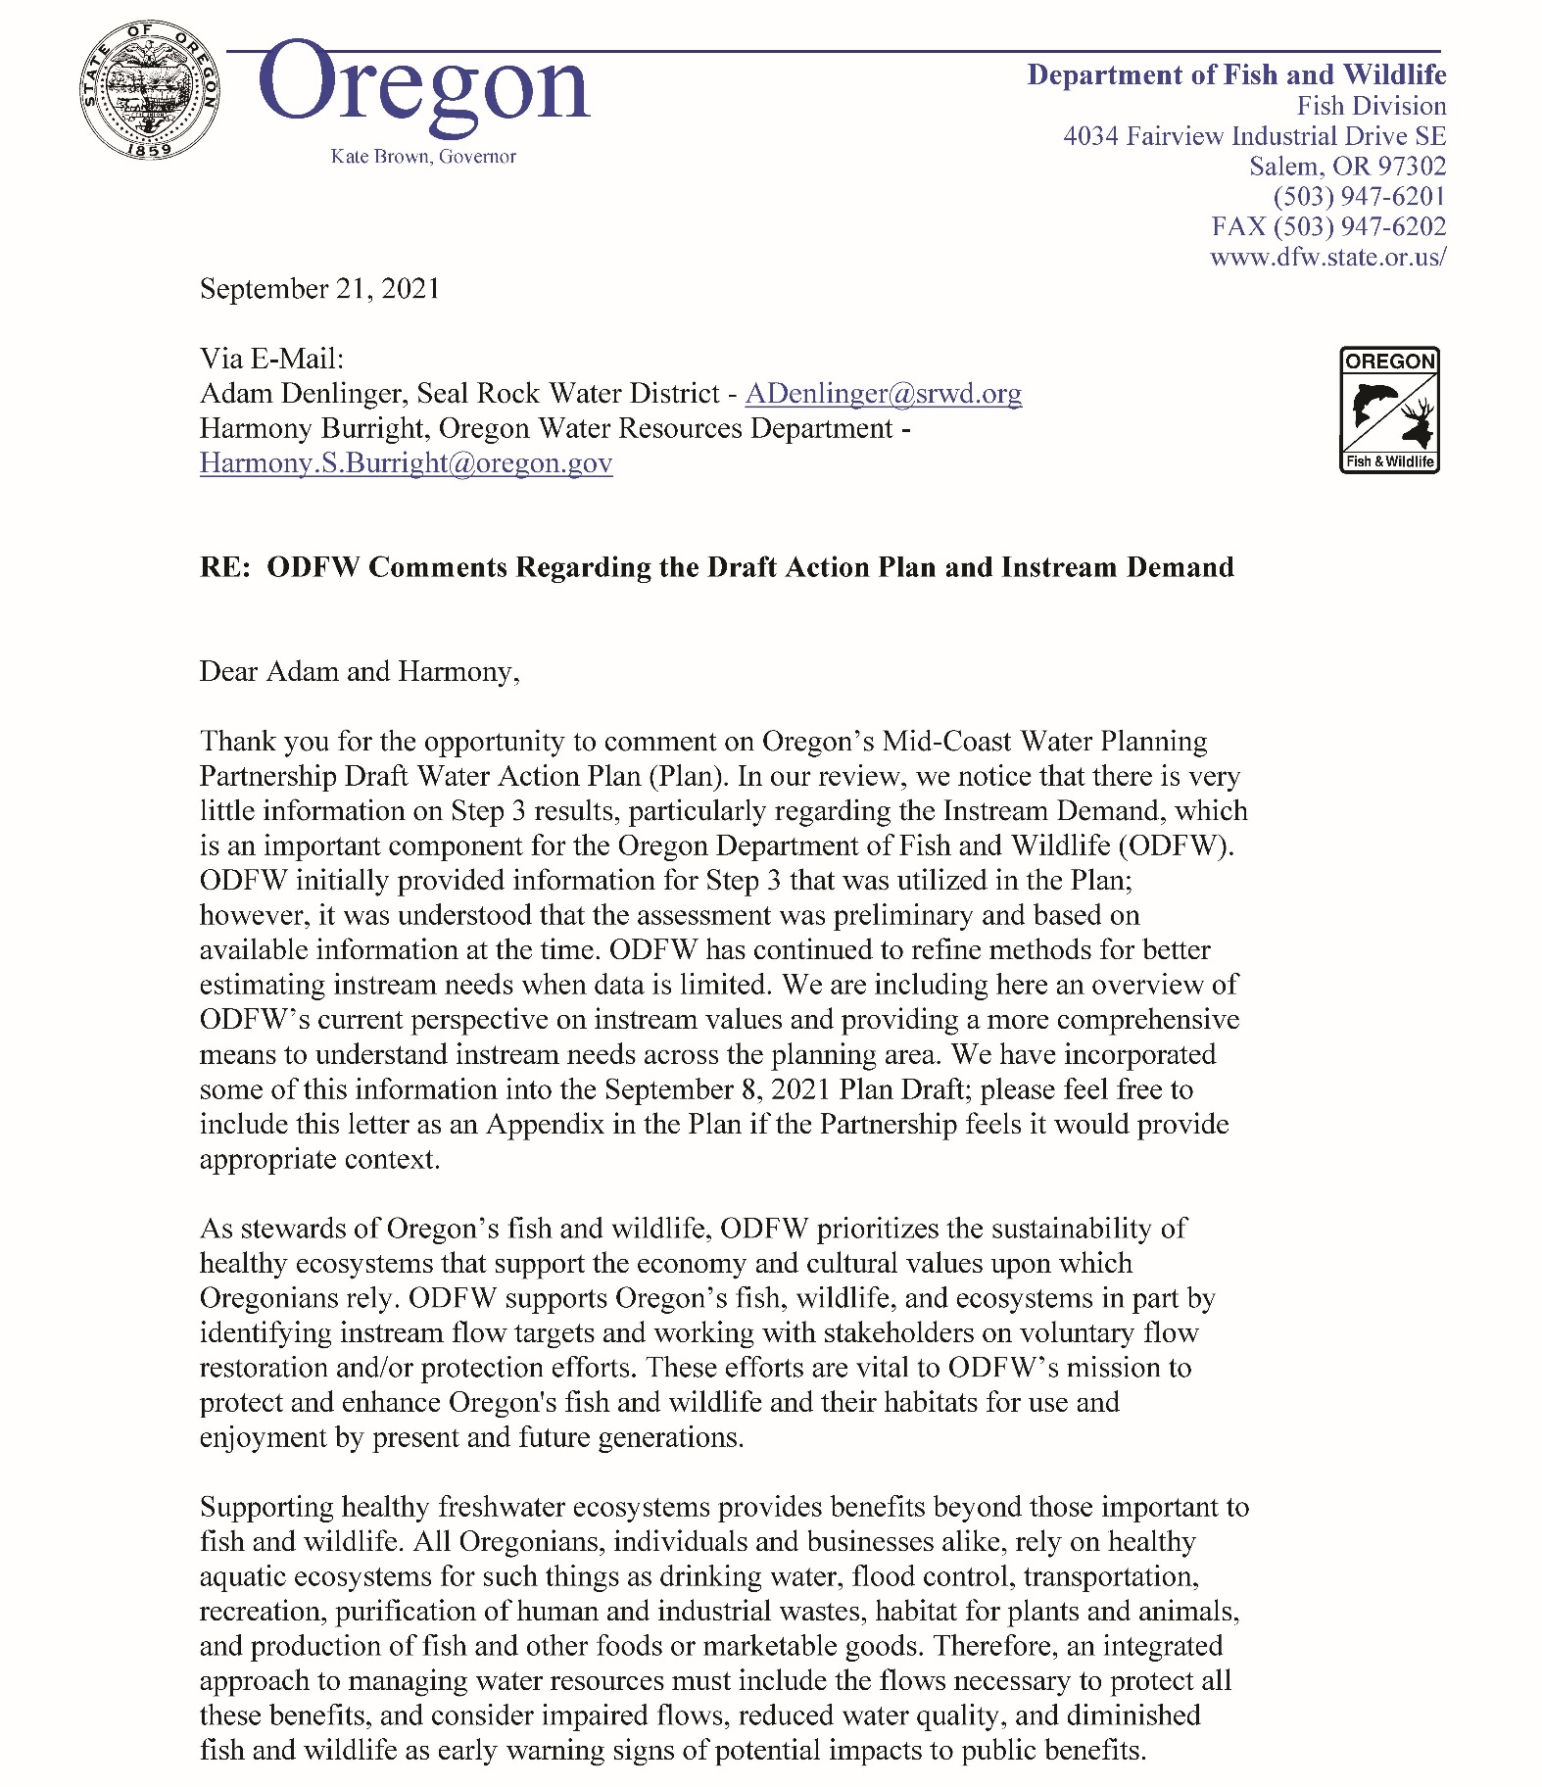
Appendix H. ODFW Comments Regarding the Draft Action Plan and Instream Demand
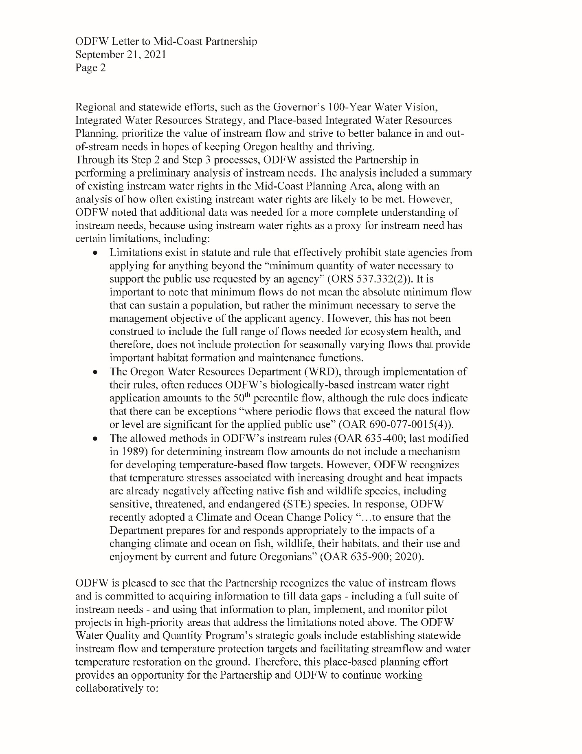
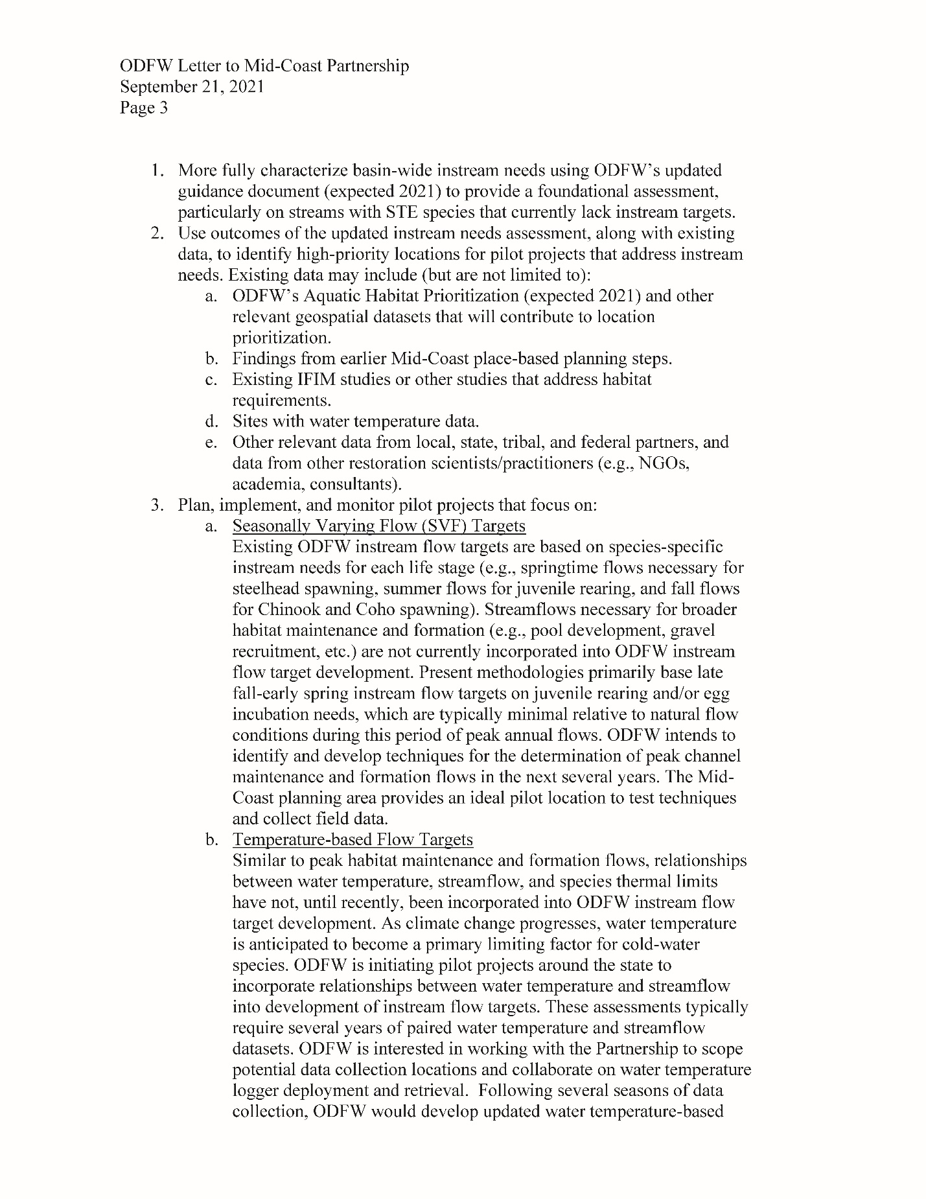

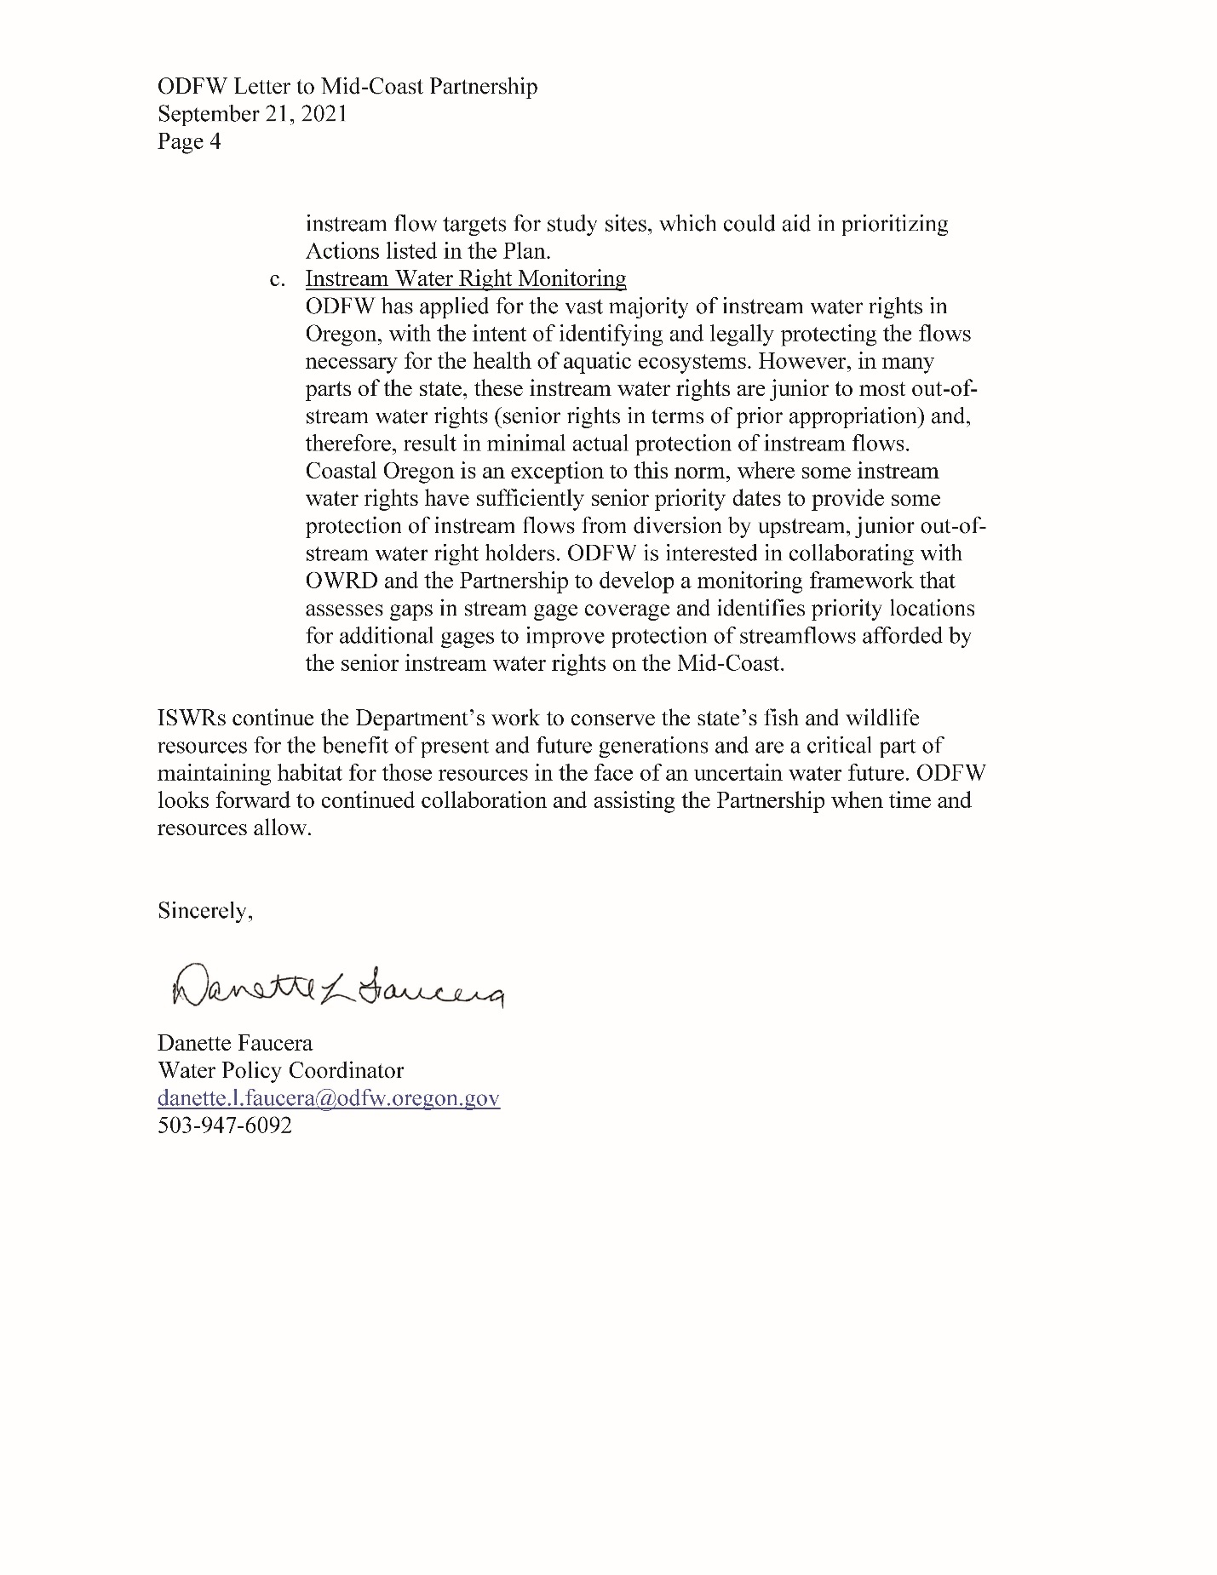
Appendix I. Water Use and Availability Summaries by Sub-Area
This section includes a high-level summary of water use and availability for each of the eight sub-areas in the Mid-Coast planning area. Summaries of water use by sub-area as well as water availability by water availability basin can be found in the Water Use Summary produced by the Oregon Water Resources Department (OWRD, 2021), the StoryMap generated by the Mid-Coast Water Partners or via an interactive data explorer. Methods and calculations can be found in the Water Use Summary produced by the Department (OWRD, 2021).Most data reproduced in the tables below were derived from the Oregon Water Resources Department Water Availability Reporting System accessed in 2019.
Each summary includes a table summarizing water supply, uses, and availability. The table includes the following columns:
- WAB ID = Water Availability Basin Identifier
- Drainage Area Description
  - Blue highlighted drainage areas discharge directly to a bay or the ocean and are considered “ocean tributaries.” Those that are not highlighted are tributaries to rivers or streams.
- Estimated Annual Supply based on 50% exceedance values in the Water Availability Reporting System, represented in acre feet
- NF in SEP = Natural Flow in September – approximated using the 50% exceedance values developed through the Water Availability Reporting System
- % of NF Consumed in Sep = Percent of Natural Flow (calculated at 50% exceedance) consumed in September
- Types of Use = the types of use identified in the Water Availability Reporting System
  - MUN = Municipal, COM = Commercial, AGR = Agricultural, DOM = Domestic, IND = Industrial, IRR = Irrigation, STO = Storage, OTH = Other
- ISWR = Instream Water Right – Indicates presence or absence of instream water right but does not indicate effectiveness
- Months Water is Available = the number of months that water is available according to the Water Availability Reporting System
- Water Available in SEP = whether water is available at 80% exceedance in the month of September, the most supply limited month
- Storage Water Available = whether water is available at 50% exceedance any of the 12 months
WAB ID | Drainage Area Description | Estimated Annual Supply (50% Exceedance) | NF in SEP (50% Exceedance) | % of NF Consumed in SEP | Types of Use | ISWR | Months Water is Available | Water Available in SEP | Storage Water Available

Table 1. Water supply, uses, and availability in the Salmon River sub-area
WAB ID | Drainage Area Description | Estimated Annual Supply (50% Exceedance) | NF in SEP (50% Exceedance) | % of NF Consumed in SEP | Types of Use | ISWR | Months Water is Available | Water Available in SEP | Storage Water Available
492 | SALMON R> PACIFIC OCEAN- AT MOUTH | 260,000 afy | 47.9 cfs | 2% | DOM, IND, IRR, STO | Yes | 4 (DEC, JAN, FEB, MAR) | No | Yes
71395 | SALMON CR > SALMON R – AT MOUTH | 10,100 afy | 1.31 cfs | 3% | DOM, IRR | Yes | 0 | No | Yes
71391 | DEER CR > SALMON R – AT MOUTH | 7,570 afy | 1.43 cfs | 2% | DOM, IRR | Yes | 0 | No | Yes
72002 | PANTHER CR > SALMON R – AT MOUTH | 5,590 afy | 0.64 cfs | 7% | DOM | Yes | 0 | No | Yes
31820436 | SALMON R > PACIFIC OCEAN – AB DEER CR AT GAGE 14303750 | 224,000 afy | 41.6 cfs | 2% | DOM, IND, IRR, STO | Yes | 4 (DEC, JAN, FEB, MAR) | No | Yes
71388 | BEAR CR > SALMON R – AT MOUTH | 14,200 afy | 1.76 cfs | 6% | DOM, IND, IRR | Yes | 0 | No | Yes
72001 | SALMON R> PACIFIC OCEAN- AB SLICK ROCK CR | 132,000 afy | 23.5 cfs | <1% | DOM, IRR | Yes | 4 (DEC, JAN, FEB, MAR) | No | Yes
72003 | SULPHUR CR> SALMON R- AT MOUTH | 3,190 afy | 0.23 cfs | 13% | DOM | Yes | 0 | No | Yes
511 | SLICK ROCK CR> SALMON R- AT MOUTH | 57,300 afy | 12.9 cfs | 1% | DOM | Yes | 0 | No | Yes

Table 2. Water supply, uses, and availability in the Siletz Bay-Ocean Tributaries sub-area
WAB ID | Drainage Area Description | Estimated Annual Supply (50% Exceedance) | NF in SEP (50% Exceedance) | % of NF Consumed in SEP | Types of Use | ISWR | Months Water is Available | Water Available in SEP | Storage Water Available
31820403 | LOGAN CR > PACIFIC OCEAN - AT MOUTH | 1,500 afy | 0.33 cfs | 32% | DOM | No | 12 (ALL) | Yes | Yes
31820425 | D R > PACIFIC OCEAN - AT MOUTH | 37,400 afy | 16 cfs | 33% | MUN, DOM, IRR, STO | No | 12 (ALL) | Yes | Yes
31820426 | UNN STR > DEVILS L - AT MOUTH | 594 afy | 0.1 cfs | 0% |  | No | 12 (ALL) | Yes | Yes
31820427 | UNN STR > DEVILS L - AT MOUTH | 3,830 afy | 1.2 cfs | 4% | DOM | No | 12 (ALL) | Yes | Yes
72004 | ROCK CR > DEVILS L - AT MOUTH | 15,700 afy | 6.7 cfs | 56% | MUN, DOM | No | 0 | No | No
31820437 | ROCK CR > DEVILS L - AB UNN STR AT GAGE 14303800 | 9,020 afy | 3.6 cfs | 66% | MUN, DOM, IRR | No | 0 | No | No
495 | SCHOONER CR > SILETZ BAY - AT MOUTH | 69,300 afy | 17.5 cfs | >100% | MUN, DOM, STO | Yes | 0 | No | Yes
31820438 | SCHOONER CR > SILETZ BAY - AB ABRAMS CR AT GAGE 14303950 | 55,400 afy | 13.8 cfs | >100% | MUN, DOM | No | 4 (DEC, JAN, FEB, MAR) | No | Yes
446 | DRIFT CR > SILETZ BAY - AT MOUTH | 126,000 afy | 24.1 cfs | 39% | MUN, DOM, IRR | Yes | 2 (FEB, MAR) | No | Yes

Table 3. Water supply, uses, and availability in the Siletz River sub-area
WAB ID | Drainage Area Description | Estimated Annual Supply (50% Exceedance) | NF in SEP (50% Exceedance) | % of NF Consumed in SEP | Types of Use | ISWR | Months Water is Available | Water Available in SEP | Storage Water Available
31820404 | SIJOTA CR > SILETZ BAY - AT MOUTH | 2,460 afy | 1.07 cfs | 8% | DOM, IRR | No | 12 (ALL) | Yes | Yes
498 | SILETZ R > SILETZ BAY - AT MOUTH | 1,040,000 afy | 158 cfs | 43% | MUN, DOM, IND, IRR, AGR, STO, OTH | Yes | 8 (JAN, FEB, MAR, APR, MAY, JUN, NOV, DEC) | No | Yes
71389 | BEAR CR > SILETZ R - AT MOUTH | 9,800 afy | 2.82 cfs | 0% | None | Yes | 0 | No | Yes
71390 | CEDAR CR > SILETZ R - AT MOUTH | 44,600 afy | 18.9 cfs | 0% | None | Yes | 0 | No | Yes
71392 | EUCHRE CR > SILETZ R - AT MOUTH | 46,600 afy | 17.4 cfs | <1% | DOM, IRR | Yes | 0 | No | Yes
31820439 | SILETZ R > SILETZ BAY - AB MILL CR AT GAGE 14305500 | 765,000 afy | 114 cfs | <1% | DOM, IRR, STO | Yes | 8 (JAN, FEB, MAR, APR, MAY, JUN, NOV, DEC) | No | Yes
72015 | MILL CR > SILETZ R - AT MOUTH | 43,300 afy | 5.48 cfs | <1% | DOM, IRR | Yes | 0 | No | Yes
72016 | ROCK CR > SILETZ R - AT MOUTH | 131,000 afy | 18.5 cfs | <1% | DOM, IRR | Yes | 8 (JAN, FEB, MAR, APR, MAY, JUN, NOV, DEC) | No | Yes
72006 | LITTLE ROCK CR> ROCK CR- AT MOUTH | 56,100 afy | 6.95 cfs | <1% | DOM, IRR | Yes | 2 (JAN, FEB) | No | Yes
72005 | BIG ROCK CR > ROCK CR - AT MOUTH | 56,500 afy | 9.12 cfs | 0% | None | Yes | 0 | No | Yes
31820440 | BIG ROCK CR > ROCK CR - AB LUCAS CR AT GAGE 14304850 | 23,200 afy | 3 cfs | 0% | None | No | 0 | No | Yes
494 | SAM CR > SILETZ R - AT MOUTH | 32,700 afy | 4.1 cfs | 0% | None | Yes | 0 | No | Yes
500 | SILETZ R > SILETZ BAY - AB SUNSHINE CR | 454,000 afy | 70.4 cfs | <1% | DOM | Yes | 8 (JAN, FEB, MAR, APR, MAY, JUN, NOV, DEC) | No | Yes
501 | SILETZ R > SILETZ BAY - AB GRAVEL CR | 365,000 afy | 58.6 cfs | <1% | DOM | Yes | 7 (JAN, FEB, MAR, APR, MAY, NOV, DEC) | No | Yes
460 | GRAVEL CR > SILETZ R - AT MOUTH | 38,500 afy | 4.37 cfs | 0% | None | Yes | 0 | No | Yes
72882 | N FK SILETZ R > SILETZ R - AT MOUTH | 256,000 afy | 43.5 cfs | 0% | None | Yes | 7 (JAN, FEB, MAR, APR, MAY, NOV, DEC) | No | Yes
488 | S FK SILETZ R > SILETZ R - AT MOUTH | 107,000 afy | 14.9 cfs | <1% | DOM | Yes | 4 (JAN, FEB, MAR, DEC) | No | Yes

Table 4. Water supply, uses, and availability in the Depoe Bay-Ocean Tributaries sub-area
WAB ID | Drainage Area Description | Estimated Annual Supply (50% Exceedance) | NF in SEP (50% Exceedance) | % of NF Consumed in SEP | Types of Use | ISWR | Months Water is Available | Water Available in SEP | Storage Water Available
31820405 | SCHOOLHOUSE CR > PACIFIC OCEAN - AT MOUTH | 2,670 afy | 1.2 cfs | 0% | None | No | 12 (ALL) | Yes | Yes
31820406 | FOGARTY CR > PACIFIC OCEAN - AT MOUTH | 12,900 afy | 4.31 cfs | 0% | None | No | 12 (ALL) | Yes | Yes
31820407 | DEPOE BAY CR > DEPOE BAY - AT MOUTH | 12,400 afy | 4.24 cfs | >100% | MUN, DOM | No | 10 (JAN, FEB, MAR, APR, MAY, JUN, JUL, AUG, NOV, DEC) | No | Yes
31820408 | DEADHORSE CR > PACIFIC OCEAN - AT MOUTH | 798 afy | 0.26 cfs | >100% | MUN, DOM | No | 9 (JAN, FEB, MAR, APR, MAY, JUN, JUL, NOV, DEC) | No | Yes
31820409 | ROCKY CR > PACIFIC OCEAN - AT MOUTH | 13,100 afy | 4.32 cfs | >100% | MUN, DOM, STO | No | 6 (FEB, APR, MAY, JUN, JUL, NOV) | No | Yes
31820410 | JOHNSON CR > PACIFIC OCEAN - AT MOUTH | 2,460 afy | 0.92 cfs | >100% | MUN, DOM, COM, IRR | No | 0 | No | Yes
31820411 | SPENCER CR > PACIFIC OCEAN - AT MOUTH | 16,200 afy | 5.59 cfs | 7% | MUN, DOM | No | 12 (ALL) | Yes | Yes
31820412 | WADE CR > PACIFIC OCEAN - AT MOUTH | 5,830 afy | 2.03 cfs | 42% | MUN, DOM | No | 12 (ALL) | Yes | Yes
31820413 | COAL CR > PACIFIC OCEAN - AT MOUTH | 5,150 afy | 1.66 cfs | <1% | DOM | No | 12 (ALL) | Yes | Yes
31820414 | MOOLACK CR > PACIFIC OCEAN - AT MOUTH | 5,150 afy | 1.68 cfs | 5% | DOM | No | 12 (ALL) | Yes | Yes
31820415 | SCHOONER CR > PACIFIC OCEAN - AT MOUTH | 2,470 afy | 1.05 cfs | 1% | DOM | No | 12 (ALL) | Yes | Yes
31820416 | LITTLE CR > PACIFIC OCEAN - AT MOUTH | 3,300 afy | 1.1 cfs | 35% | MUN | No | 12 (ALL) | Yes | Yes
31820417 | BIG CR > PACIFIC OCEAN - AT MOUTH | 12,200 afy | 4 cfs | >100% | MUN, DOM, STO | No | 5 (JAN, FEB, MAR, APR, DEC) | No | Yes

Table 5X. Water supply, uses, and availability in the Yaquina River sub-area
WAB ID | Drainage Area Description | Estimated Annual Supply (50% Exceedance) | NF in SEP (50% Exceedance) | % of NF Consumed in SEP | Types of Use | ISWR | Months Water is Available | Water Available in SEP | Storage Water Available
31820418 | KING SL > YAQUINA BAY - AT MOUTH | 412,000 afy | 0.61 cfs | 16% | IND | No | 12 (ALL) | Yes | Yes
526 | YAQUINA R> YAQUINA BAY- AT MOUTH | 4,370 afy | 41.2 cfs | 20% | MUN, DOM, IND, IRR, AGR, STO, OTH | Yes | 11 (JAN, FEB, MAR, APR, MAY, JUN, JUL, AUG, SEP, NOV, DEC) | Yes | Yes
72007 | OLALLA CR> YAQUINA R- AT MOUTH | 20,900 afy | 3.28 cfs | >100% | DOM, IND, IRR | Yes | 0 | No | Yes
71393 | MILL CR> YAQUINA R- AT MOUTH | 19,900 afy | 3.16 cfs | 93% | MUN, STO | Yes | 0 | No | No
31820441 | MILL CR > YAQUINA R - AB UNN STR AT GAGE 14306036 | 10,600 afy | 1.8 cfs | 0% | STO | N | 0 | No | No
502 | SIMPSON CR> YAQUINA R- AT MOUTH | 8,040 afy | 0.65 cfs | 3% | DOM | Yes | 0 | No | No
71396 | YAQUINA R> YAQUINA BAY- AB ELK CR | 153,000 afy | 13.9 cfs | 3% | DOM, IND, COM, IRR | Yes | 6 (JAN, FEB, MAR, APR, MAY, DEC) | No | Yes
448 | ELK CR> YAQUINA R- AT MOUTH | 181,000 afy | 17.8 cfs | <1% | DOM, IRR | Yes | 6 (JAN, FEB, MAR, APR, MAY, DEC) | No | Yes
527 | YAQUINA R> YAQUINA BAY- AB SIMPSON CR | 137,000 afy | 12.4 cfs | 3% | DOM, IND, COM, IRR | Yes | 8 (JAN, FEB, MAR, APR, MAY, JUN, JUL, DEC) | No | Yes
31820442 | YAQUINA R> YAQUINA BAY- AB TRAPP CR AT GAGE 14306030 | 132,000 afy | 11.8 cfs | 4% | DOM, IND, COM, IRR | Yes | 8 (JAN, FEB, MAR, APR, MAY, JUN, JUL, DEC) | No | Yes
72885 | BEAR CR> ELK CR- AT MOUTH | 8,310 afy | 0.75 cfs | 0% | None | Yes | 0 | No | No
449 | ELK CR > YAQUINA R - AB BEAR CR | 172,000 afy | 16.7 cfs | 1% | DOM, IRR | Yes | 6 (JAN, FEB, MAR, APR, MAY, DEC) | No | Yes
71397 | YAQUINA R> YAQUINA BAY- AB BALES CR | 60,000 afy | 5.02 cfs | 3% | DOM, IND, IRR | Yes | 0 | No | Yes
470 | LITTLE ELK CR> YAQUINA R- AT MOUTH | 33,100 afy | 2.79 cfs | 8% | DOM, COM, IRR | Yes | 0 | No | Yes
72881 | DEER CR> ELK CR- AT MOUTH | 11,400 afy | 1 cfs | 0% | None | Yes | 2 (JUN, JUL) | No | Yes
72009 | GRANT CR> ELK CR- AT MOUTH | 19,400 afy | 1.79 cfs | 0% | None | Yes | 0 | No | Yes
72010 | FEAGLES CR> ELK CR- AT MOUTH | 17,200 afy | 1.94 cfs | <1% | IRR, STO | Yes | 0 | No | Yes
72008 | ELK CR> YAQUINA R- AB GRANT CR | 74,200 afy | 7.25 cfs | 2% | DOM, IRR | Yes | 4 (JAN, FEB, MAR, DEC) | No | Yes

Table 6. Water supply, uses, and availability in the Beaver Creek - Ocean Tributaries sub-area
WAB ID | Drainage Area Description | Estimated Annual Supply (50% Exceedance) | NF in SEP (50% Exceedance) | % of NF Consumed in SEP | Types of Use | ISWR | Months Water is Available | Water Available in SEP | Storage Water Available
31820419 | HENDERSON CR > PACIFIC OCEAN - AT MOUTH | 2,020 afy/  3 cfs | 0.68 cfs | >100% | MUN, DOM | No | 7 (JAN, FEB, MAR, APR, MAY, NOV, DEC) | No | Yes
31820420 | GRANT CR > PACIFIC OCEAN - AT MOUTH | 1,950 afy/  3 cfs | 0.64 cfs | 0% | None | No | 12 (ALL) | Yes | Yes
31820421 | MOORE CR > PACIFIC OCEAN - AT MOUTH | 2,360 afy/  3 cfs | 0.8 cfs | 0% | IRR | No | 12 (ALL) | Yes | Yes
31820422 | THIEL CR > PACIFIC OCEAN - AT MOUTH | 10,600 afy/  15 cfs | 2.94 cfs | <1% | DOM | No | 12 (ALL) | Yes | Yes
31820423 | LOST CR > PACIFIC OCEAN - AT MOUTH | 1,060 afy/  1 cfs | 0.38 cfs | 0% | None | No | 12 (ALL) | Yes | Yes
31820424 | DEER CR > PACIFIC OCEAN - AT MOUTH | 2,300 afy/  3 cfs | 0.8 cfs | 0% | IRR | No | 12 (ALL) | Yes | Yes
31820502 | HILL CR > PACIFIC OCEAN - AT MOUTH | 862 afy/  1 cfs | 0.38 cfs | >100% | MUN | No | 7 (JAN, FEB, MAR, APR, MAY, NOV, DEC) | No | Yes
31820503 | LITTLE CR > PACIFIC OCEAN - AT MOUTH | 863 afy/  1 cfs | 0.25 cfs | 25% | DOM | No | 12 (ALL) | Yes | Yes
31820504 | COLLINS CR > PACIFIC OCEAN - AT MOUTH | 3,420 | 1.23 cfs | 0% | None | No | 12 (ALL) | Yes | Yes
31820505 | BUCKLEY CR > PACIFIC OCEAN - AT MOUTH | 2,840 | 1.11 cfs | 0% | IRR | No | 12 (ALL) | Yes | Yes
31820501 | BEAVER CR > PACIFIC OCEAN - AT MOUTH | 93,800 afy | 31.2 cfs | 19% | DOM, IND, IRR | No | 12 (ALL) | Yes | Yes
31820542 | N FK BEAVER CR > BEAVER CR - AB PETERSON CR AT GAGE 1430604 | 27,900 afy | 9.6 cfs | <1% | DOM | No | 12 (ALL) | Yes | Yes

Table 7. Water supply, uses, and availability in the Alsea River sub-area
WAB ID | Drainage Area Description | Estimated Annual Supply (50% Exceedance) | NF in SEP (50% Exceedance) | % of NF Consumed in SEP | Types of Use | ISWR | Months Water is Available | Water Available in SEP | Storage Water Available
31820506 | BURNHAM CR > ALSEA BAY - AT MOUTH | 1,070 afy | 0.29 cfs | 0% | None | Yes | 12 (ALL) | No | Yes
31820509 | LINT SL> ALSEA BAY- AT MOUTH | 10,100 afy | 2.83 cfs | 4% | DOM | Yes | 12 (ALL) | No | Yes
432 | ALSEA R > ALSEA BAY - AT MOUTH | 1,030,000 afy | 147 cfs | 6% | MUN, DOM, IND, COM, IRR, AGR, STO, OTH | No | 11 (JAN, FEB, MAR, APR, MAY, JUN, JUL, AUG, SEP, NOV, DEC) | Yes | Yes
443 | DRIFT CR> ALSEA R- AT MOUTH | 195,000 afy | 31.7 cfs | <1% | DOM, IRR | Yes | 3 (JAN, FEB, DEC) | No | Yes
441 | DRIFT CR> ALSEA R- AB WHEELOCK CR | 185,000 afy | 29.6 cfs | <1% | IRR | Yes | 3 (JAN, FEB, DEC) | No | Yes
31820543 | DRIFT CR> ALSEA R- AB MEADOW CR AT GAGE 14306600 | 59,000 afy | 8.6 cfs | 0% | None | No | 10 (JAN, FEB, MAR, APR, MAY, JUN, JUL, AUG, SEP, DEC) | No | Yes
71386 | ALSEA R > ALSEA BAY - AB LINE CR | 786,000 afy | 106 cfs | 2% | MUN, DOM, IND, IRR, AGR, STO, OTH | Yes | 9 (JAN, FEB, MAR, APR, MAY, JUN, JUL, NOV, DEC) | No | Yes
31820544 | ALSEA R > ALSEA BAY - AB HELLION CAN AT GAGE 1430650 | 745,000 afy | 99.9 cfs | 2% | MUN, DOM, IND, IRR, AGR, STO, OTH | Yes | 9 (JAN, FEB, MAR, APR, MAY, JUN, JUL, NOV, DEC) | No | Yes
72017 | FIVE RIVERS> ALSEA R- AT MOUTH | 278,000 afy | 36.8 cfs | <1% | DOM, IND, IRR, STO | Yes | 6 (JAN, FEB, MAR, APR, MAY, DEC) | No | Yes
31820545 | FIVE RIVERS> ALSEA R- AB ELK CR AT GAGE 14306400 | 268,000 afy | 35 cfs | <1% | DOM, IND, IRR, STO | Yes | 5 (JAN, FEB, MAR, MAY, DEC) | Yes | Yes
72018 | FIVE RIVERS> ALSEA R- AB LOBSTER CR | 120,000 afy | 14.3 cfs | <1% | DOM, IRR, STO | Yes | 6 (JAN, FEB, MAR, APR, JUL, DEC) | No | Yes
72014 | LOBSTER CR> FIVE RIVERS- AT MOUTH | 143,000 afy | 19.1 cfs | <1% | DOM, IND, IRR, STO | Yes | 5 (JAN, FEB, MAR, MAY, DEC) | No | Yes
71387 | ALSEA R> ALSEA BAY- AB FIVE RIVERS | 442,000 afy | 59.8 cfs | 2% | MUN, DOM, IRR, AGR, STO, OTH | No | 7 (JAN, FEB, MAR, APR, MAY, JUN, DEC) | Yes | Yes
72012 | FALL CR> ALSEA R- AT MOUTH | 90,800 afy | 13.9 cfs | <1% | DOM, IRR, STO | No | 3 (JAN, FEB, MAR) | Yes | Yes
31820546 | FALL CR> ALSEA R- AB SKUNK CR AT GAGE 14306300 | 90,400 afy | 13.8 cfs | 0% | None | Yes | 3 (JAN, FEB, MAR) | No | Yes
72883 | N FK ALSEA R> ALSEA R- AT MOUTH | 136,000 afy | 22.7 cfs | 2% | MUN, DOM, IRR, AGR, STO | Yes | 7 (JAN, FEB, MAR, APR, MAY, JUN, DEC) | No | Yes
72011 | S FK ALSEA R > ALSEA R - AT MOUTH | 86,000 afy | 16.3 cfs | <1% | DOM, IRR, OTH | Yes | 3 (JAN, FEB, MAR) | No | Yes
31820547 | S FK ALSEA R > ALSEA R - AB BUMMER CR AT GAGE 14306200 | 83,400 afy | 12 cfs | <1% | IRR, OTH | Yes | 3 (JAN, FEB, MAR) | No | Yes
72884 | BUMMER CR> S FK ALSEA R- AT MOUTH | 114,000 afy | 3.68 cfs | <1% | DOM, IRR | Yes | 3 (JAN, FEB, MAR) | No | Yes
72019 | FIVE RIVERS> ALSEA R- AB GREEN R | 23,400 afy | 2.65 cfs | <1% | IRR, STO | Yes | 0 | No | Yes
72013 | GREEN R> FIVE RIVERS- AT MOUTH | 19,000 afy | 2.31 cfs | 0% | None | Yes | 0 | No | Yes

Table 7. Water supply, uses, and availability in the Yachats River sub-area
WAB ID | Drainage Area Description | Estimated Annual Supply (50% Exceedance) | NF in SEP (50% Exceedance) | % of NF Consumed in SEP | Types of Use | ISWR | Months Water is Available | Water Available in SEP | Storage Water Available
31820507 | PATTERSON CR > PACIFIC OCEAN - AT MOUTH | 1,130 afy | 0.4 cfs | 0% | None (STO) | No | 12 (ALL) | Yes | Yes
31820508 | LITTLE CR > PACIFIC OCEAN - AT MOUTH | 2,400 afy | 0.66 cfs | 5% | DOM, IRR | No | 12 (ALL) | Yes | Yes
31820510 | BIG CR > PACIFIC OCEAN - AT MOUTH | 23,900 afy | 9.95 cfs | 20% | MUN, DOM, IRR | No | 12 (ALL) | Yes | Yes
31820511 | STARR CR > PACIFIC OCEAN - AT MOUTH | 5,000 afy | 2.47 cfs | 35% | MUN | No | 12 (ALL) | Yes | Yes
31820512 | AGENCY CR > PACIFIC OCEAN - AT MOUTH | 576 afy | 0.37 cfs | 7% | DOM | No | 12 (ALL) | Yes | Yes
31820525 | VINGIE CR > PACIFIC OCEAN - AT MOUTH | 6,640 afy | 2.91 cfs | >100% | MUN, DOM | No | 9 (JAN, FEB, MAR, APR, MAY, JUN, JUL, NOV, DEC) | No | Yes
71427 | YACHATS R> PACIFIC OCEAN- AT MOUTH | 170,000 afy | 25.4 cfs | 26% | MUN, DOM, IRR (STO) | Yes | 6 (JAN, FEB, MAR, APR, MAY, DEC) | No | Yes
523 | YACHATS R> PACIFIC OCEAN- AB BEAMER CR | 132,000 afy | 20.3 cfs | <1% | DOM, IRR (STO) | Yes | 6 (JAN, FEB, MAR, APR, MAY, DEC) | No | Yes
71429 | N FK YACHATS R> YACHATS R- AT MOUTH | 40,500 afy | 6.15 cfs | 0% | IRR (STO) | Yes | 1 (FEB) | No | Yes
71430 | WILLIAMSON CR> N FK YACHATS R- AT MOUTH | 7,660 afy | 0.92 cfs | 0% | None | Yes | 0 | No | Yes
71426 | YACHATS R> PACIFIC OCEAN- AB N FK YACHATS R | 66,500 afy | 10.2 cfs | <1% | DOM, IRR | Yes | 6 (JAN, FEB, MAR, DEC) | No | Yes
71428 | SCHOOL FK> YACHATS R- AT MOUTH | 11,700 afy | 1.83 cfs | 0% | None | Yes | 0 | No | Yes

Appendix J. State Plan Review Team Feedback, Feedback from Charter Signatories, Compiled 30-day Public Review Feedback that Informed May 2022 Version

Feedback from Charter Signatories during 12/15/21 Consensus Vote on Draft Plan

Meeting Materials from 12/15/21 Consensus Vote on Draft Plan
Yellow Card Consensus Vote Discussion Notes (2021)
Charter Signatories Eligible to Participate in in the 12/15/21 Consensus Vote (2021)

State Plan Review Team Feedback

Review Documents
Response Letter from the Plan Review Team (2022)
Required Improvements to the 12/15/21 Draft Plan (2022)
Plan Strengths Identified by Plan Review Team (2022)
Considerations for Plan Implementation (2022)

30-Day Public Review of the Draft Plan

Review Documents
30-Day Public Review Compiled Comments (2022)
30-Day Public Review News Release (2022)
30-Day Public Review Flyer (2022)

The other three areas include the Lower John Day Sub-basin, Upper Grande Ronde Sub-basin, and Harney Basin.
NMFS (National Marine Fisheries Service). 2016. Recovery Plan for Oregon Coast Coho Salmon Evolutionarily Significant Unit. National Marine Fisheries Service, West Coast Region, Portland, Oregon.
https://www.co.lincoln.or.us/planning/page/natural-hazards-mitigation-plan
https://www.oregon.gov/lcd/OCMP/Pages/Water-Quality.aspx
https://www.oregon.gov/deq/wq/programs/Pages/Nonpoint.aspx
https://www.ctsi.nsn.us/tribal-services/
https://www.oregon.gov/dhs/ABOUTDHS/DataDocuments/County-Quick-Facts-2018.pdf
https://www.oregon.gov/lcd/Publications/TheOregonEstuaryPlanBook_1987.pdf
https://flo.uri.sh/visualisation/5093406/embed
https://www.fs.fed.us/r6/reo/acs/
http://watershedsresearch.org/alsea-study
Source: Oregon’s 2018/2020 Integrated Report and Assessment Database https://www.oregon.gov/deq/wq/Pages/epaApprovedIR.aspx
https://www.dfw.state.or.us/wildlife/working_group/beaver_management.asp
https://www.environment.gov.au/system/files/resources/b7cd579b-89b0-4602-9ba8-118b4f55ab84/files/factsheet-wetlands-water-quality.pdf
https://www.americanrivers.org/wp-content/uploads/2020/02/DamsRemoved_1999-2019.pdf
https://drive.google.com/file/d/1Aj_CzVxgvsCNJWsWgO0ED9iXM6PSGPxi/view?usp=sharing
https://www.oregon.gov/owrd/WRDPublications1/aquabook.pdf
https://public.flourish.studio/visualisation/5054074/
CH2MHILL. (2002). Rocky Creek Regional Water Supply Project: Preliminary Water Management Plan. Prepared for The Central Coast Water Council. Newport, OR. Accessed at: https://drive.google.com/drive/folders/0BxtG96VYSHkCU0FxV3oxMkFvdUk?resourcekey=0-b4VvXqpn19h-h4vYBXzD0g.
Fuller and Morris. (1997) Long-Range Water Supply: A Study of Newport’s Water Supply and the Potential for Future Regionalization of Water Supplies. Prepared for the City of Newport. Newport, OR. Accessed at: https://drive.google.com/drive/folders/0BxtG96VYSHkCU0FxV3oxMkFvdUk?resourcekey=0-b4VvXqpn19h-h4vYBXzD0g
The per acre duty is derived from the OWRD WRIS database that shows the general maximum allowed duty for irrigation water rights is generally 2.5-acre feet per year per acre. Estimated diversions are derived by multiplying acres by a 2.5-acre foot per year per acre duty.
The Oregon Water Resources Department Water Availability Reporting System estimates that 50% of irrigation water use is consumed. The remainder returns to local instream flows.
WABs are water availability basins determined by the Oregon Water Resources Department for purposes of estimating available supply and demand. There are 111 water availability basins in the Mid-Coast planning area.
For more information on how the Water Availability Reporting System was developed, see: https://www.oregon.gov/owrd/WRDPublications1/DeterminingSurfaceWaterAvailabilityInOregon.pdf.
Note: Not all model runs or scenarios resulted in the projected changes shown in the graphic; there were differences in model outputs for these parameters. However, this graphic illustrates likely Mid-Coast trends.
https://www.epa.gov/sourcewaterprotection/basic-information-about-source-water-protection
Potential lead and partners have been identified for most of the actions. The entities listed in the table have not yet confirmed their roles as of the development of this plan. If and when they confirm interest in leading that action, the table will be modified to signal that intent. Two-year work plans will be developed by the Partnership to highlight specific actions that will be implemented during that time frame.
Initial Estimated Investments were based on partner input and reviewing other plans, and should be further validated during implementation.
(Eligible projects include but are not limited to outreach/education, monitoring efforts (outside of what is required by the state), restoration design and implementation, groundwater risk assessments. Publicly and privately-owned community and nonprofit non-community water systems are eligible to apply for DWSPF funding.
Invites proposals from high school organizations providing natural resources education. Funding is available for natural resource related tools, equipment, technology, and other educational resources.
Grants are awarded to smaller non-profit organizations; most often to groups with social service, arts, and culture, educational, environmental and/or youth-centered missions.
Must be tied to existing or potential future project.
Must be tied to existing or potential future project.
Eligible projects include but are not limited to outreach/education, monitoring efforts (outside of what is required by the state), restoration design and implementation, groundwater risk assessments. Publicly and privately-owned community and nonprofit non-community water systems are eligible to apply for DWSPF funding.
https://www.oregon.gov/deq/wq/programs/Pages/Water-Reuse.aspx
Will fund irrigation modernization projects for water efficiency if it benefits water quality.
(Oregon State University, Oregon Water Resources Department, and MCWPP are developing a Water Management Economic Assessment Model using existing water supply, pricing, and consumption data integrated with climate change projections to simulate the impact of future water shortages and illustrate trade-offs among potential adaptation measures.)
https://www.epa.gov/sourcewaterprotection/basic-information-about-source-water-protection
Consider existing studies for additional water sources, such as the 2001 CH2MHill Report on the Rocky Creek Regional Water Supply Project and Preliminary Water Management Plan, and conduct an updated analysis of supply and demand (considering the Multi-jurisdictional Natural Hazard Mitigation Plan and other risks, e.g., cyber security).
(Oregon State University, Oregon Water Resources Department, and MCWPP are developing a Water Management Economic Assessment Model using existing water supply, pricing, and consumption data integrated with climate change projections to simulate the impact of future water shortages and illustrate trade-offs among potential adaptation measures.)
Source: Oregon Forest Resources Institute: https://oregonforests.org/sites/default/files/2019-01/OFRI_2019-20_ForestFacts_WEB.pdf
Community demonstration & capacity-building projects that help communities understand environmental risks and opportunities and organize and take actions to improve local resiliency by enhancing natural buffers and system functions.
Methods based on Cost Estimate to Restore Riparian Forest Buffers and Improve Stream Habitat in the Willamette Basin, Oregon (DEQ, 2010): ftp://deqftp2.deq.state.or.us/dwaltz/MCWPP/WillametteRipCost030310_V2.pdf
Oregon Watershed Restoration Inventory (OWRI)
https://secure.sos.state.or.us/oard/displayDivisionRules.action?selectedDivision=3153
Oregon Plan Habitat Monitoring: https://odfw.forestry.oregonstate.edu/freshwater/inventory/op_reports.htm.
ODFW Aquatic Inventories Project: https://odfw.forestry.oregonstate.edu/freshwater/inventory/methods.html.
NMFS (National Marine Fisheries Service). 2016. Recovery Plan for Oregon Coast Coho Salmon Evolutionarily Significant Unit. National Marine Fisheries Service, West Coast Region, Portland, Oregon.
https://www.co.lincoln.or.us/planning/page/natural-hazards-mitigation-plan
https://www.oregon.gov/oweb/grants/Pages/fips.aspx

